Estimating Calculations – Codebreaker
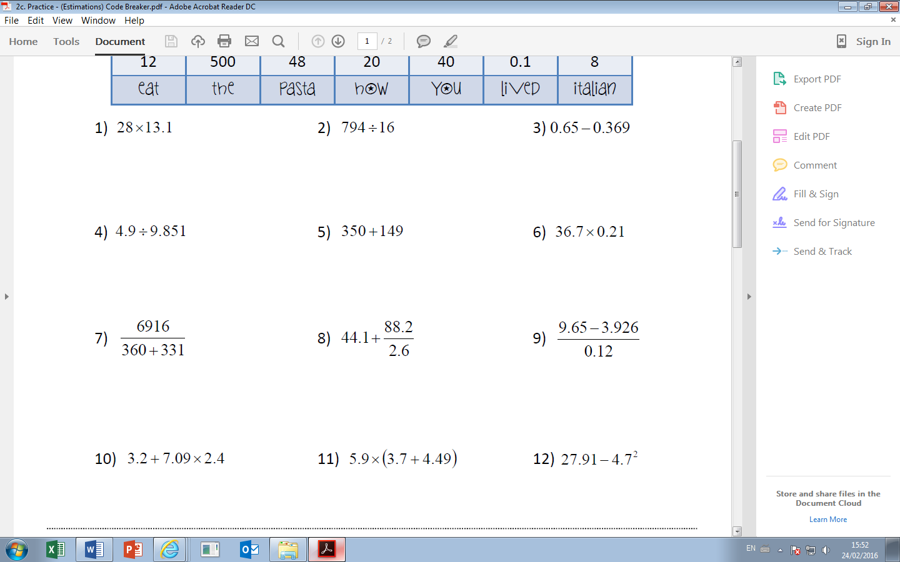
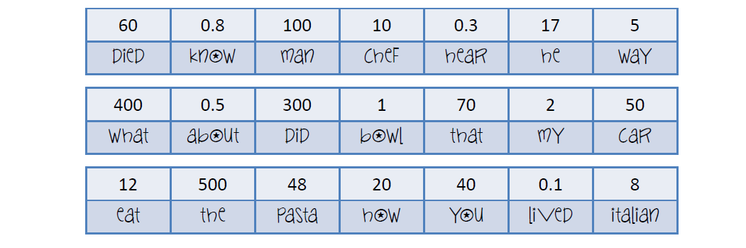
Find the word matching to each answer.
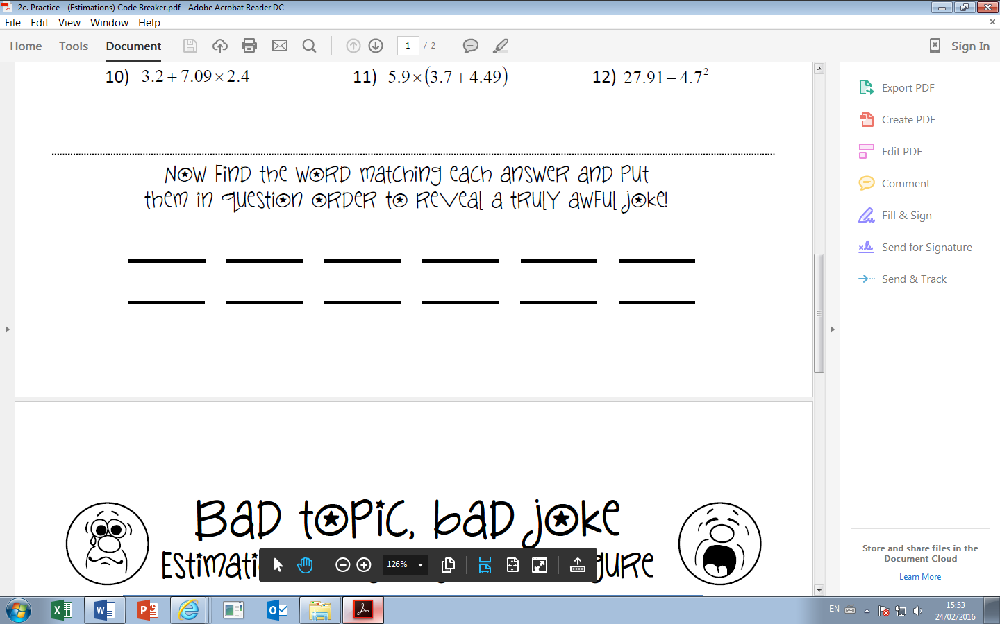
Estimating Calculations – Codebreaker
Find the word matching to each answer.

