Conversion graphs – inches to centimetres
2 inches = 5cm
Use this fact to complete these number sentences:
- 20 inches = __________ cm
- _________ inches = 10cm
- 25 inches = _______ cm
- ___________ inches = 30cm
Plot these points on the conversion graph below. Join the points with a line. (You should have a single straight line starting at (0, 0).)
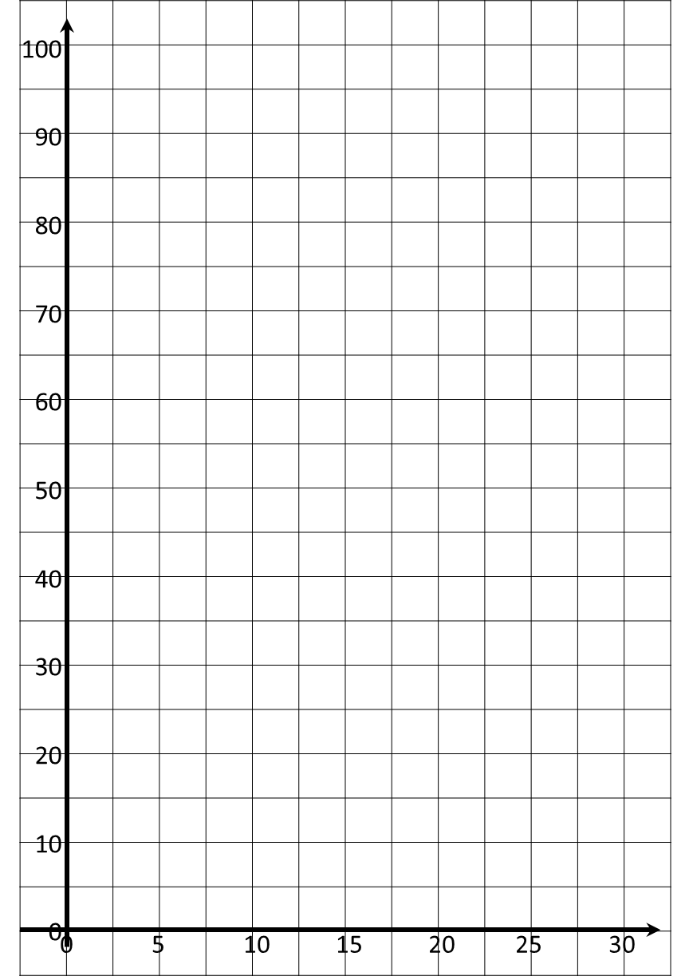
Centimetres
Inches
Use your graph to estimate the answers for these conversions.
- 17.5 inches = __________ cm
- _________ inches = 70cm
- 40 inches = _______ cm
- ___________ inches = 300cm

Conversion graphs – Pounds to Euros
£1.00 = €1.20
Use this fact to complete this table of values:
Pounds (£) | 1.00 | 10.00 |  | 25.00 |  | 100.00
Euros (€) | 1.20 |  | 24.00 |  | 60.00 | 120.00
Plot these points on the conversion graph below. Join the points with a line. (You should have a single straight line starting at (0, 0).)
- Use your graph to estimate the answers for these conversions.
- £60 = €__________
- £_________ = €140
- £200 = €_______
- £_________ = €500

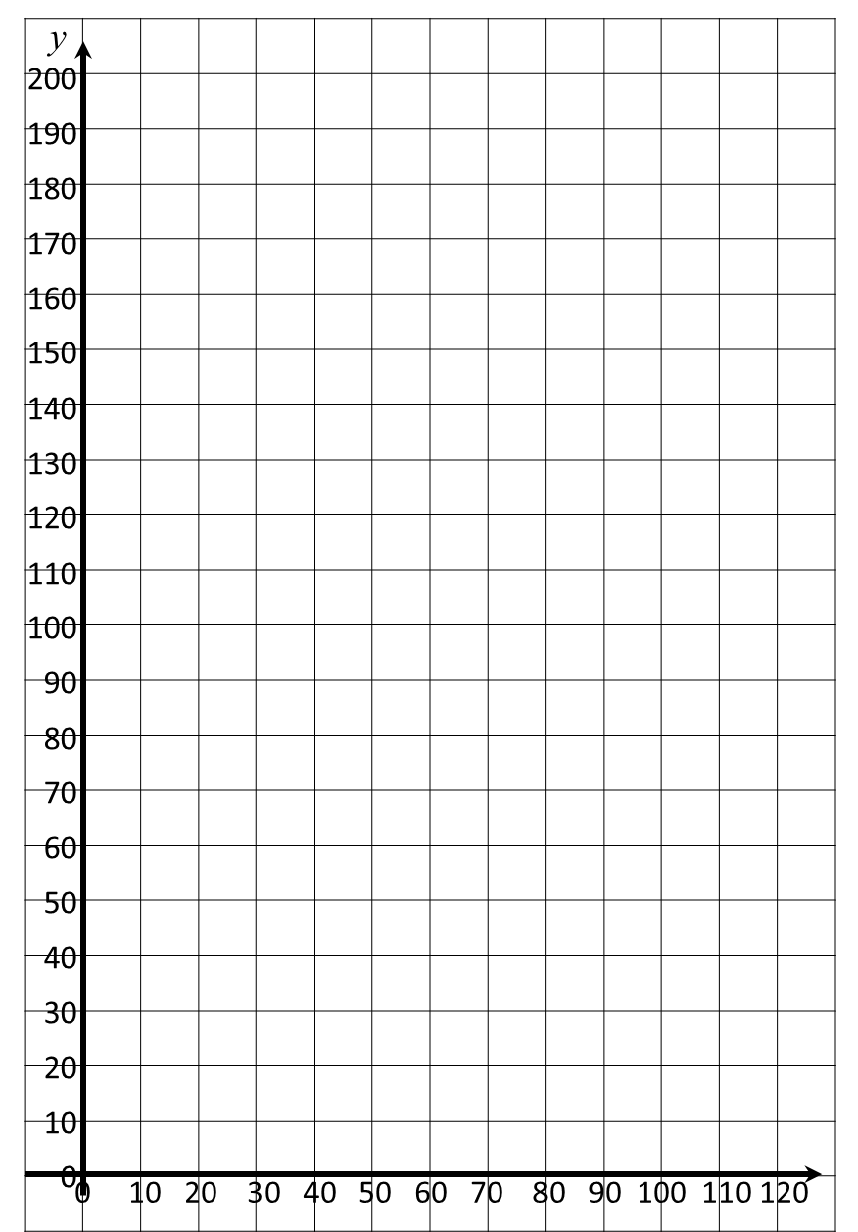
- Monica earns €90,000 as a senior doctor in Milan. How much would she expect to earn in Leeds? £_______________
- Pierre wants to buy a camera. It cost £130 in London and €140 in Paris. Which is the better deal? _______
Pounds (£)
Euros (€)

Conversion graphs – Miles to Kilometres
5 miles = 8km
Use this fact to complete these number sentences:
- 10 miles = __________ km
- _________ miles = 40km
- 20 miles = _______ km
- ___________ miles = 80km
Plot these points on the conversion graph below. Join the points with a line. (You should have a single straight line starting at (0, 0).)
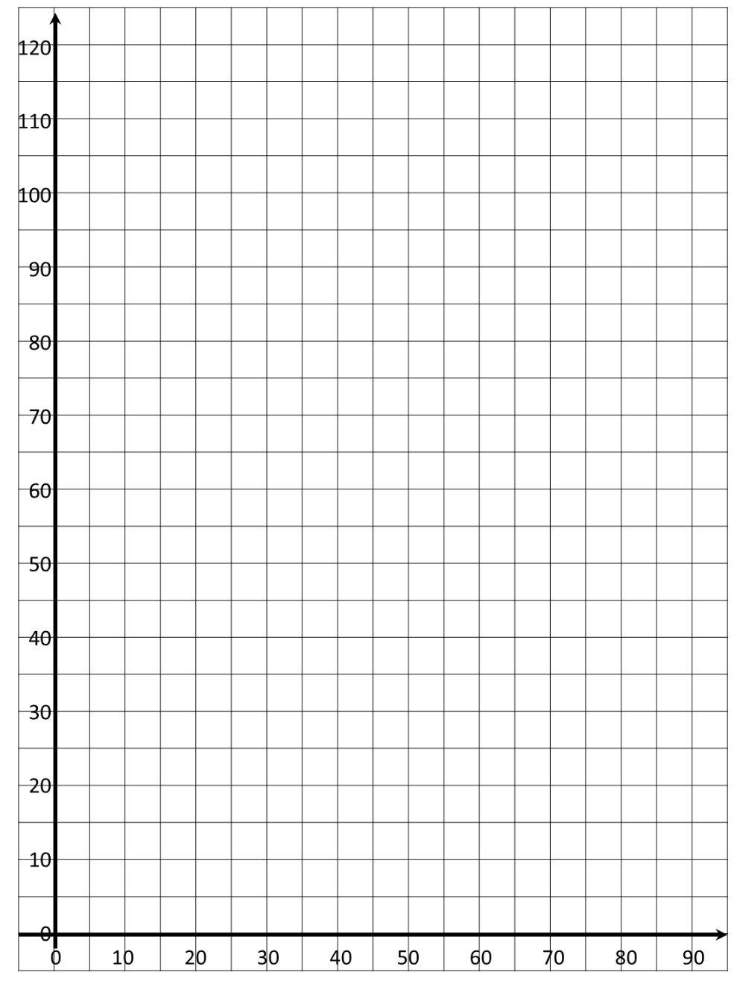
Kilometres
Miles
Use your graph to estimate the answers for these conversions.
- 35 miles = __________ km
- _________ miles = 90km
- 80 miles = _______ km
- ___________ miles = 200km

Converting Graphs - Temperatures
a) Draw a conversion graph for converting Celsius to Fahrenheit.

Celsius  ºC | -10 | 0 | 10 | 30
Fahrenheit  ºF | 14 | 32 | 50 | 86

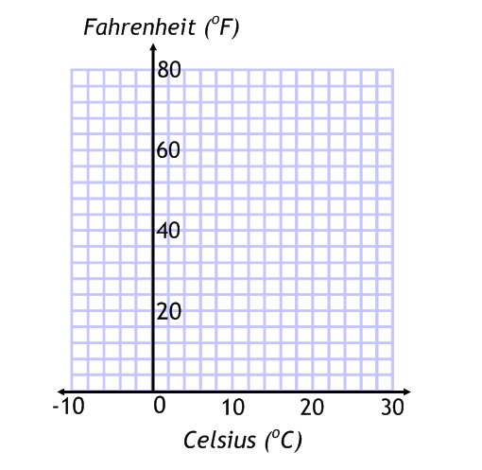

b) Convert 20ºC to Fahrenheit

