Exponetial Graphs
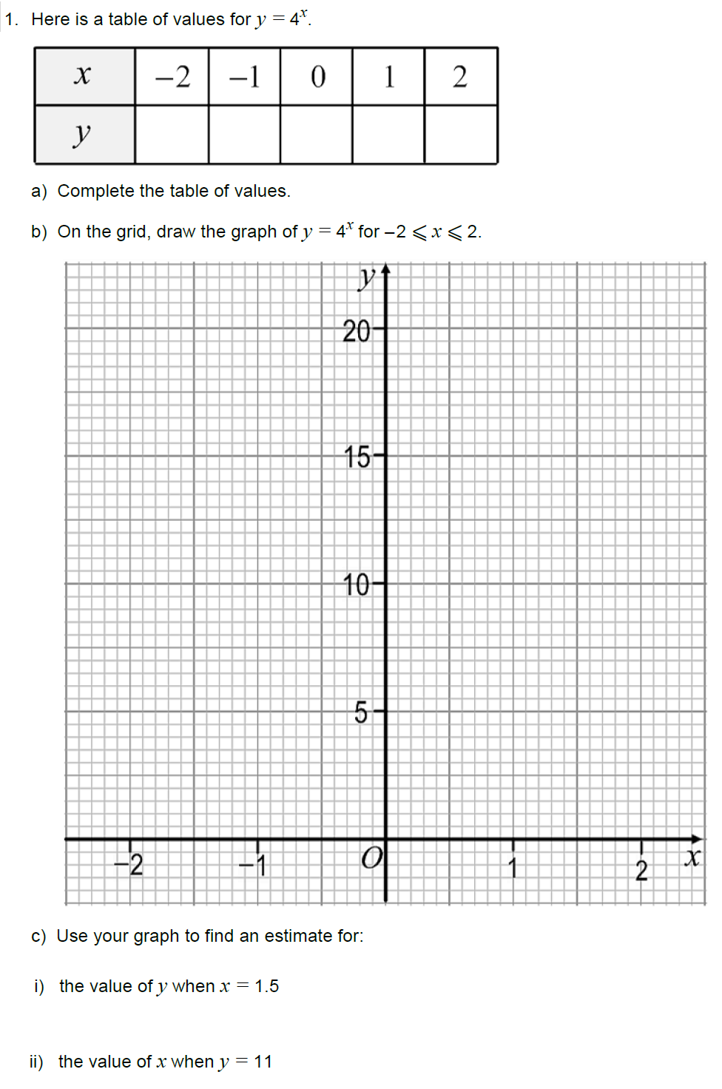
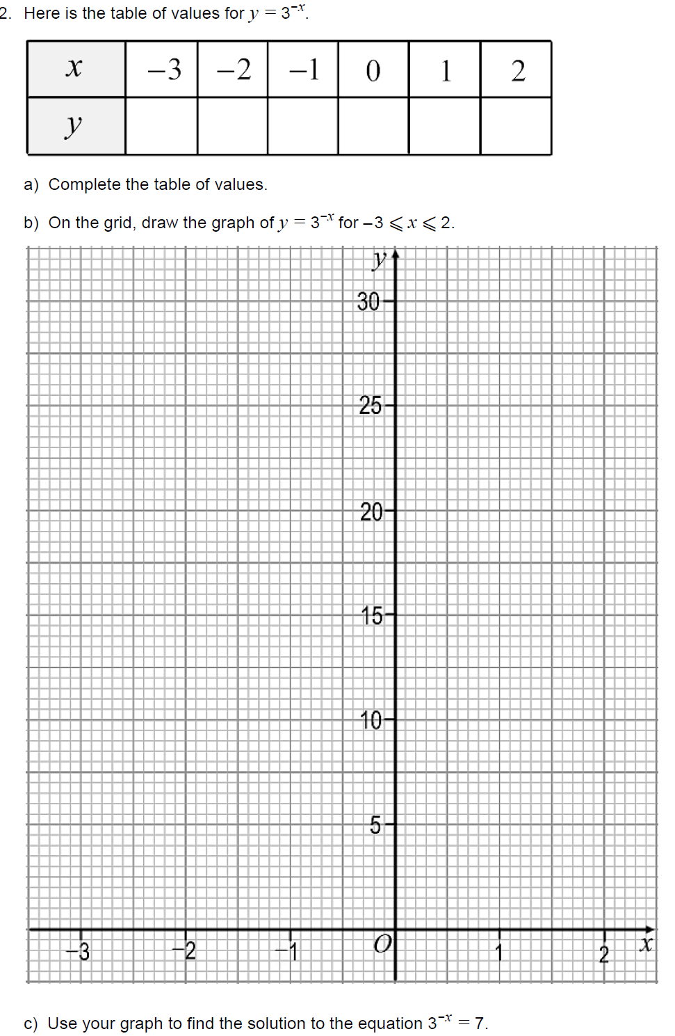
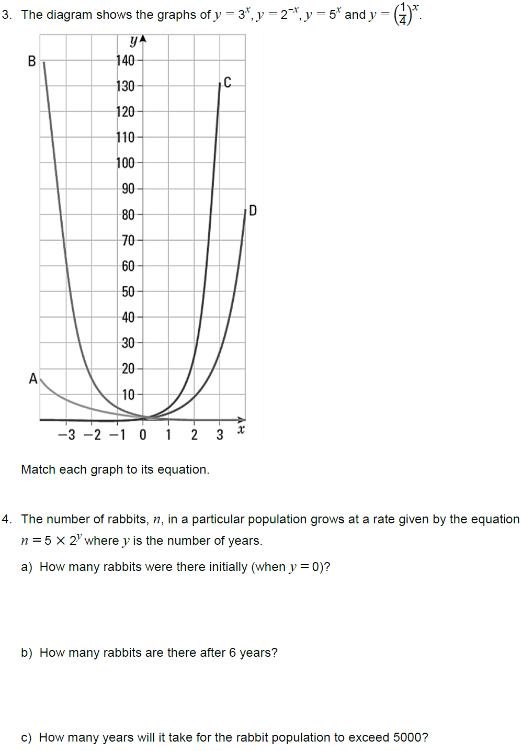
5. The p = 2000(0.9)^{x}, where x is the time in years, models a dog population.
a) Complete the table.
Time (years) | Population
0
1
2
3

b) What is the starting population?

c) By how much is the population multiplied each year?

d) How many dogs will there be in 8 years?

6. p = 200,000(0.98)^{x}
where x is the time in years, models the population of a city.

a) By how much is the population multiplied each year?

b) What is the starting population?

c) Complete the table.
Time (years) | Population
0
1
2
3

d) What the population will be in 7 years?

