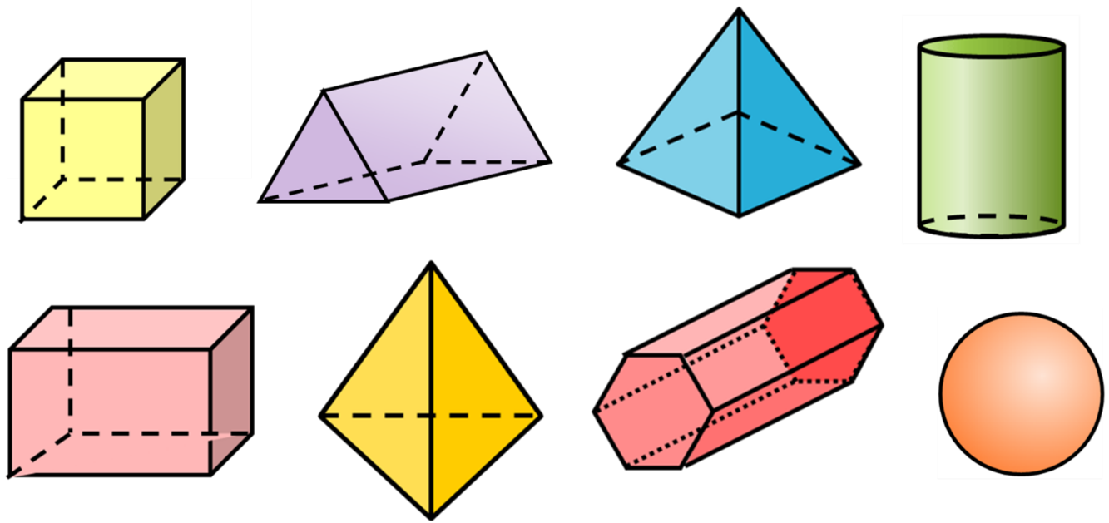
1) Complete the table.
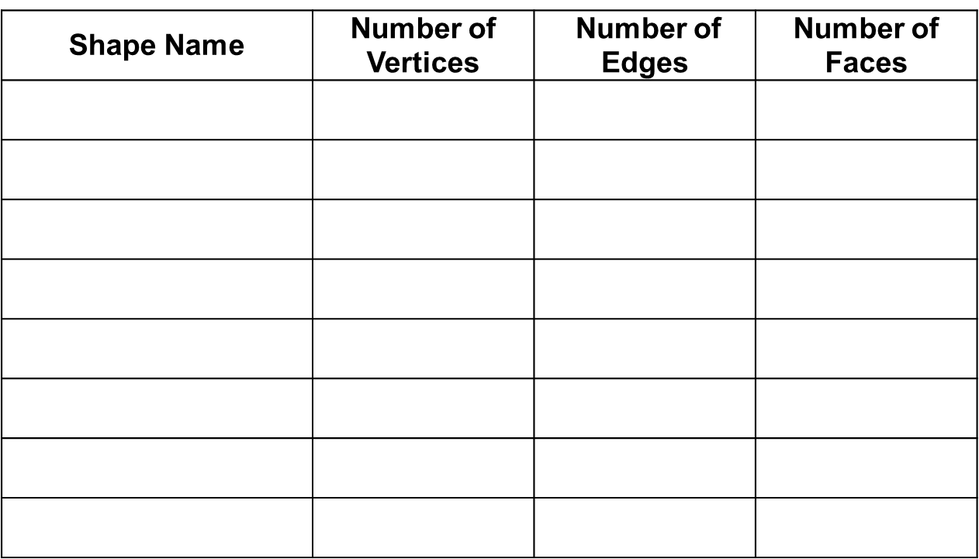
2) Do all 3D shapes have the same number of vertices as they do faces? Why?

3) Do all 3D shapes have an equal number of edges and vertices. Why?

4) Do all prisms have a number of edges which are a multiple of 3?

5) Can you find a formula for calculating Edges using faces and vertices?
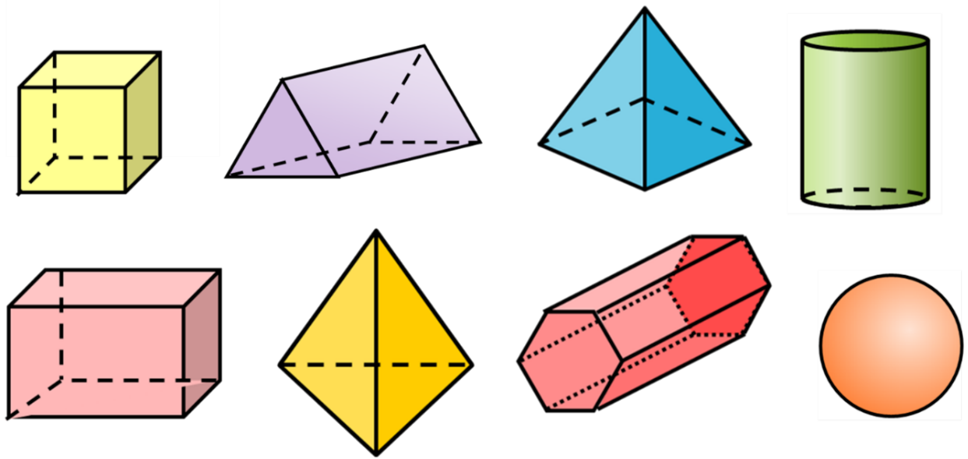
1) Complete the table.
2) Do all 3D shapes have the same number of vertices as they do faces? Why?

3) Do all 3D shapes have an equal number of edges and vertices. Why?

4) Do all prisms have a number of edges which are a multiple of 3?

5) Can you find a formula for calculating Edges using faces and vertices?

