Circle Theorems – Missing Angles
1) ANGLE IN A SEMICIRCLE EQUALS 90°
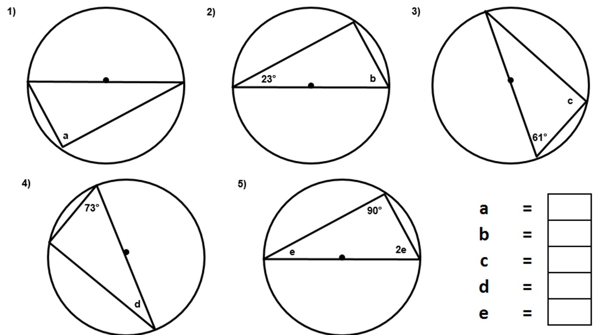
2) OPPOSITE ANGLES OF A CYCLIC QUADRILATERAL ADD UPTO 180°
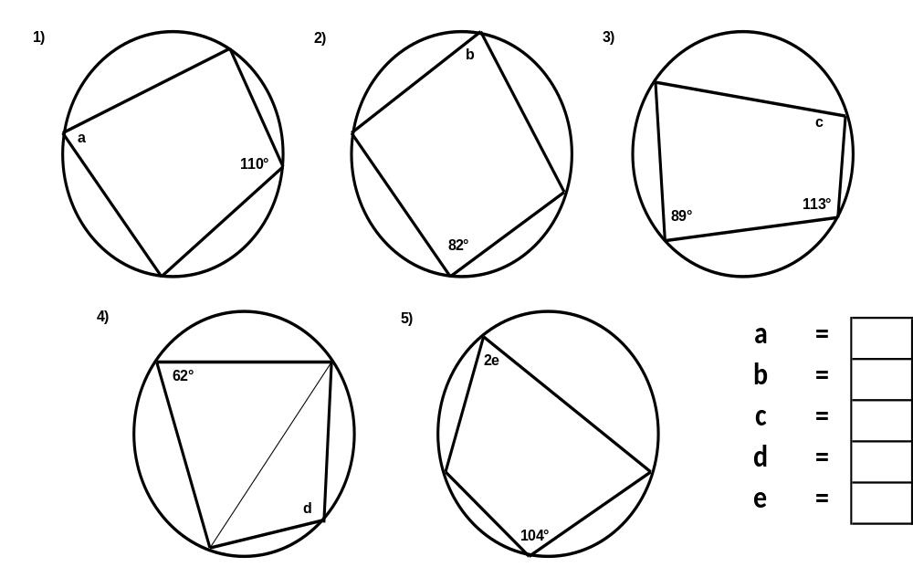
3) ANGLES FROM THE SAME CHORD ARE EQUAL
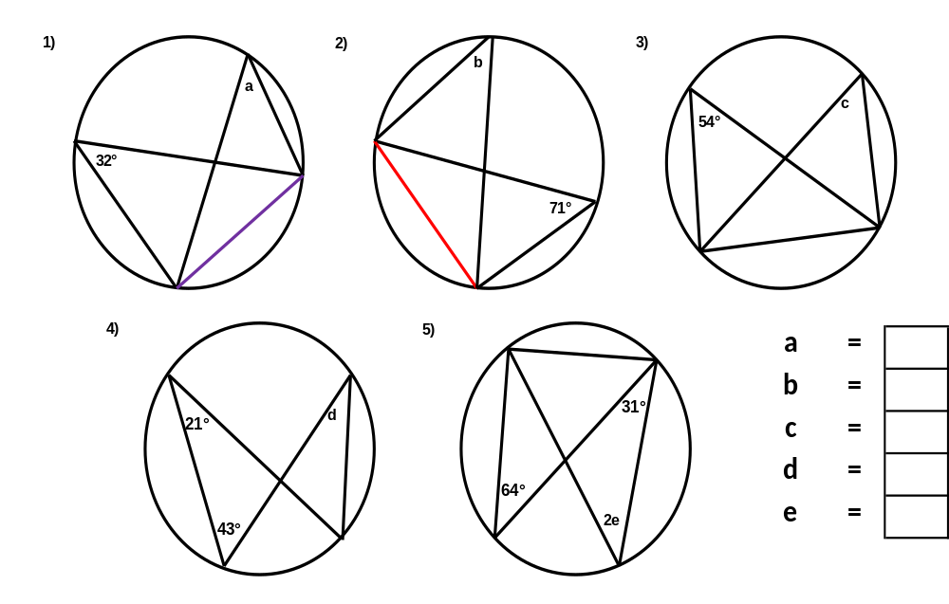
4) ANGLE AT THE CENTRE IS TWICE THE ANGLE AT THE CIRCUMFRENCE
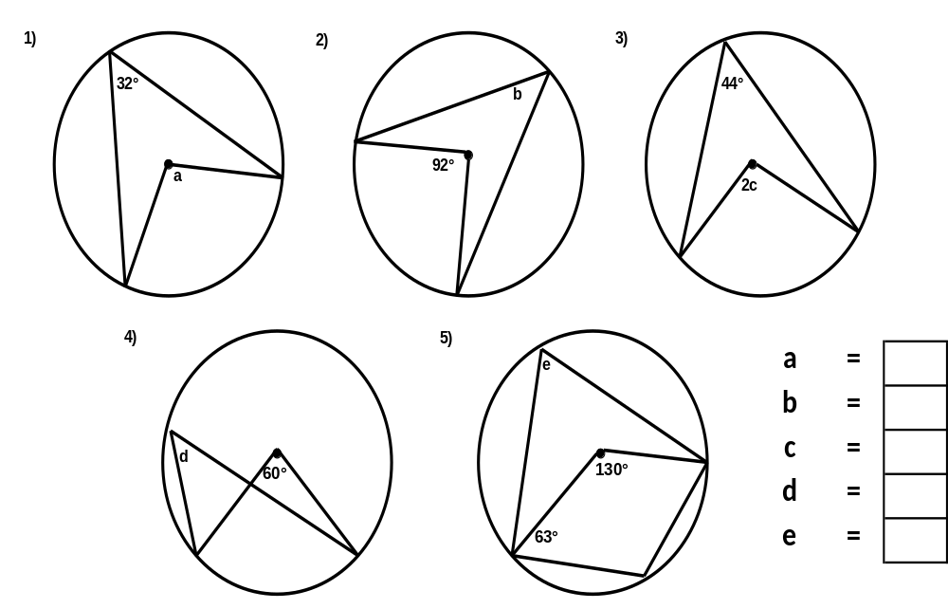
5) A TANGENT WILL ALWAYS MEET THE RADIUS AT 90°
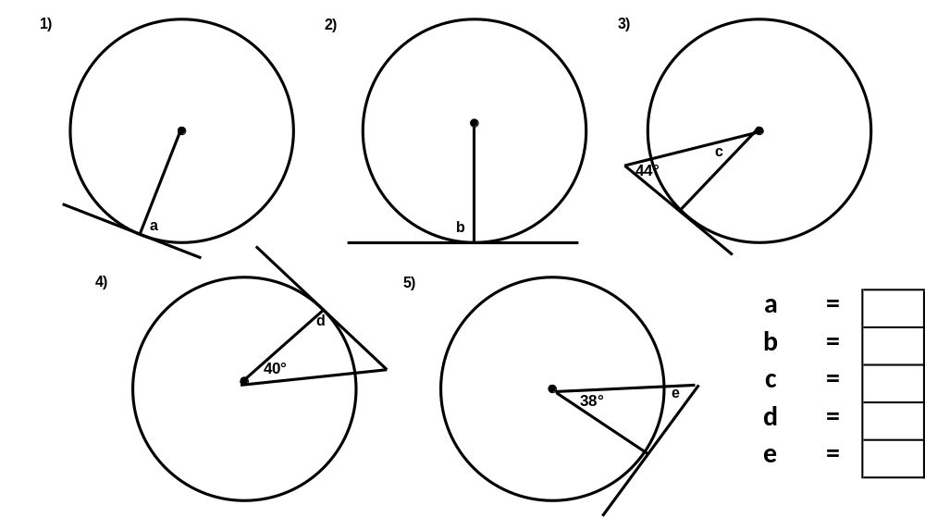
6) TANGENTS ARE EQUAL WHEN DRAWN FROM THE SAME POINT
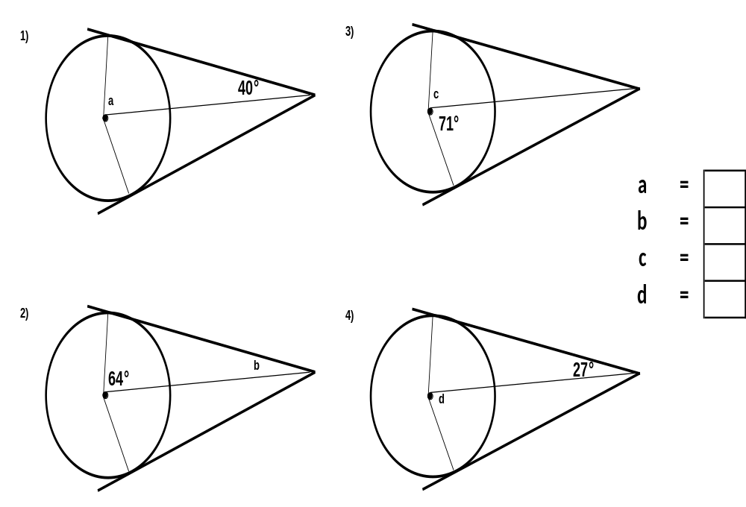
7) ANGLES IN OPPOSITE SEGMENTS ARE EQUAL
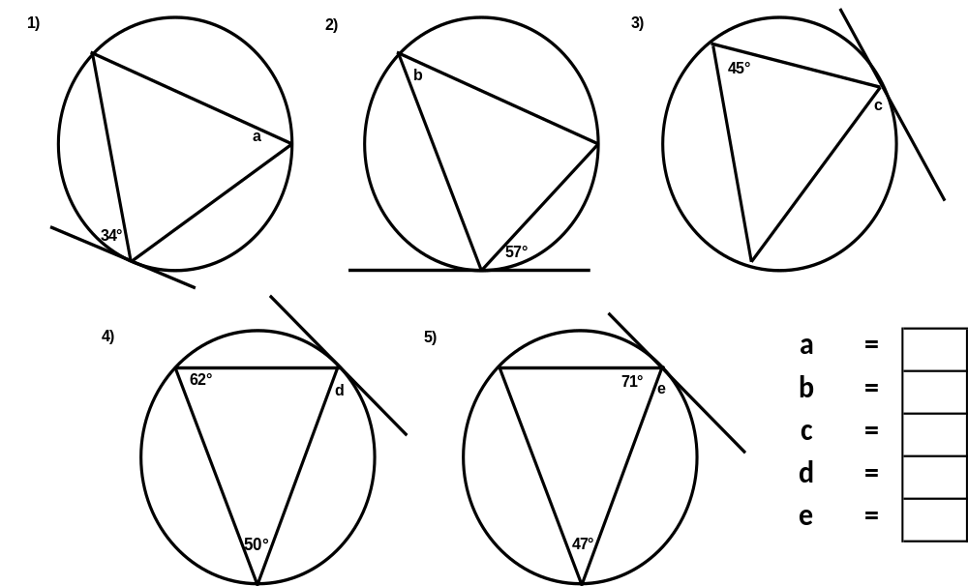
8) A PERPENDICULAR BISECTOR OF A CHORD IS THE DIAMETER
