Negatives – Battle Games
Game 1
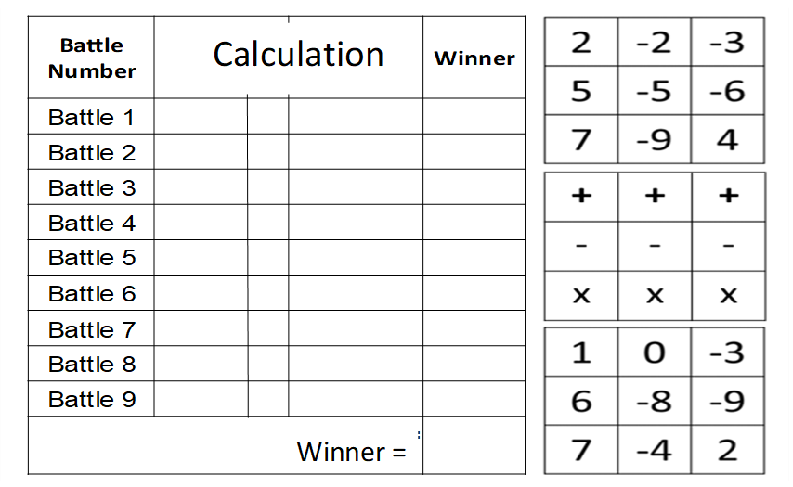
Game 2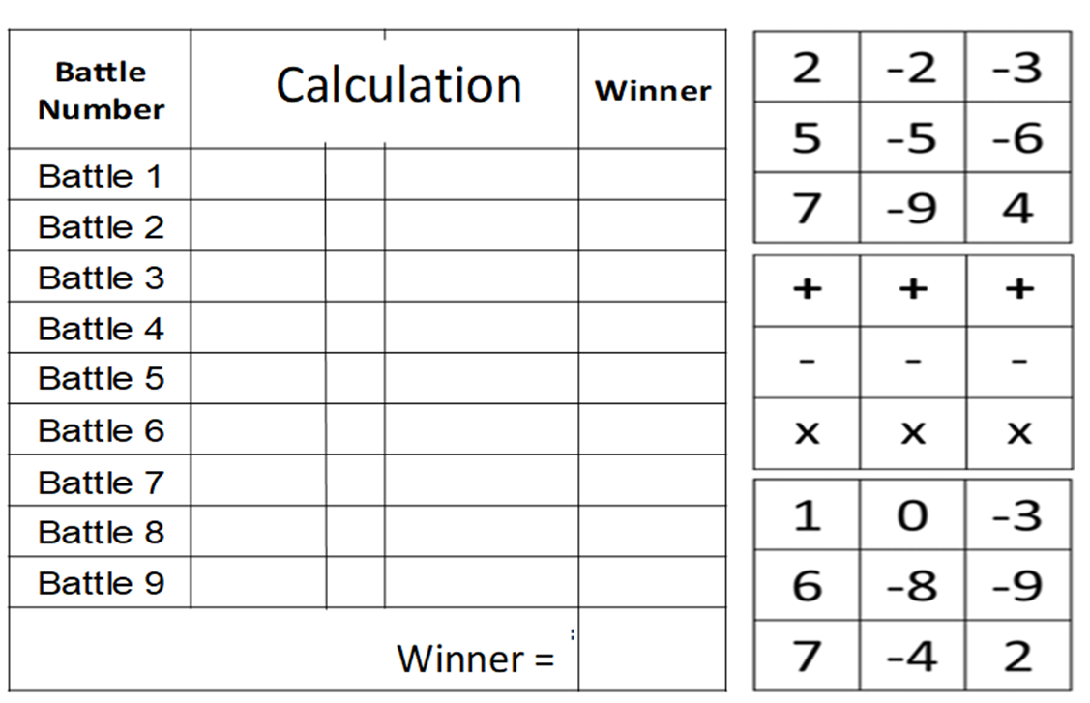
Negatives – Battle Games
Game 1
Game 2

