1) Jo, whose eyes are five feet off the ground, is standing 50 feet away from the base of a building, and she looks up at a 73° angle of elevation to a point on the edge of building’s roof. To the nearest foot, how tall is the building?

2) Stephanie and Adam work on the following problem: “A cat, who has climbed a tree, looks down at a dog at a 28° angle of depression. If the dog is 34 meters from the base of the tree, how high up is the cat?” Who is correct and how high is the cat up the tree?
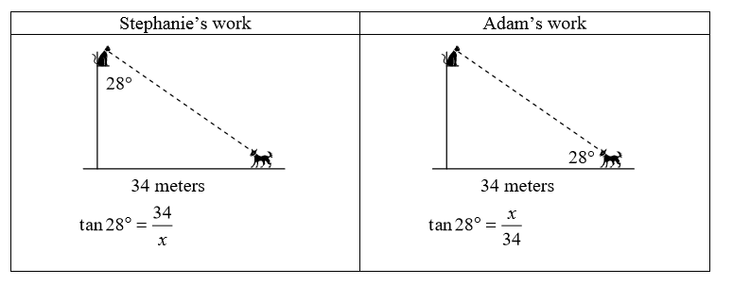
3) A ship is on the surface of the water, and its radar detects a submarine at a distance of 238 feet, at an angle of depression of 23°. How deep underwater is the submarine?

4) The sun is at an angle of depression of 58°. A tree casts a shadow 20 meters long on the ground. How tall is the tree?

5) Two observers on the ground are looking up at the top of the same tree from two different points on the horizontal ground. The first observer, who is 83 feet away from the base of the tree, looks up at an angle of elevation of 58°. The second observer is standing only 46 feet from the base of the tree.
How tall is the tree, to the nearest foot?
At what angle of elevation must the second observer look up to see the top of the tree?

6) A person starts out 17 miles from the base of a tall mountain, and looks up at a 4° angle of elevation to the top of the mountain. When they move 12 miles closer to the base of the mountain, what will be their angle of elevation when they look to the top? Answer to the nearest degree.

7) A pilot maintains an altitude of 25,000 feet over level ground. The pilot observes a crater on the ground at an angle of depression of 5°. If the plane continues for a further 100000ft, what will be the angle of depression to the crater? Answer to the nearest degree.
1) Jo, whose eyes are five feet off the ground, is standing 50 feet away from the base of a building, and she looks up at a 73° angle of elevation to a point on the edge of building’s roof. To the nearest foot, how tall is the building?

2) Stephanie and Adam work on the following problem: “A cat, who has climbed a tree, looks down at a dog at a 28° angle of depression. If the dog is 34 meters from the base of the tree, how high up is the cat?” Who is correct and how high is the cat up the tree?
3) A ship is on the surface of the water, and its radar detects a submarine at a distance of 238 feet, at an angle of depression of 23°. How deep underwater is the submarine?

4) The sun is at an angle of depression of 58°. A tree casts a shadow 20 meters long on the ground. How tall is the tree?

5) Two observers on the ground are looking up at the top of the same tree from two different points on the horizontal ground. The first observer, who is 83 feet away from the base of the tree, looks up at an angle of elevation of 58°. The second observer is standing only 46 feet from the base of the tree.
How tall is the tree, to the nearest foot?
At what angle of elevation must the second observer look up to see the top of the tree?

6) A person starts out 17 miles from the base of a tall mountain, and looks up at a 4° angle of elevation to the top of the mountain. When they move 12 miles closer to the base of the mountain, what will be their angle of elevation when they look to the top? Answer to the nearest degree.

7) A pilot maintains an altitude of 25,000 feet over level ground. The pilot observes a crater on the ground at an angle of depression of 5°. If the plane continues for a further 100000ft, what will be the angle of depression to the crater? Answer to the nearest degree.

