Quadratics, Cubic and Reciprocals Graphs

TIP: When joining up the points that you have plotted, join them with a smooth curve, not a straight line!

1a) Complete the following table for the equation

y = x² + 2, for -3 $≤x ≤$ 3:

x | -3 | -2 | -1 | 0 | 1 | 2 | 3
y

b) Draw the graph of y = x² + 2 on the grid:
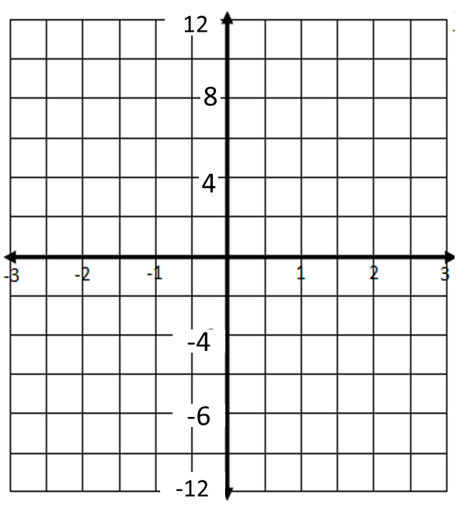
-8

2a) Complete the following table for the equation

y = x² - 1, for -3 $≤x ≤$ 3:

x | -3 | -2 | -1 | 0 | 1 | 2 | 3
y

b) Draw the graph of y = x² – 1 on the grid:

-8

3a) Complete the following table for the equation

y = x³, for -3 $≤x ≤$ 3:

x | -3 | -2 | -1 | 0 | 1 | 2 | 3
y

b) Draw the graph of y = x³ on the grid:

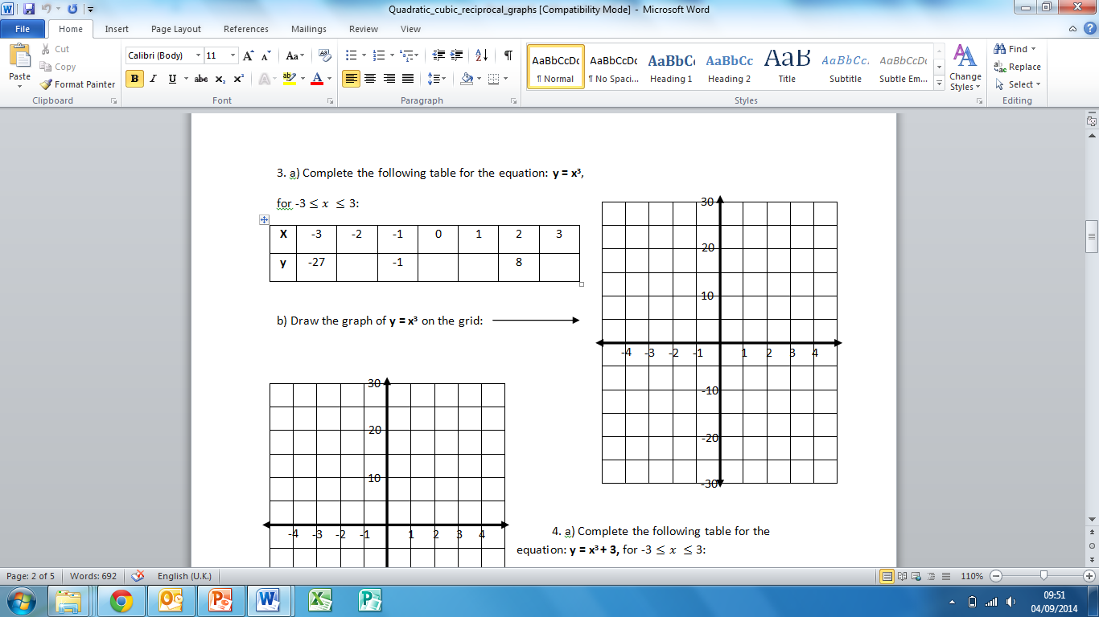

4a) Complete the following table for the equation

y = x³ + 3, for -3 $≤x ≤$ 3:
x | -3 | -2 | -1 | 0 | 1 | 2 | 3
y

b) Draw the graph of y = x³ + 3 on the grid:

5a) Complete the following table for the equation: y = $\frac{3}{x}$ , for -3 $≤x ≤$ 3:

x | -3 | -2.5 | -2 | -1.5 | -1 | -0.5 | 0 | 0.5 | 1 | 1.5 | 2 | 2.5 | 3
y

b) Draw the graph of y = $\frac{3}{x}$ on the grid:

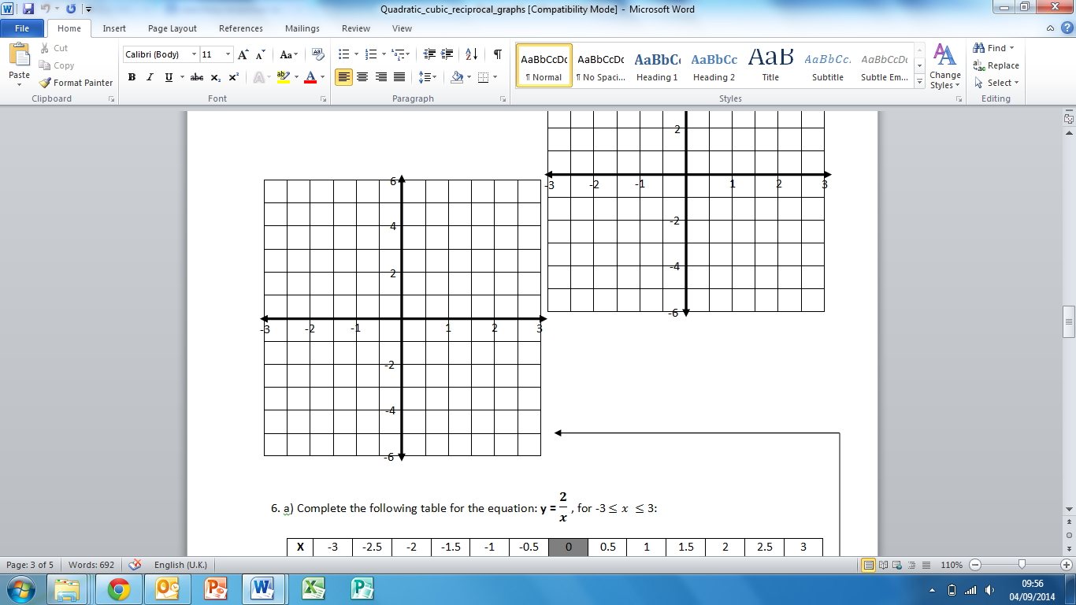

6a) Complete the following table for the equation: y = $\frac{2}{x}$ for -3 $≤x ≤$ 3:

x | -3 | -2.5 | -2 | -1.5 | -1 | -0.5 | 0 | 0.5 | 1 | 1.5 | 2 | 2.5 | 3
y

b) Draw the graph of y = $\frac{2}{x}$ on the grid:

7) Fill in the gaps using the following words:
Cubic / Linear / Reciprocal / Quadratic

Equations where the highest power of x is 1 (‘x’) are called _________________ equations.
They create a straight line when drawn graphically.

Equations where the highest power of x is 2 (‘x²’) are called ________________ equations.
They create a ‘U’ or ‘n’ shape when drawn graphically.

Equations where the highest power of x is 3 (‘x³) are called _________________ equations.
They create a ‘ ‘ or ‘ ‘ shape when drawn graphically.

Equations that include a number divided by x (e.g. $\frac{4}{x}$) are called ______________ equations. The graph never touches the axes.

8) Name the type of equation for each of the following:

a) $y= 3x^{2}+ 2x+1$
b) $y= 4x^{3}+ x^{2}$
c) $y= \frac{7}{x}$
d) $y= 5x+9$
e) $y= 4x^{2}- 5$
f) $y= 9x^{2}- 6x^{3}$

9) Write the type of equation (linear/quadratic/cubic/reciprocal) of each graph:
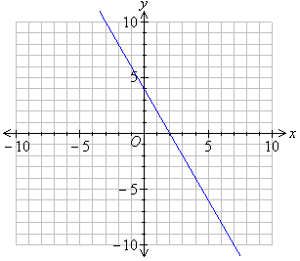
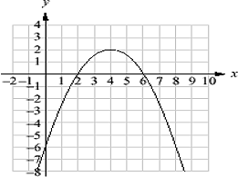
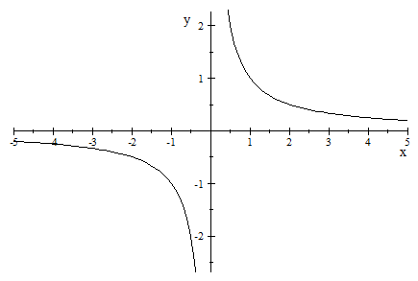
a) b) c)

_______
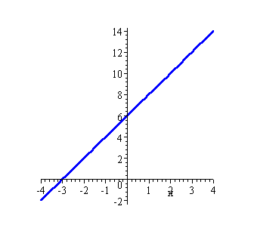
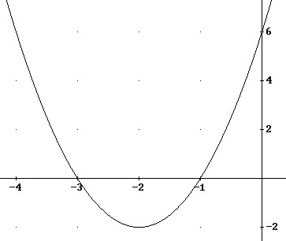
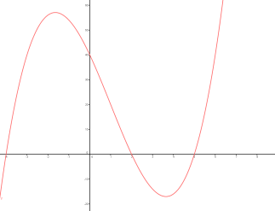
d) e) f)

10) Match the graph to the equation:

Graph (letter) | Equation
 | y = 2x – 5
 | y = $\frac{5}{x}$
 | y = 2x³
 | y = x² – 6
 | y = 7 - x

