Transforming Graphs
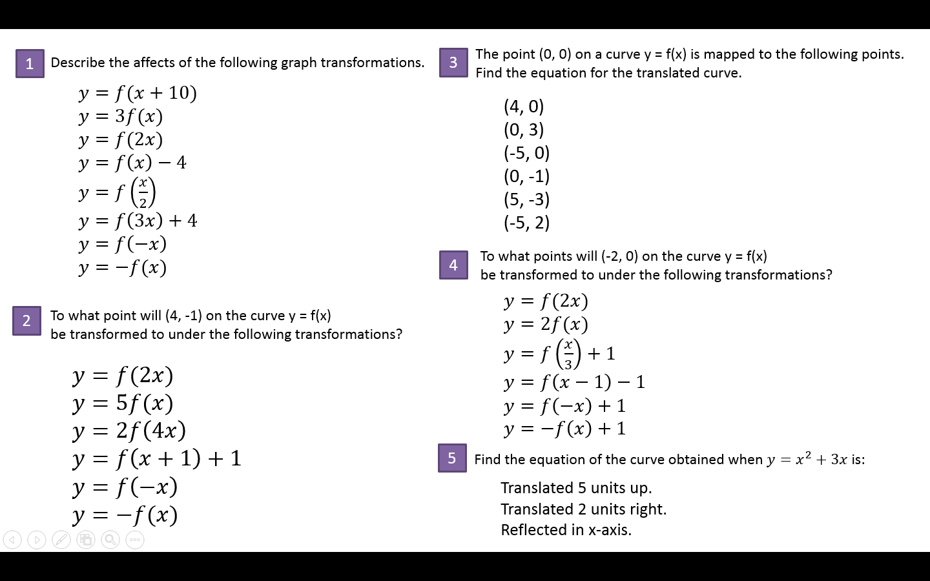
Transforming Graphs

