Translating using Co-ordinates
1)
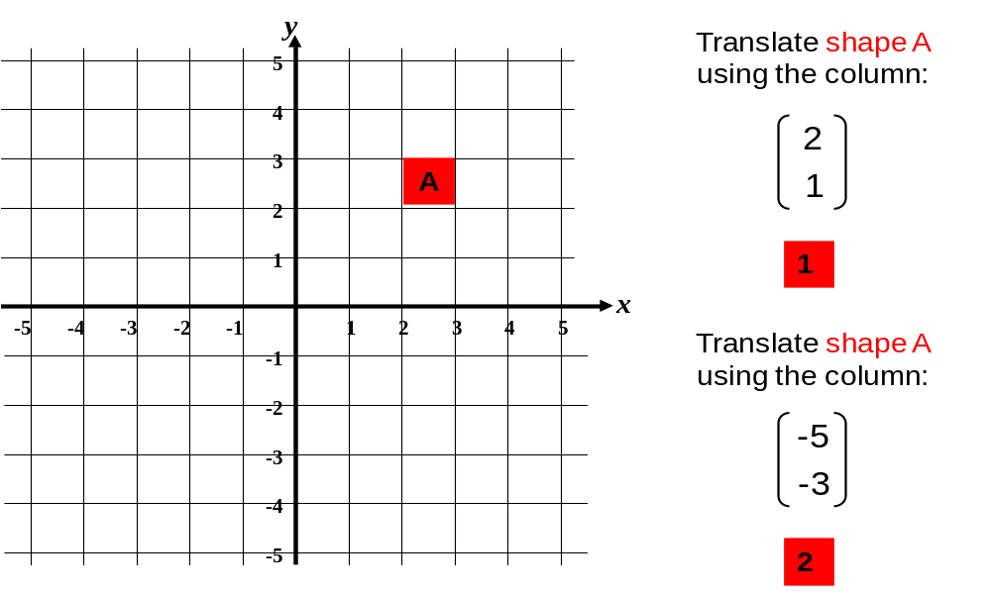
2)

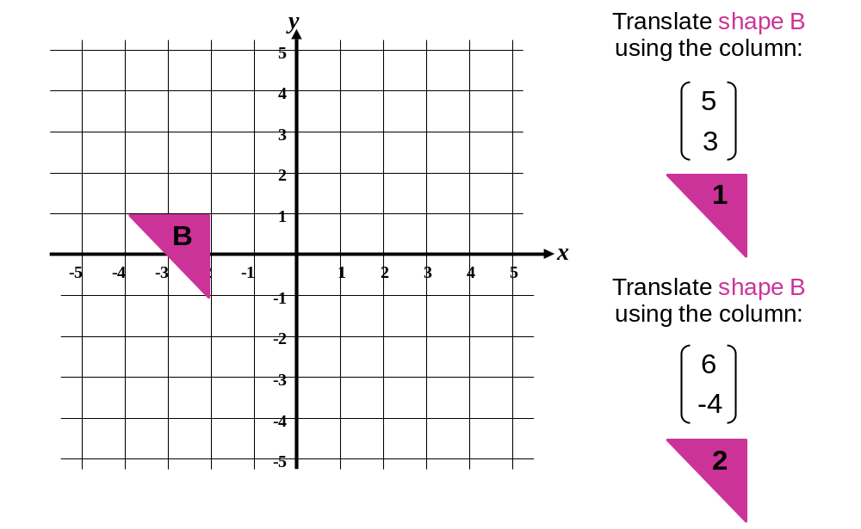
3)
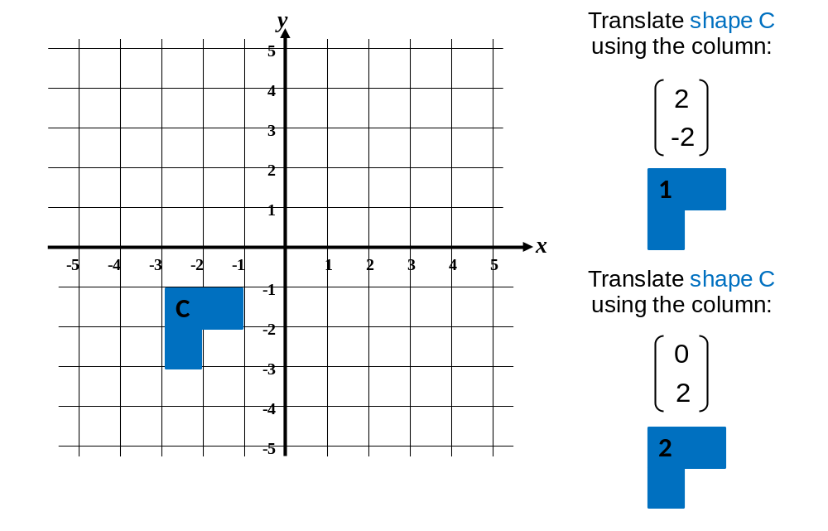
4)
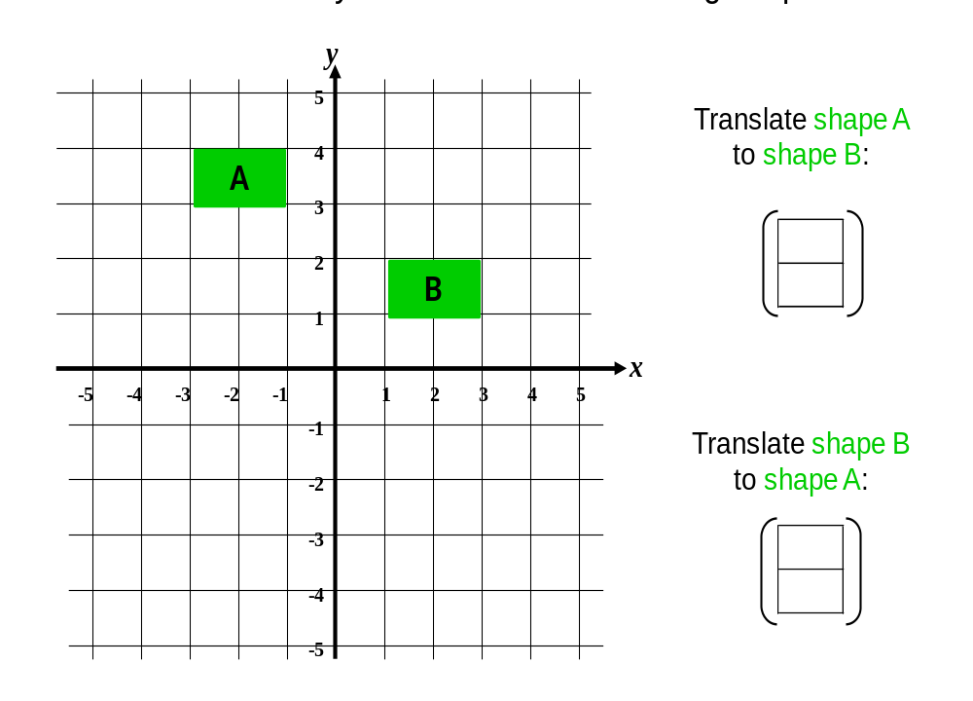
5)
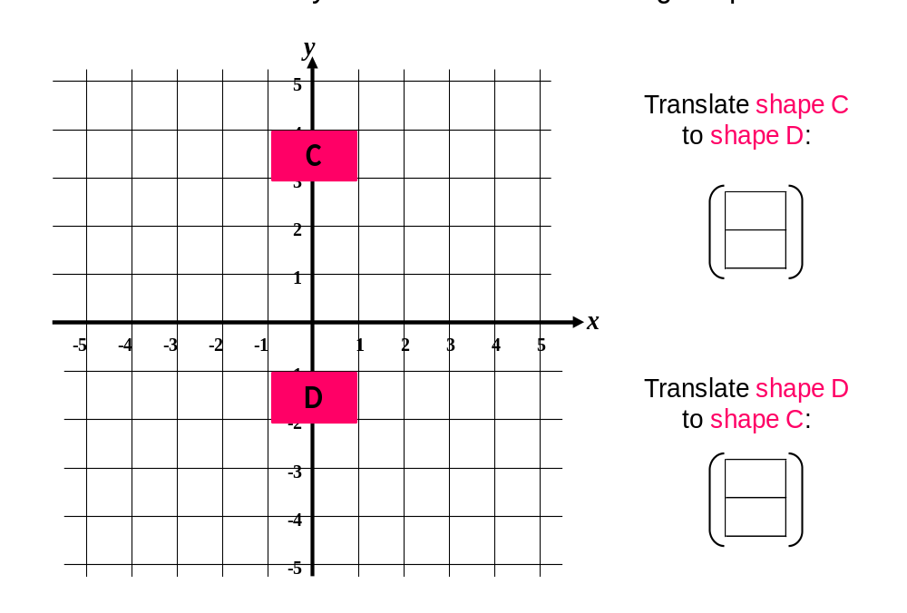
6)
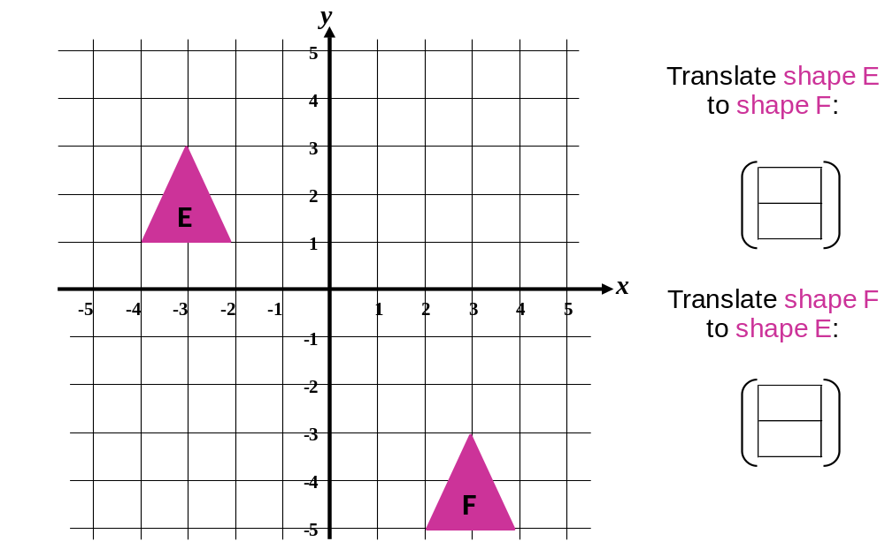

7)
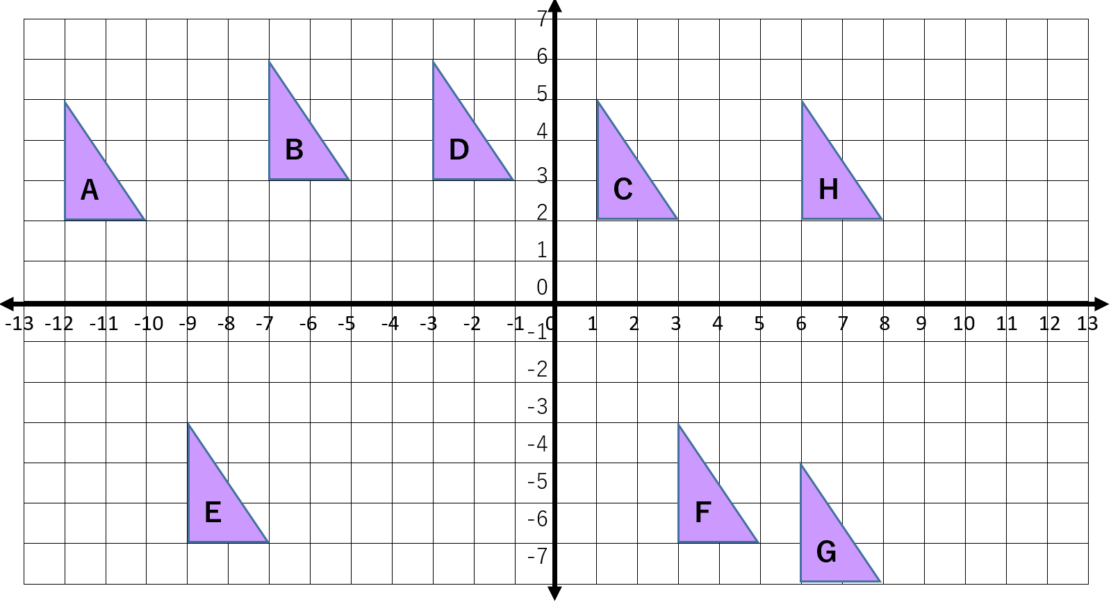
a) Write down the translation vectors for each of the following translations:
A B B C C D D E E F F G G H
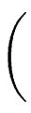

b) Write down the translation vectors for the REVERSE of the above:
B A C B D C E D F E G F H G

c) Describe the difference of column vectors between the translation vector and its reverse.

Combining Translations
d) What do you notice about the translation vector for A C and the translation vectors for
A B and B C ?

