Calculating with Negatives
All operations
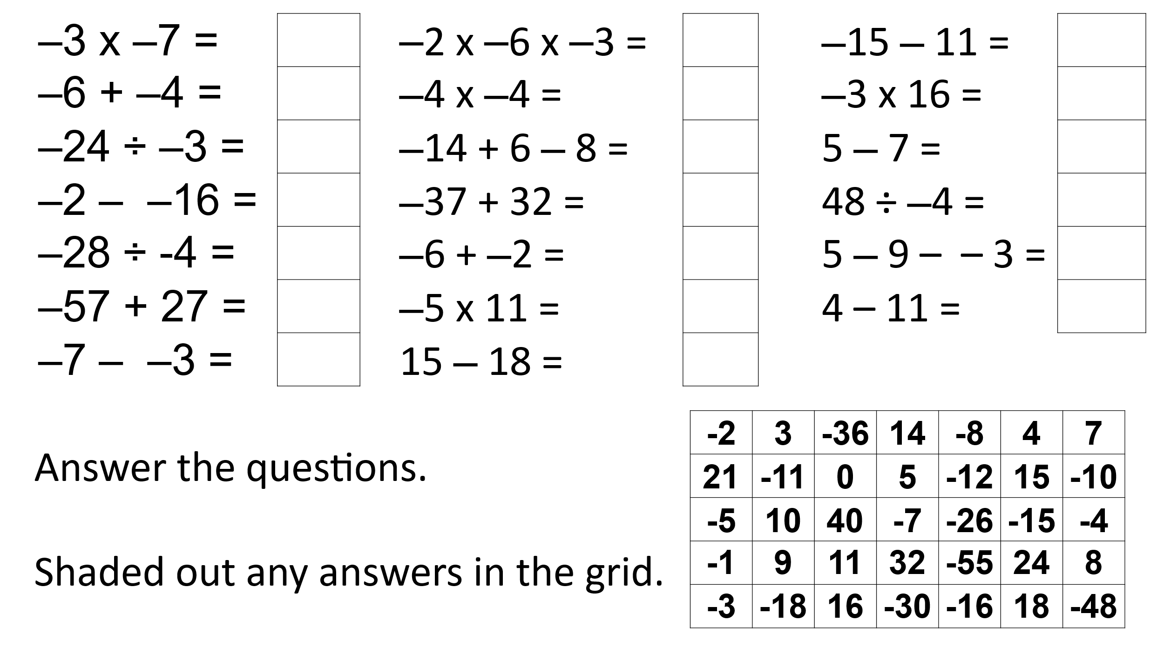
Adding and Subtracting: Find the missing numbers or operations
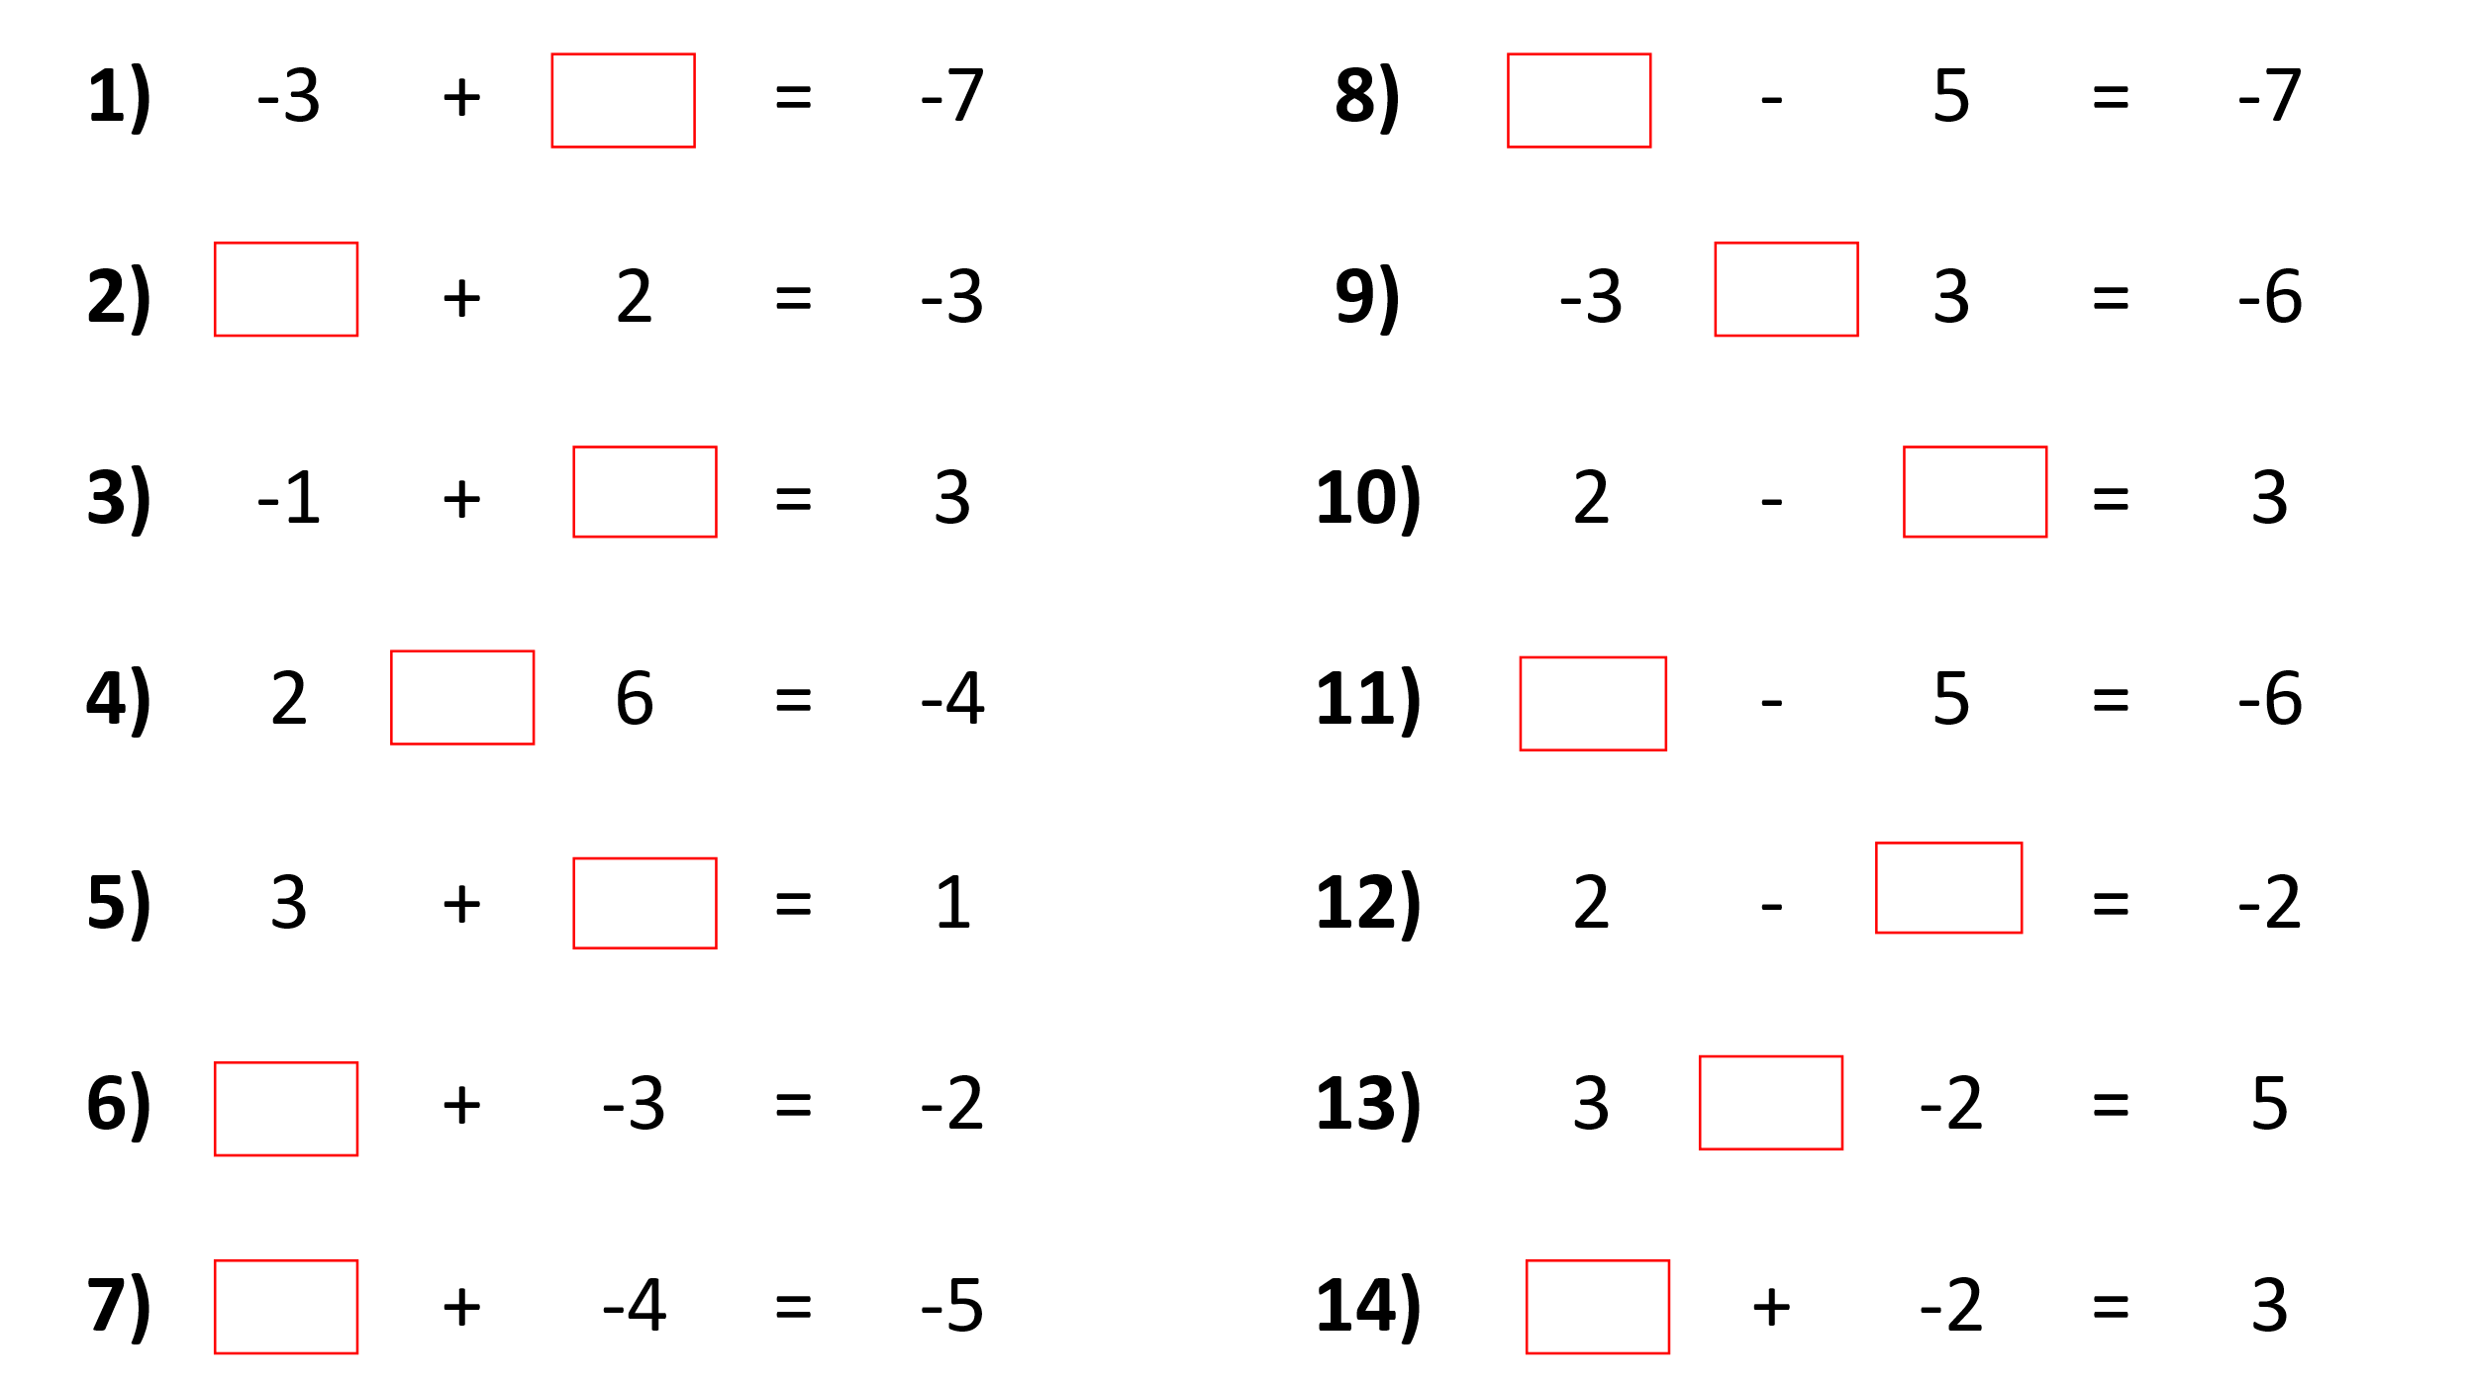
Multiplying and Dividing: Find the missing number or operations
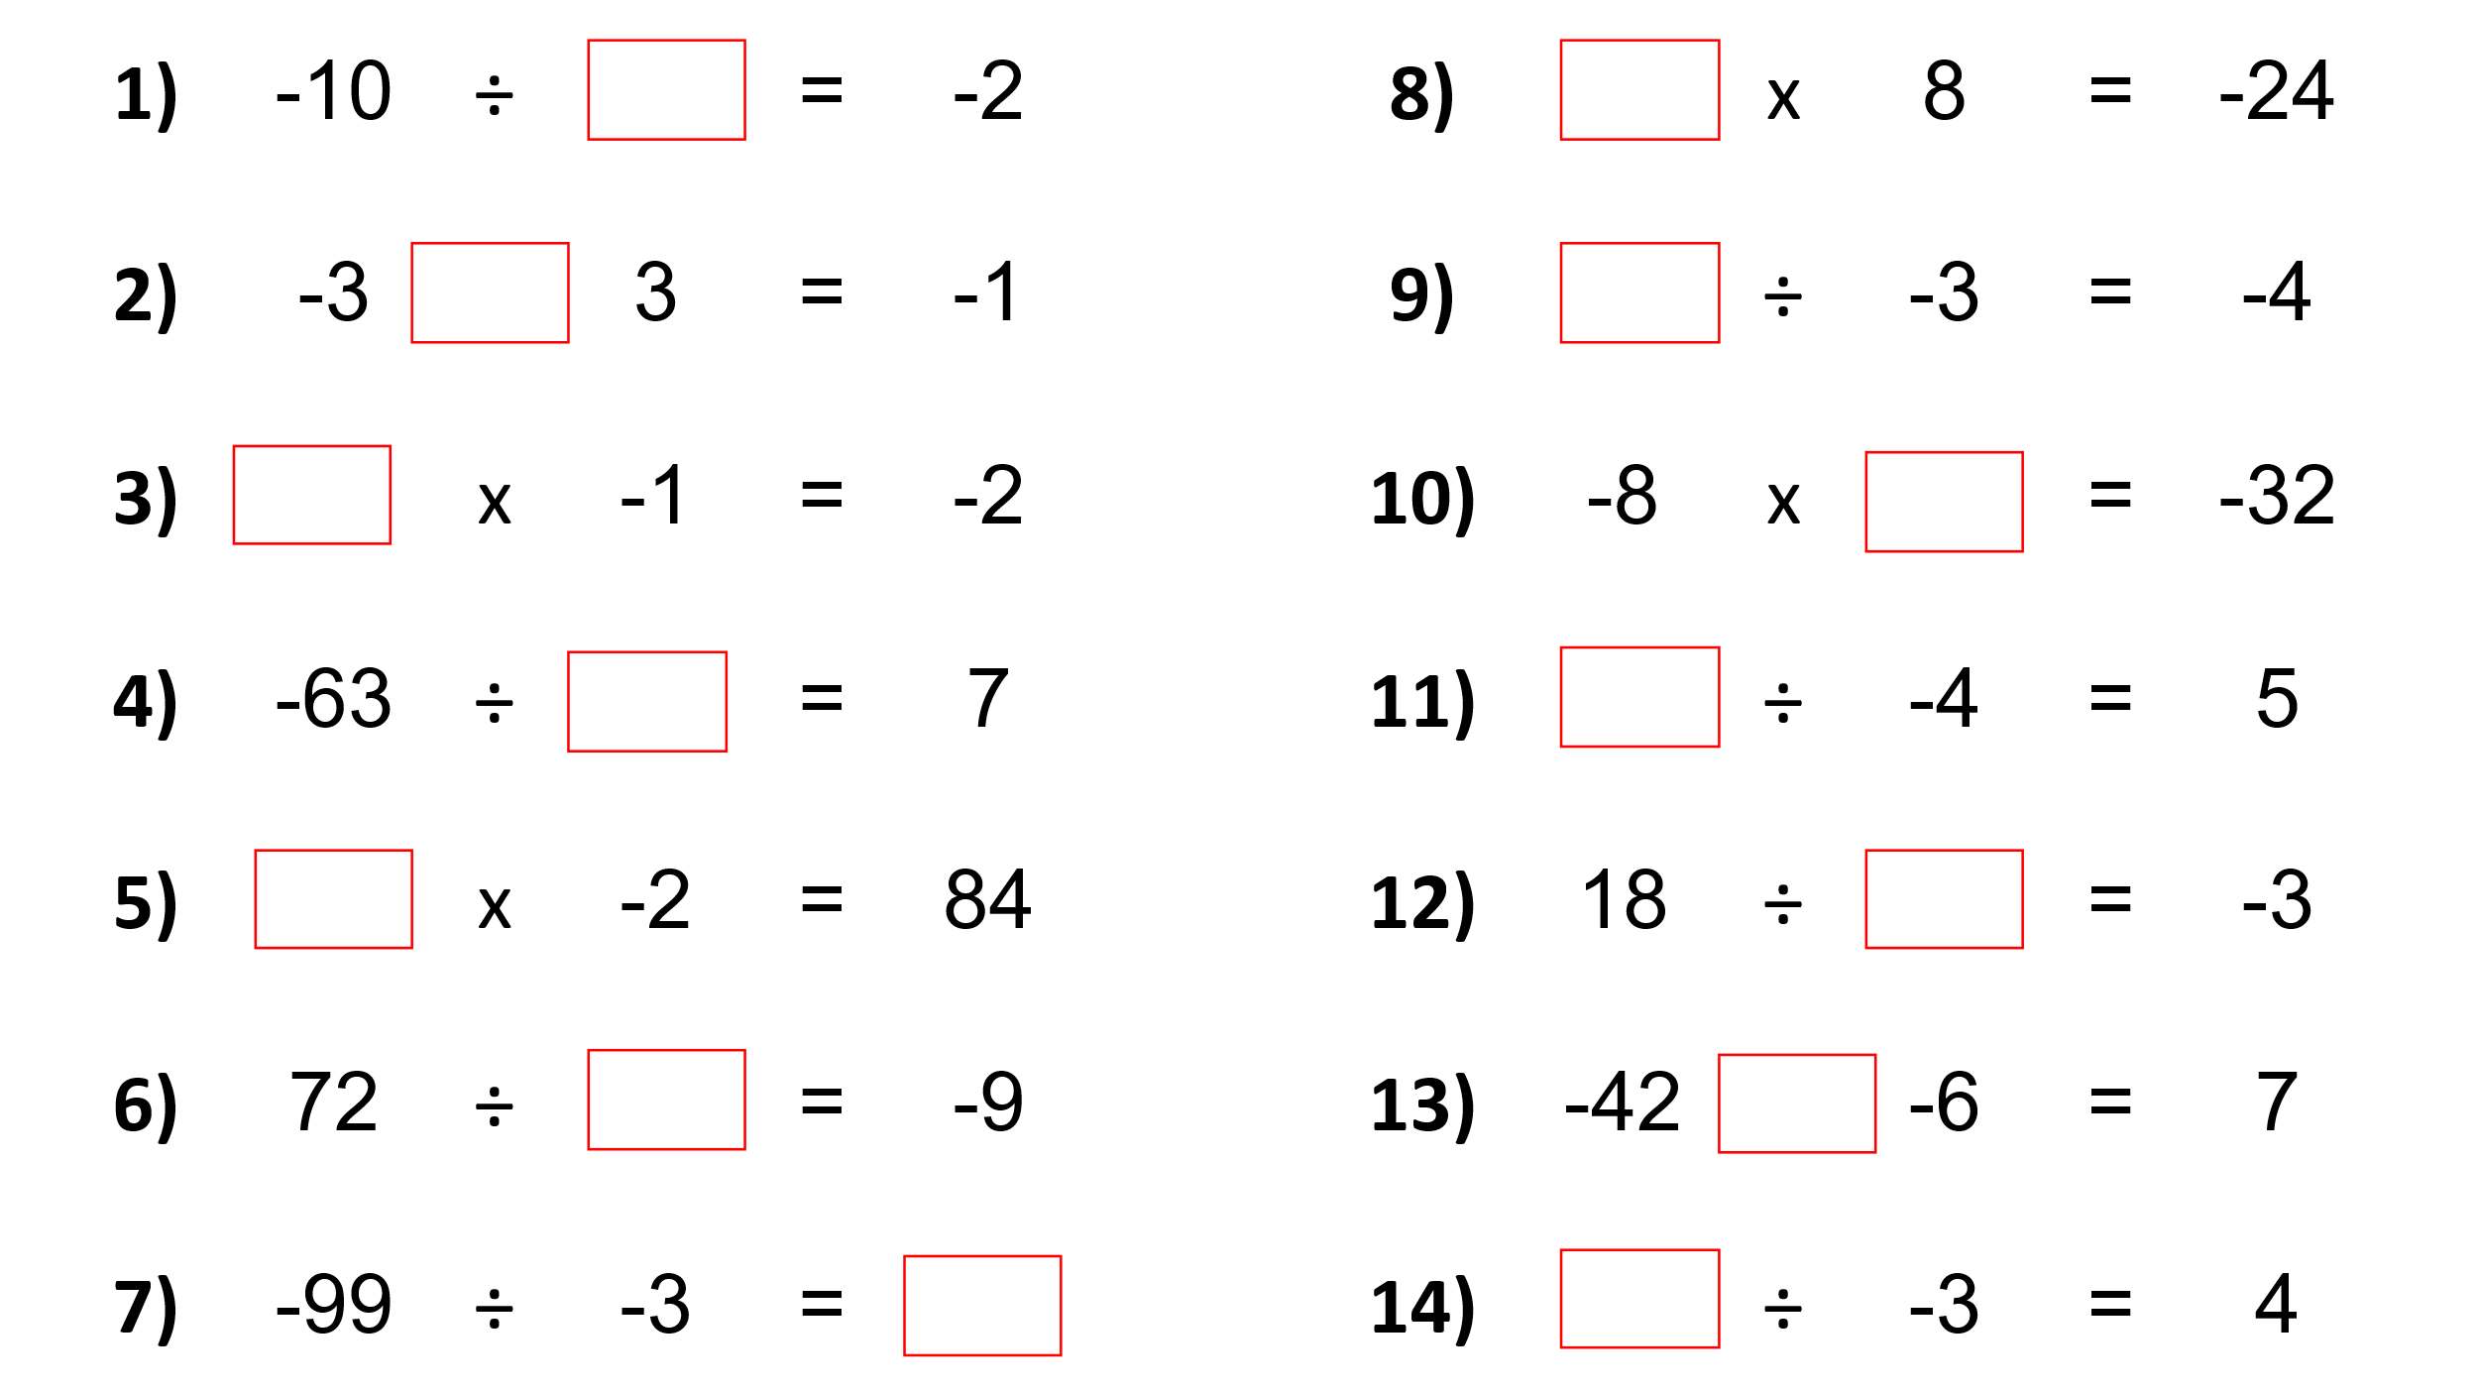

Codebreaker: Reveal the interesting fact
