Averages from Group Frequency Table
Part A: Find the modal group, median and estiamte a mean for each table.
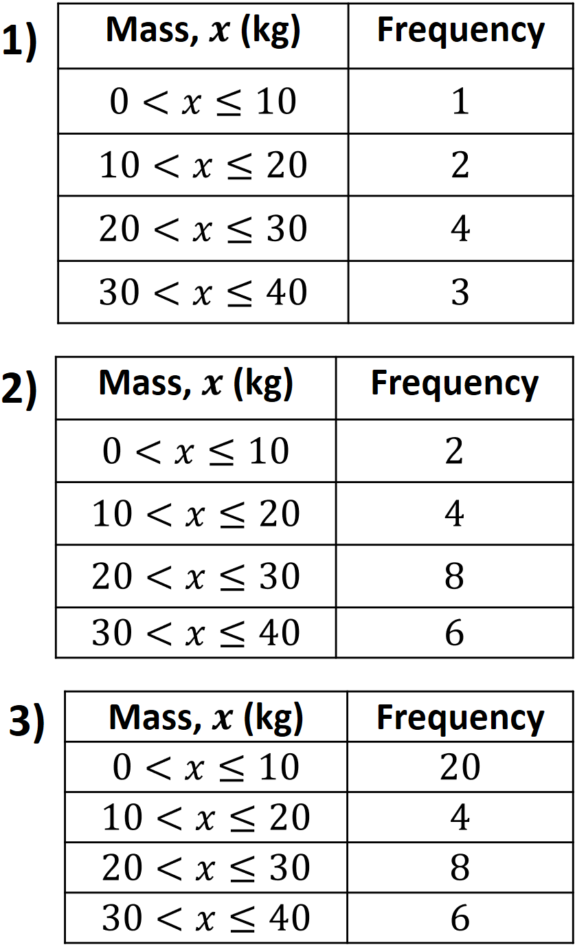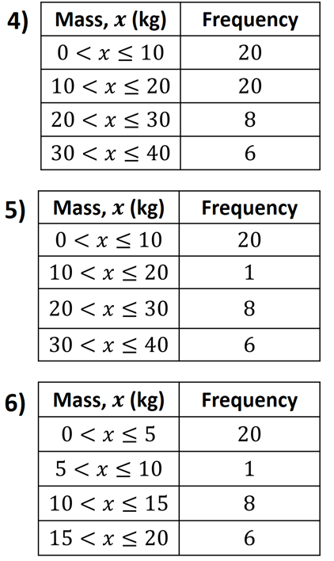
Part B: Why did the mean get bigger, smaller or stay the same compared to the previous question?

Q2
compared to
Q1
Q3
compared to Q2
Q4
compared to Q3
Q5
compared to Q4
Q6
compared to Q5

