Writing and Solving Equations

1) A taxi firm costs 320 pence hire charge plus 25 pence every mile.
If journey costs 645 pence can you write and solve an equation to work out how many miles were travelled?25m + 320 = 645
m = 13

2) A tool hire firm charges a £3 hire charge + £2 per day.
James returns a tool and has to pay £15. Can you write and solve an equation to calculate how many days he had the tool for? 3 = 15d = 6

3) A restaurant has a fixed price menu of £8 per person, and offers a £10 discount.
The total bill after the discount is £46. Can you write and solve an equation to work out the number people who ate at dinner?8p - 10 = 46
p = 7

4) The cost of a pack of whiteboard markers is £4 per pack. The company also charges £2.50 for delivery. If an invoice is paid for £38.50, can you write and solve an equation for working out how many packs of markers were bought?4+ 2.5 = 38.5
P = 9

5) A cleaning firm charges £14 per hour, but offers a £25 discount for bills over £300.
At the end of the week a company gets a bill for £395, after the discount. Can you write and solve an equation to calculate how many hours the firm claim for that week?
14h - 25 = 395
h = 30

6) A photographer charges £40 per session plus £3 for every print bought.
If a bill comes to £64, can you write and solve an equation to work out how many prints were purchased?

7) There are 376 stones in three piles.
The second pile has 24 more stones than the first pile.
The third pile has twice as many stones as the second.
Write and solve an equation to work out how many stones are there in each pile?

8) Jack, Jo and Jim are sailors.
They were shipwrecked on an island with a monkey and a crate of 185 bananas.
Jack ate 5 more bananas than Jim.
Jo ate 3 more bananas than Jim, and the monkey ate 6 bananas.
Write and solve an equation to work out how many bananas did each sailor eat?

9) Jill and Ben each have the same number of pens.
Jill has three full boxes of pens and 2 loose pens.
Ben has 2 full boxes of pens and 14 loose pens.
Write and solve an equation to work out how many pens are there in a full box?

10) The area is 10cm². Find the length and width of the rectangle.
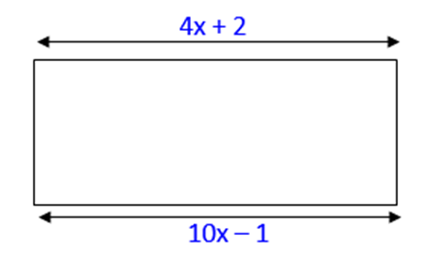

11) The sum of the ages of a mother and her daughter is 46.
In three years time the mother will be three times as old as her daughter is then.
Write and solve an equation to work out how old the daughter is now?

12) Write and solve an equation to work out what three consecutive numbers add to give 54.

