You are presented with six graphs graphing Olympic records over the years.
You task is to work out what those athletic events are.
Men's 4 x 100 metres relay, Men's High Jump, Men's Decathlon, Men's Decathlon, Men's Long Jump, Men's Javelin
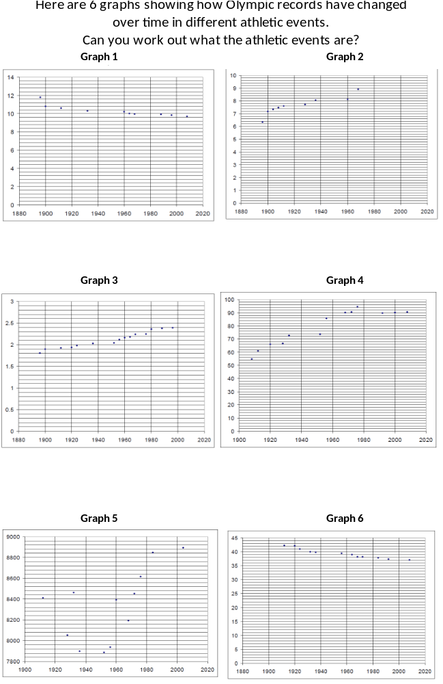
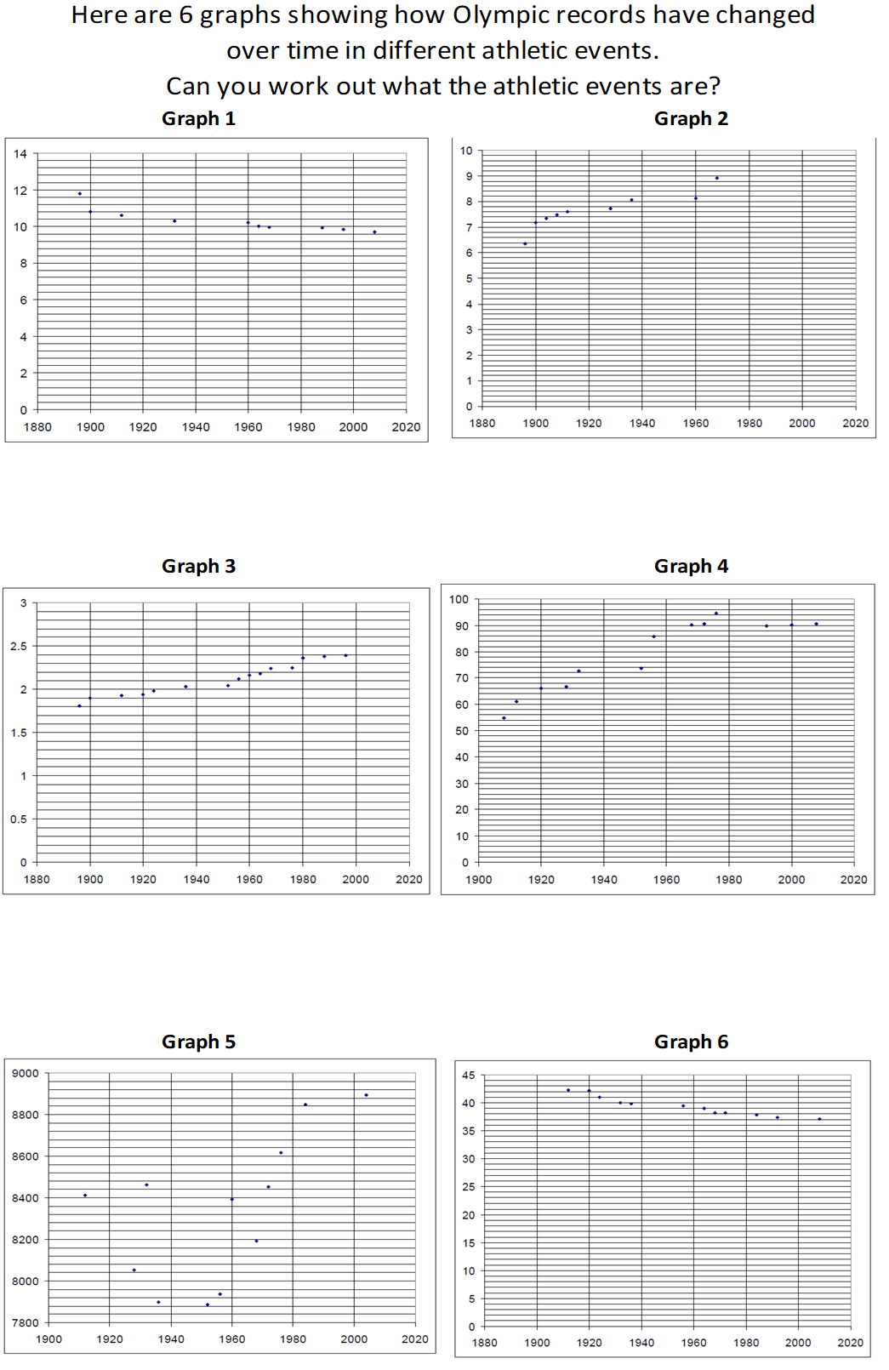
You are presented with six graphs graphing Olympic records over the years.
You task is to work out what those athletic events are.
Men's 4 x 100 metres relay, Men's High Jump, Men's Decathlon, Men's Decathlon, Men's Long Jump, Men's Javelin

