Percentage Profit and Loss - Storage Hunters
In Storage Hunters Sean Kelly auctions the contents of "bins" of those who have failed to pay their rental fees. Each "bin" is a gamble for whoever bids but there is big money to be made if the right items are hidden in there!
Can you help each "bin" winner calculate their percentage profit or loss?

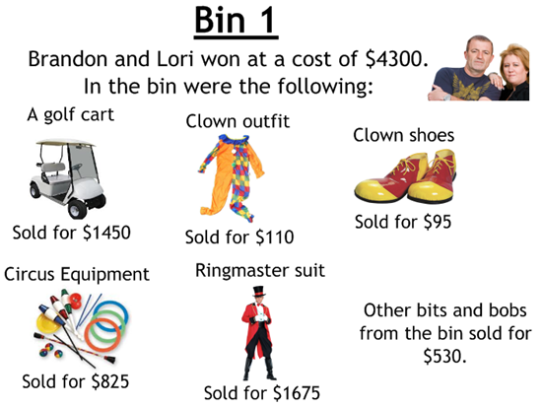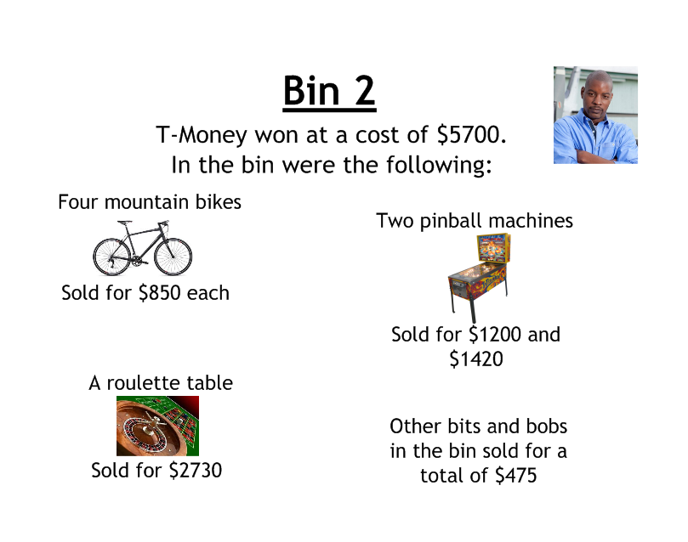
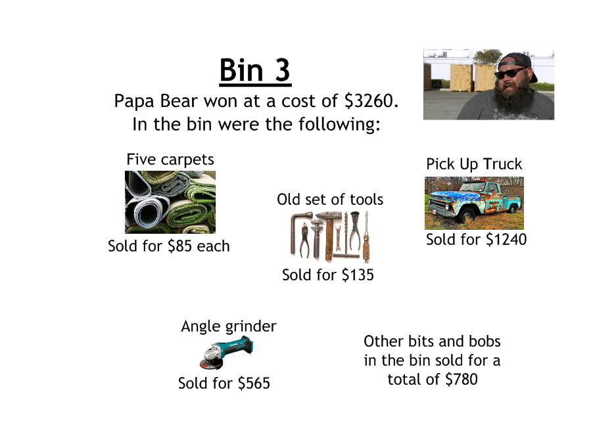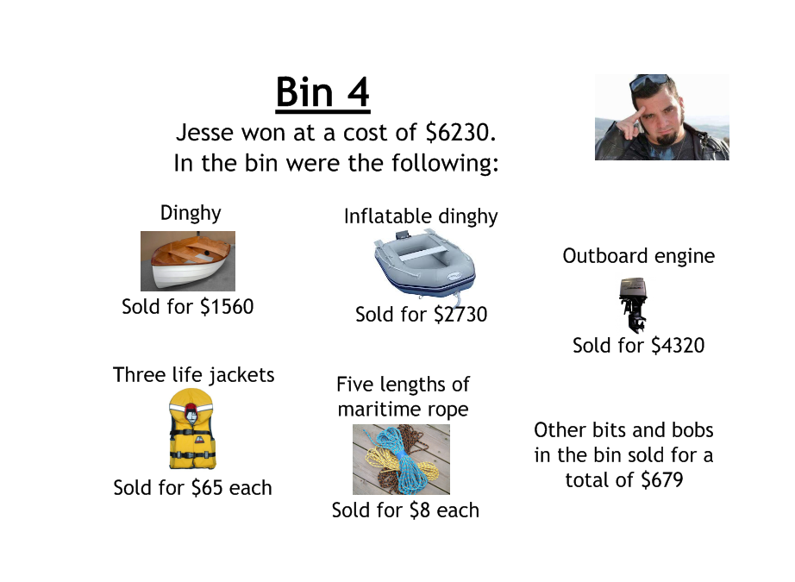
Percentage Profit and Loss - Storage Hunters
In Storage Hunters Sean Kelly auctions the contents of "bins" of those who have failed to pay their rental fees. Each "bin" is a gamble for whoever bids but there is big money to be made if the right items are hidden in there!
Can you help each "bin" winner calculate their percentage profit or loss?

