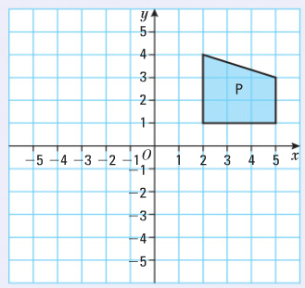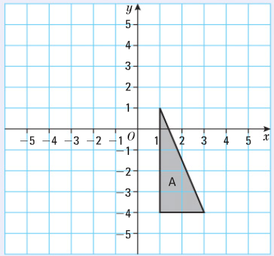
Scale factor -1, centre (1,2)
Scale factor -1/2, centre (-1,-2)
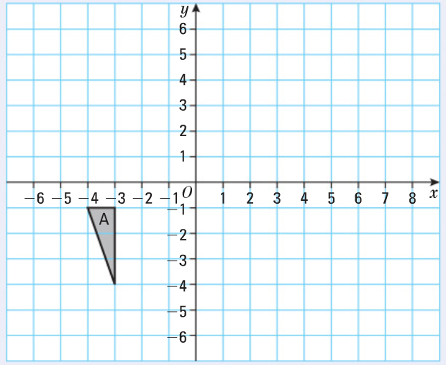
Scale factor -2, centre (-1,-1)
- Scale factor -2, centre (0,-1) Label X
- Scale factor -1, centre (0,-1) Label Y
- Scale factor ½ centre (0,-1) Label Z

