Always Positive, Always Negative or Either
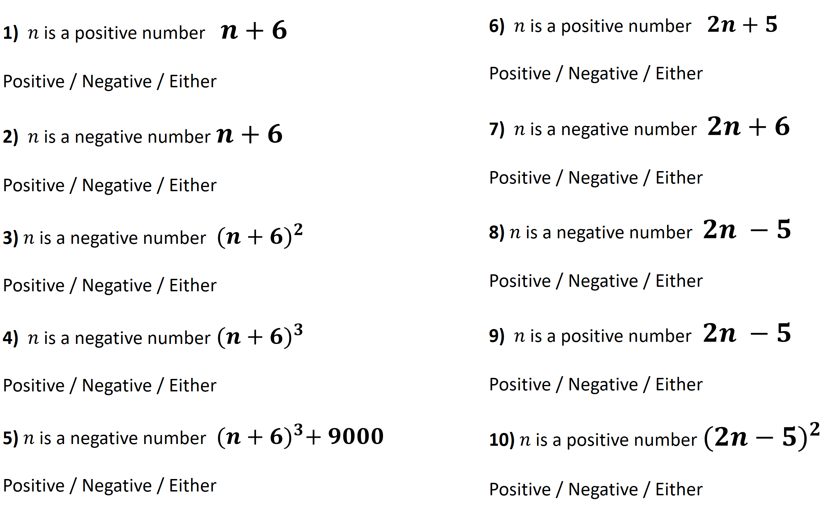

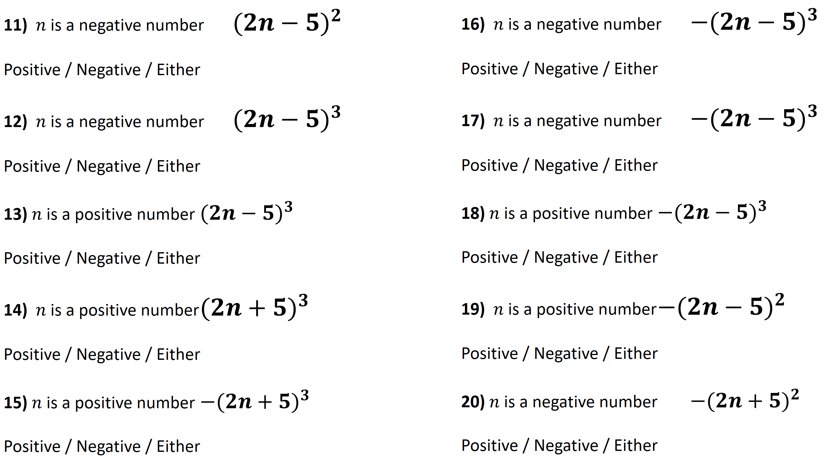
Always Positive, Always Negative or Either

