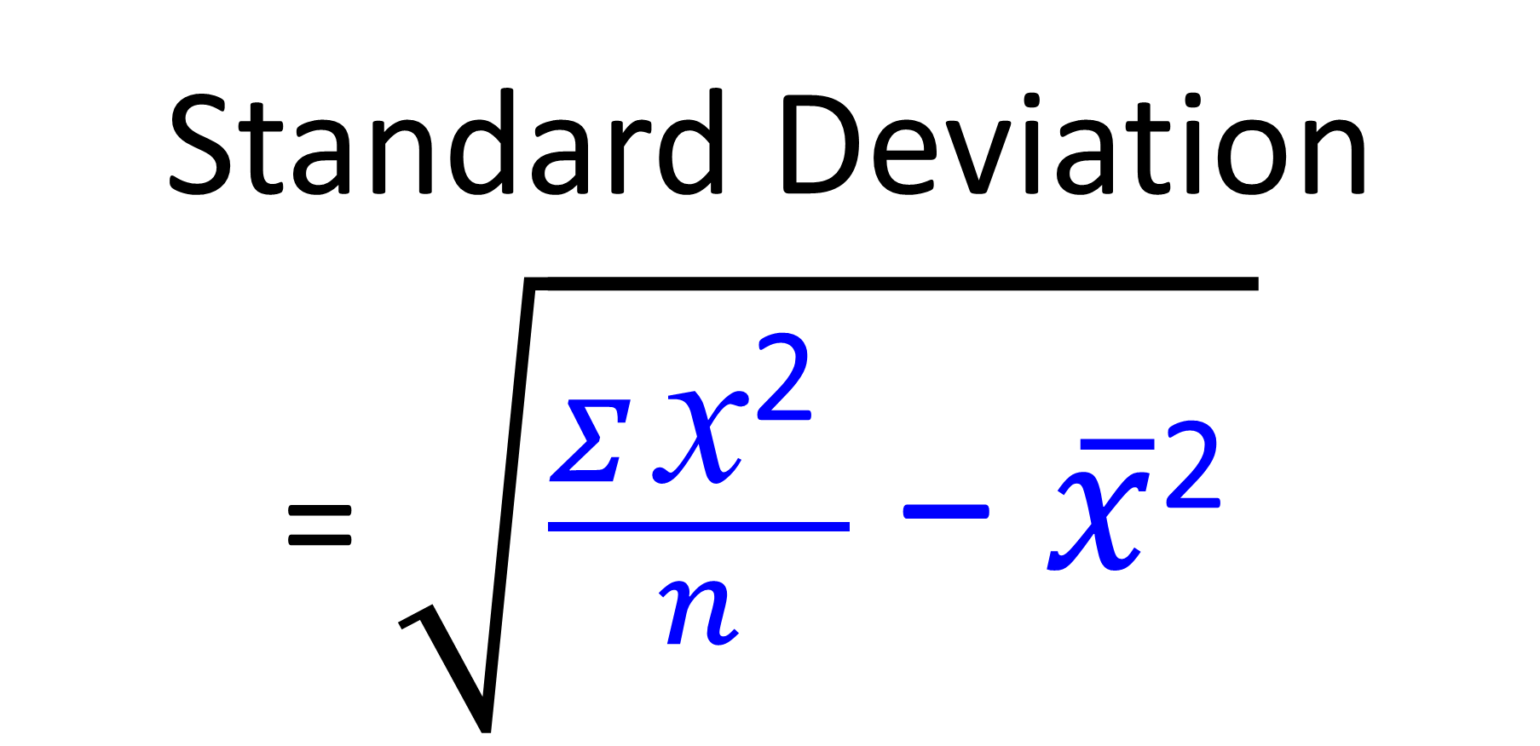
A) Find the Standard Deviation
1, 3, 6, 6, 7, 12, 14
B) Find the Standard Deviation
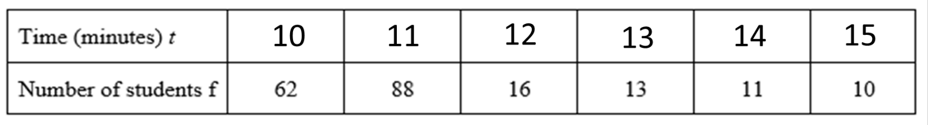 C) Find the Standard Deviation
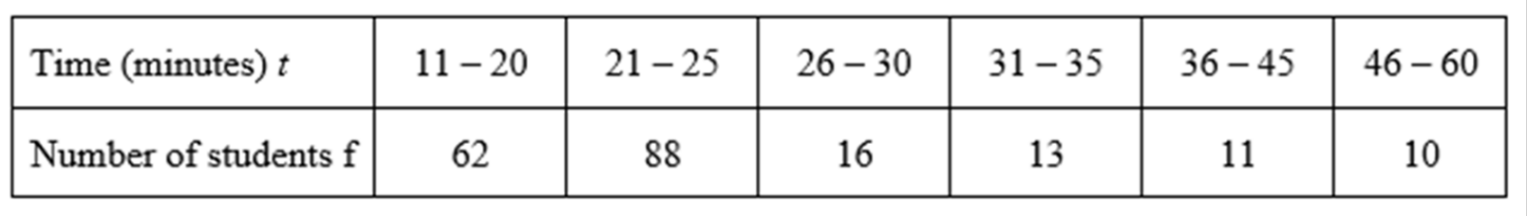
D) Find the Standard Deviation
