Bar Charts – All Types
1) The table shows pupils favourite pet animal in year 7.
Complete the tally chart and draw a bar chart.
Favourite Animal
Tally
Frequency
Dog
Cat
Rabbit
4
Hamster
13
Other
6

2) The information in the table shows the sports boys and girls in year 7 enjoy the most. Draw a dual bar chart.

 | Football | Netball | Basketball | Tennis | Other
Boys | 8 | 2 | 5 | 3 | 2
Girls | 3 | 10 | 2 | 4 | 3

3) Pupils were asked what their favourite type of social media was. The table shows the data found.
Draw a compound bar chart.

 | Facebook | Twitter | Instagram | Snapchat | Other
Year 7 | 5 | 1 | 3 | 1 | 3
Year 8 | 3 | 4 | 6 | 10 | 1
Year 9 | 8 | 5 | 7 | 6 | 2

4) A work café sells tea, coffee and hot chocolate. The following compound bar chart shows the percentage of drinks sold over a particular week.
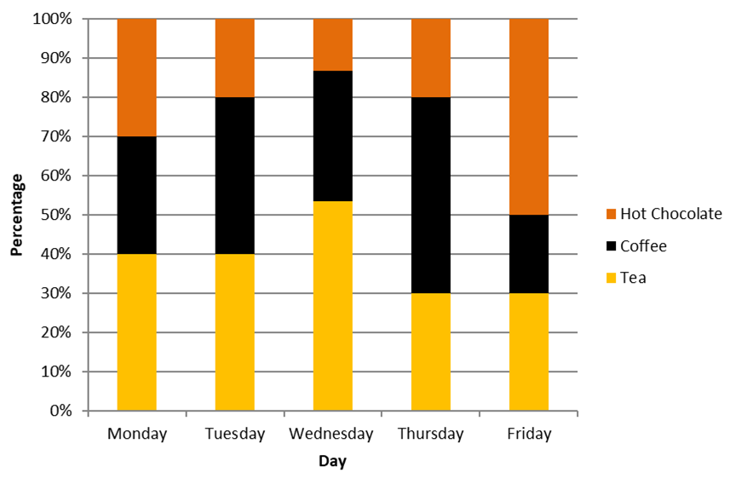
a) On which day did they sell the highest percentage of tea?
b) On which day did they sell the lowest percentage of coffee?
c) Did they sell more hot chocolates on Wednesday or Thursday? Explain your answer.
d) They sold twice as many drinks on Friday as they did on Thursday. Did they sell more coffee on Friday or tea on Thursday? Explain your answer

5) Write something that is wrong with each bar chart.
