Velocity-Time Graphs

Find the acceleration and distance travelled for these velocity time graphs
3)
5)
2)
Time sec
Time sec
Time sec
Time sec
Velocity ms⁻¹
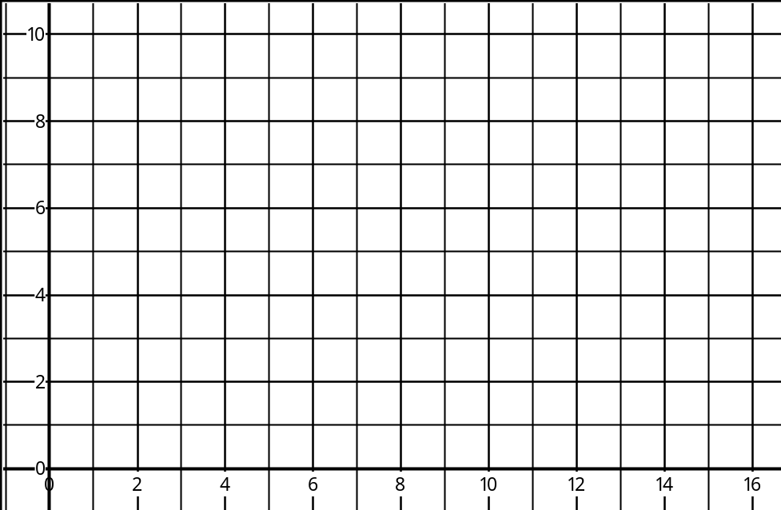  4)  1) | Time sec  Velocity ms⁻¹
6)  Time sec  Velocity ms⁻¹ | Time sec  Velocity ms⁻¹
Velocity ms⁻¹ | Velocity ms⁻¹
