Prefix Information Sheet
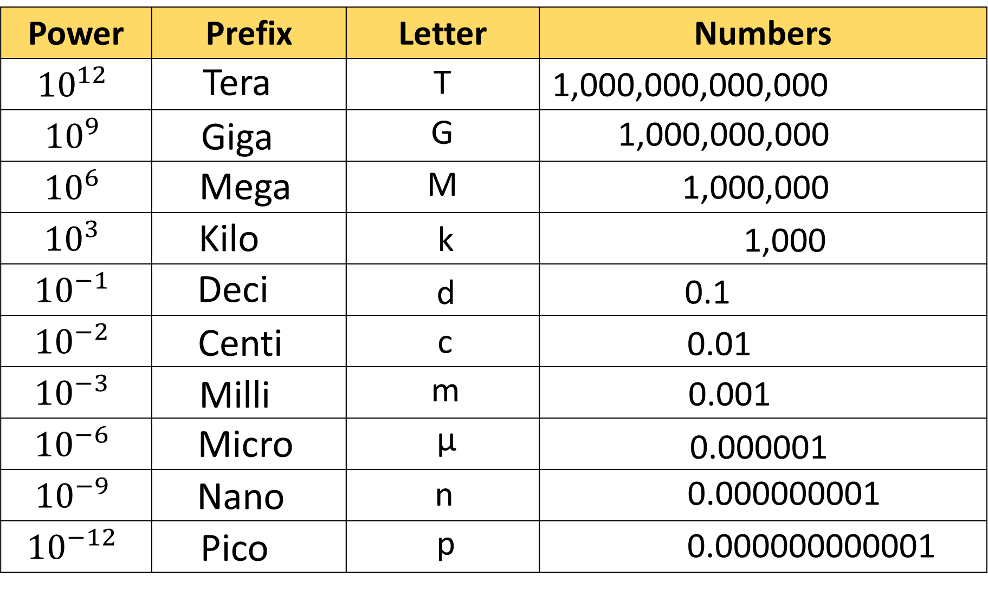
Converting between prefixes:

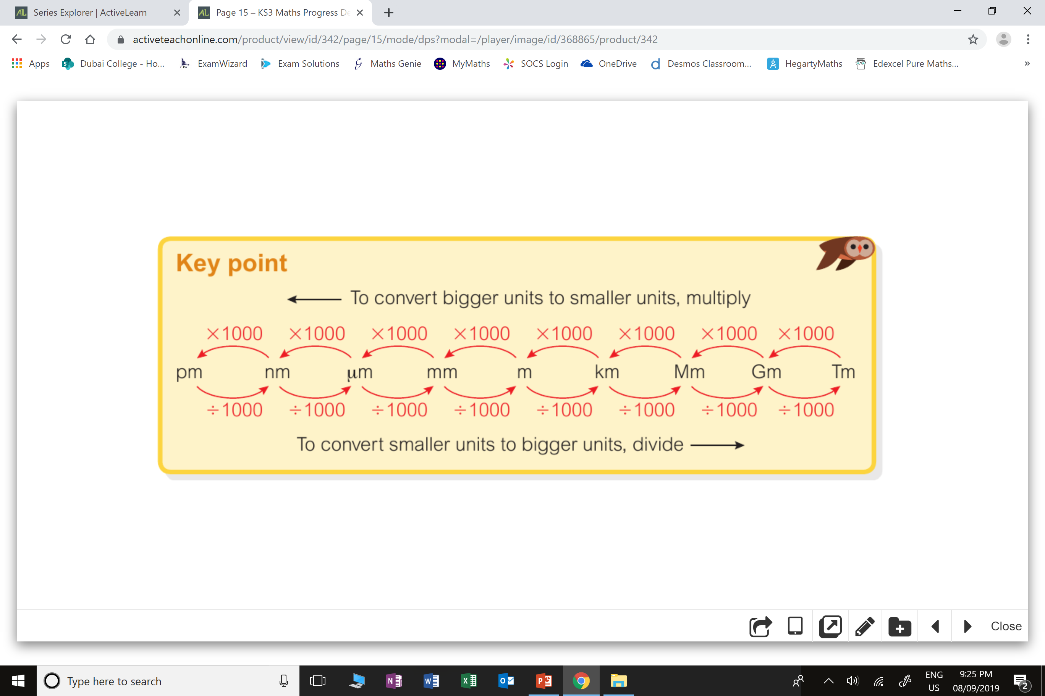
Prefix Information Sheet
Converting between prefixes:

