Interior and Exterior Angles GCSE Exam Questions

Question 1
The diagram shows a regular hexagon.

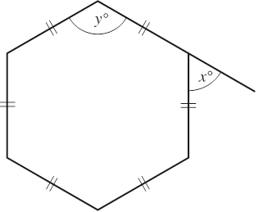

a) Work out the value of x.

b) Work out the value of y.

Question 2
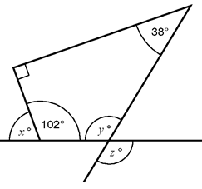

a) Work out the value of x.

b) Work out the value of y.

c) Work out the value of z.

Question 3

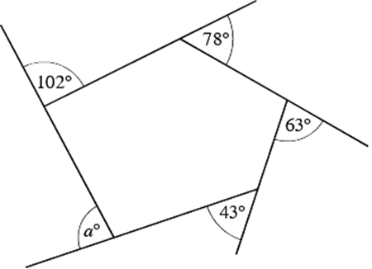

Work out the value of a.

Question 4

The diagram below
shows a quadrilateral

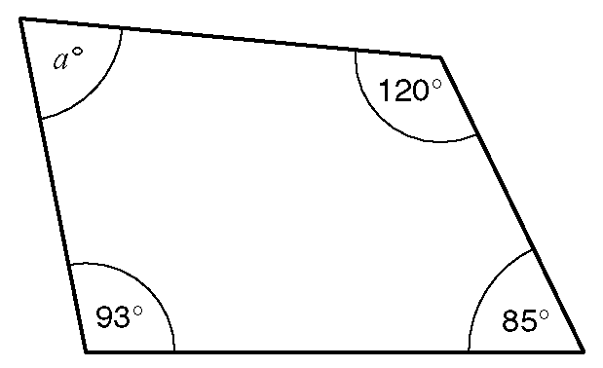

a) Work out the size of the
angle marked aº.

b) The diagram shows a regular hexagon.

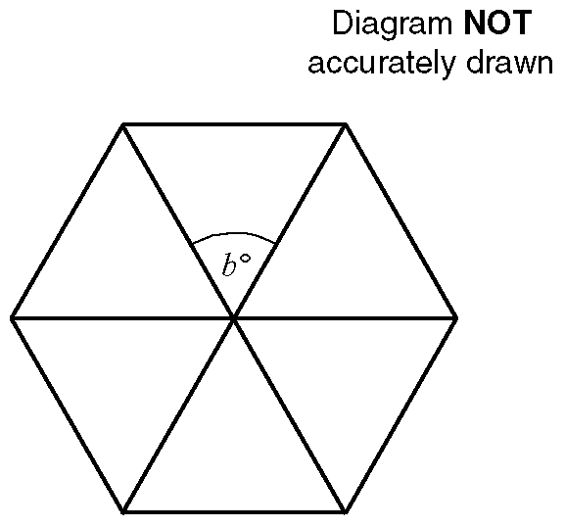

Work out the size of the angle marked bº.

(c) The diagram shows a regular octagon.

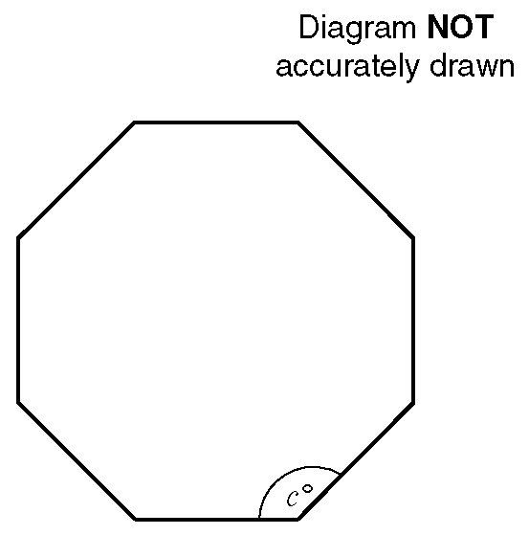

Work out the size of the angle marked cº.

Question 4
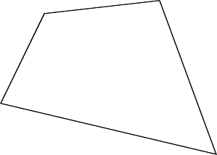

The sum of the angles of a triangle is 180°. Use this fact to explain why the sum of the angles of any quadrilateral is 360°.

Question 5

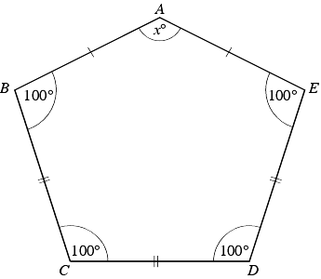

The diagram shows a pentagon.
AB = AE
BC = CD = DE

Find the size of the angle marked x°.

Question 6

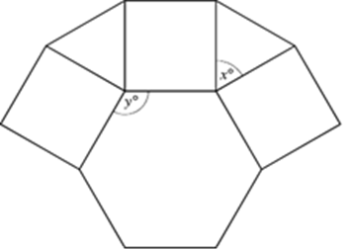

This is part of the design of a pattern found at the theatre of Diana at Alexandria.

It is made up of a regular hexagon, squares and equilateral triangles.

(a) Write down the size of the angle marked x°.

(b) Write down the size of the angle marked y°.

