Calculate my BMI
The Body Mass Index was established by a Belgian Mathematician Adolphe Quetelet (1796–1874). It is just 1 indicator of health. | It is calculated using this formula  BMI = (weight in kg)  (height in metres)² |  | If the answer is  <18.5…....... underweight  18.5-24.9………. ok  25-29.9…… overweight  > 30…………. obese
  I am 1.65m tall  I weigh 65kg  Am I Under/ok/over/obese |  |   I am 155cm tall  I weigh 40kg  Am I …Under/ok/over/obese
I am 5 ft 10 inches tall  I weigh 80kg  Am I …Under/ok/over/obese |  | I am 6 ft tall  I weigh 260lb (on a good day)    Am I …Under/ok/over/obese
  I am 1m 77cm tall  I weigh 180 lb  Am I…Under/ok/over/obese |  |   I am 6ft 6 in tall. I weigh 85kg  Am I…Under/ok/over/obese
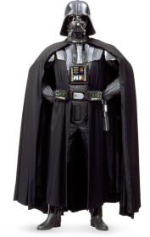  I am 1 m 90 cm tall.  I weigh 93kg.  Am I…Under/ok/over/obese |  |   I am 5ft 8 in tall  I weigh 10 ½ stone.  Am I…Under/ok/over/obese
  I am 5ft 9 ins tall and I weigh 8 ½ stone.  Am I…Under/ok/over/obese |  | 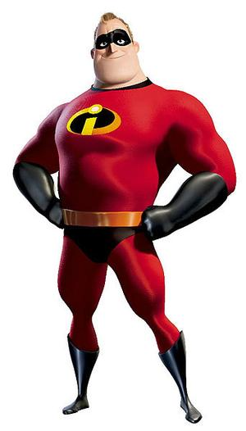  I am 6ft 7 inches tall  I weigh 240lb  Am I…Under/ok/over/obese
Calculate my BMI
The Body Mass Index was established by a Belgian Mathematician Adolphe Quetelet (1796–1874). It is just 1 indicator of health. | It is calculated using this formula  BMI= (weight in kg)  (height in metres)² |  | If the answer is  <18.5…....... underweight  18.5-24.9………. ok  25-29.9…… overweight  > 30…………. obese
I am 1.65m tall  I weigh 65kg  Am I Under/ok/over/obese |  | I am 155cm tall  I weigh 40kg  Am I …Under/ok/over/obese
I am 5 ft 10 inches tall  I weigh 80kg  Am I …Under/ok/over/obese |  | I am 6 ft tall  I weigh 260lb (on a good day)  Am I …Under/ok/over/obese
I am 1m 77cm tall  I weigh 180 lb  Am I…Under/ok/over/obese |  | I am 6ft 6 in tall. I weigh 85kg  Am I…Under/ok/over/obese
I am 1 m 90 cm tall.  I weigh 93kg.  Am I…Under/ok/over/obese |  | I am 5ft 8 in tall  I weigh 10 ½ stone.  Am I…Under/ok/over/obese
I am 5ft 9 ins tall and I weigh 8 ½ stone.  Am I…Under/ok/over/obese |  | I am 6ft 7 inches tall  I weigh 240lb  Am I…Under/ok/over/obes

