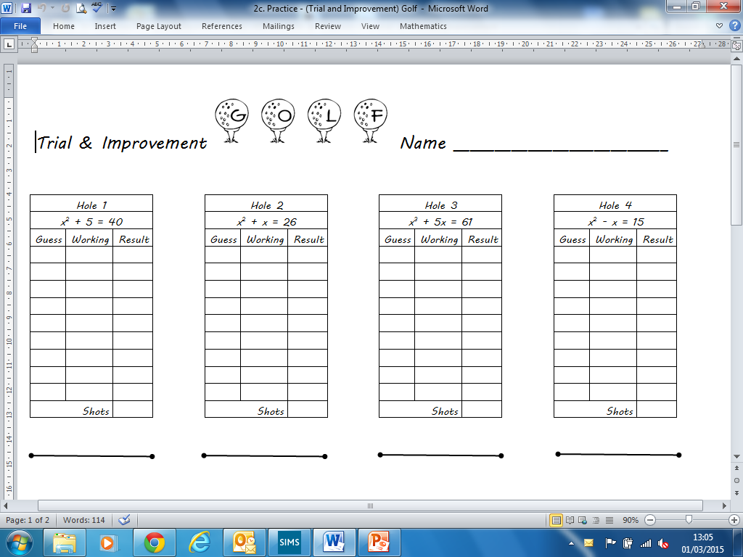
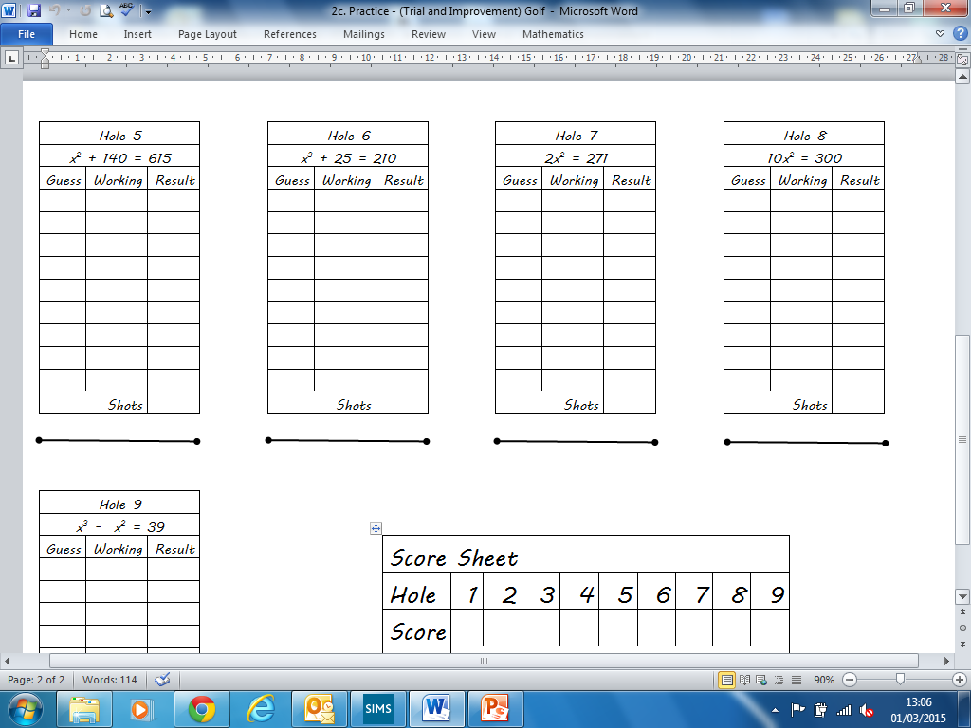
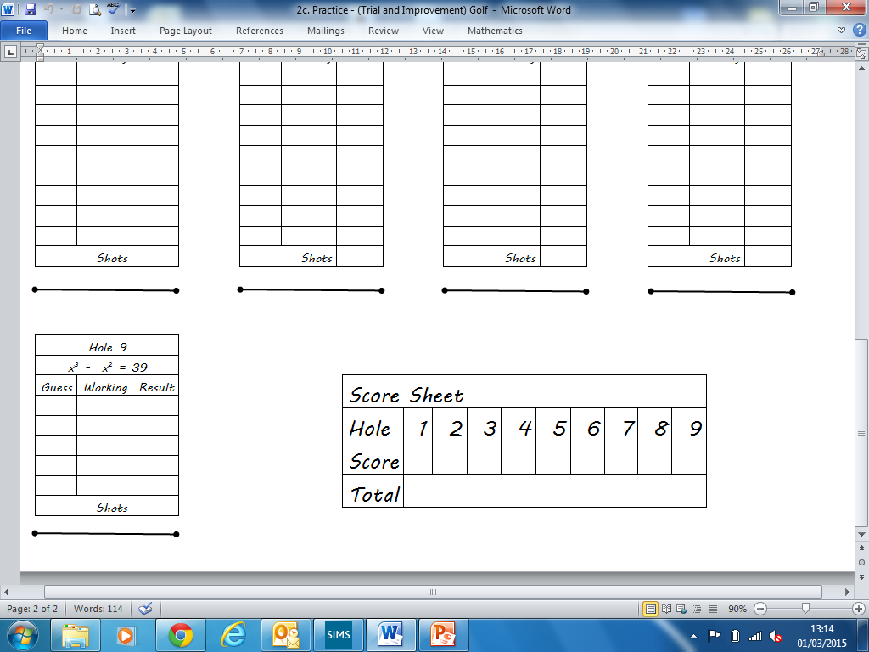
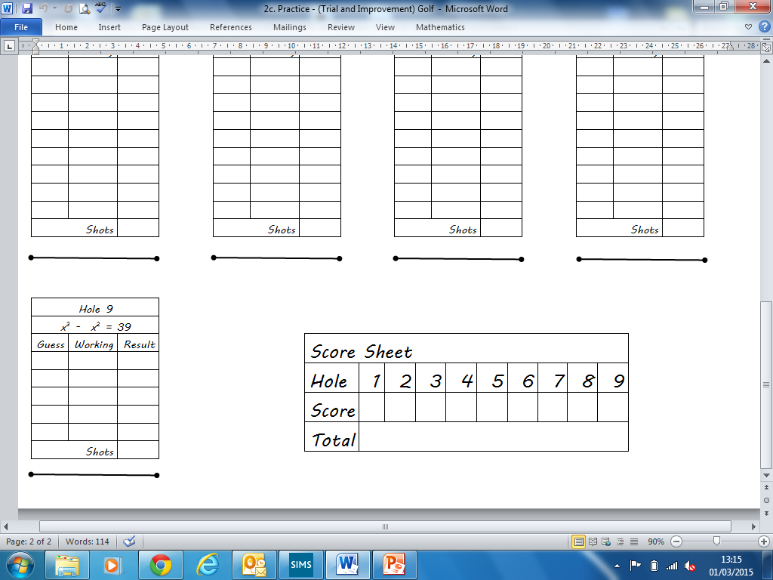
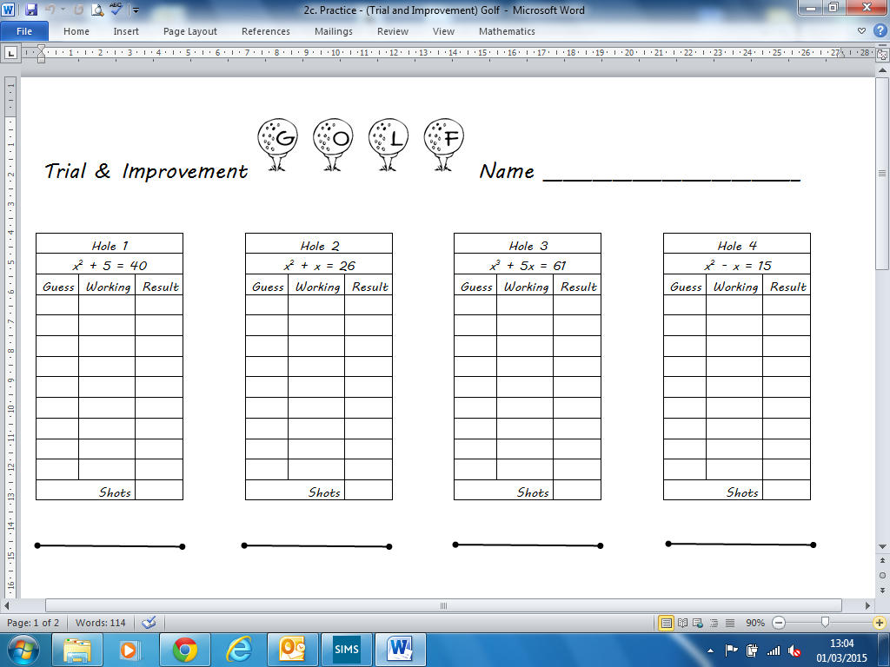
Give answers to 1dp
x is between 5 and 6
x is between 4 and 5
x is between 3 and 4
x is between 4 and 5
x is between 21 and 22
x is between 5 and 6
x is between 11 and 12
x is between 5 and 6
x is between 3 and 4
x =
x =
x =
x =
x =
x =
x =
x =
x =

Give answers to 1dp
x is between 5 and 6
x is between 4 and 5
x is between 3 and 4
x is between 4 and 5
x is between 21 and 22
x is between 5 and 6
x is between 11 and 12
x is between 5 and 6
x is between 3 and 4
x =
x =
x =
x =
x =
x =
x =
x =
x =

