Standard Form - Worded
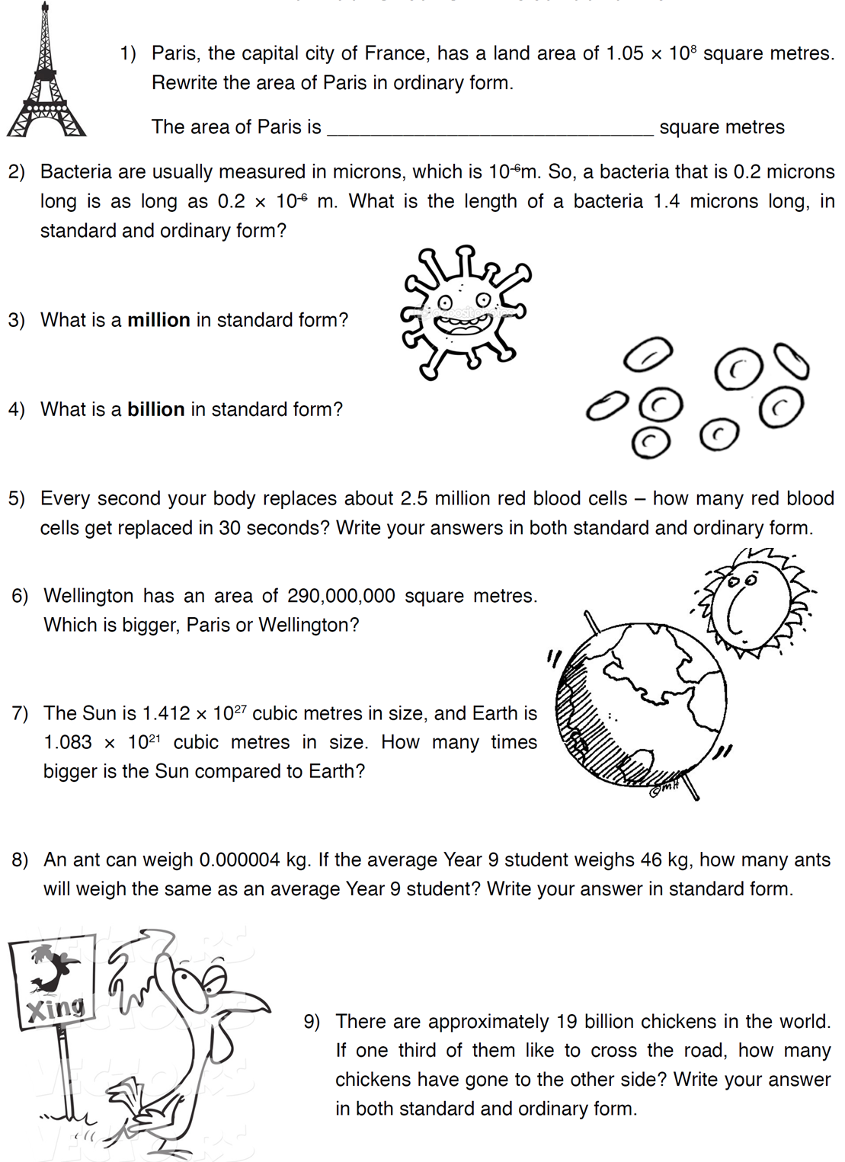
Standard Form - Worded

