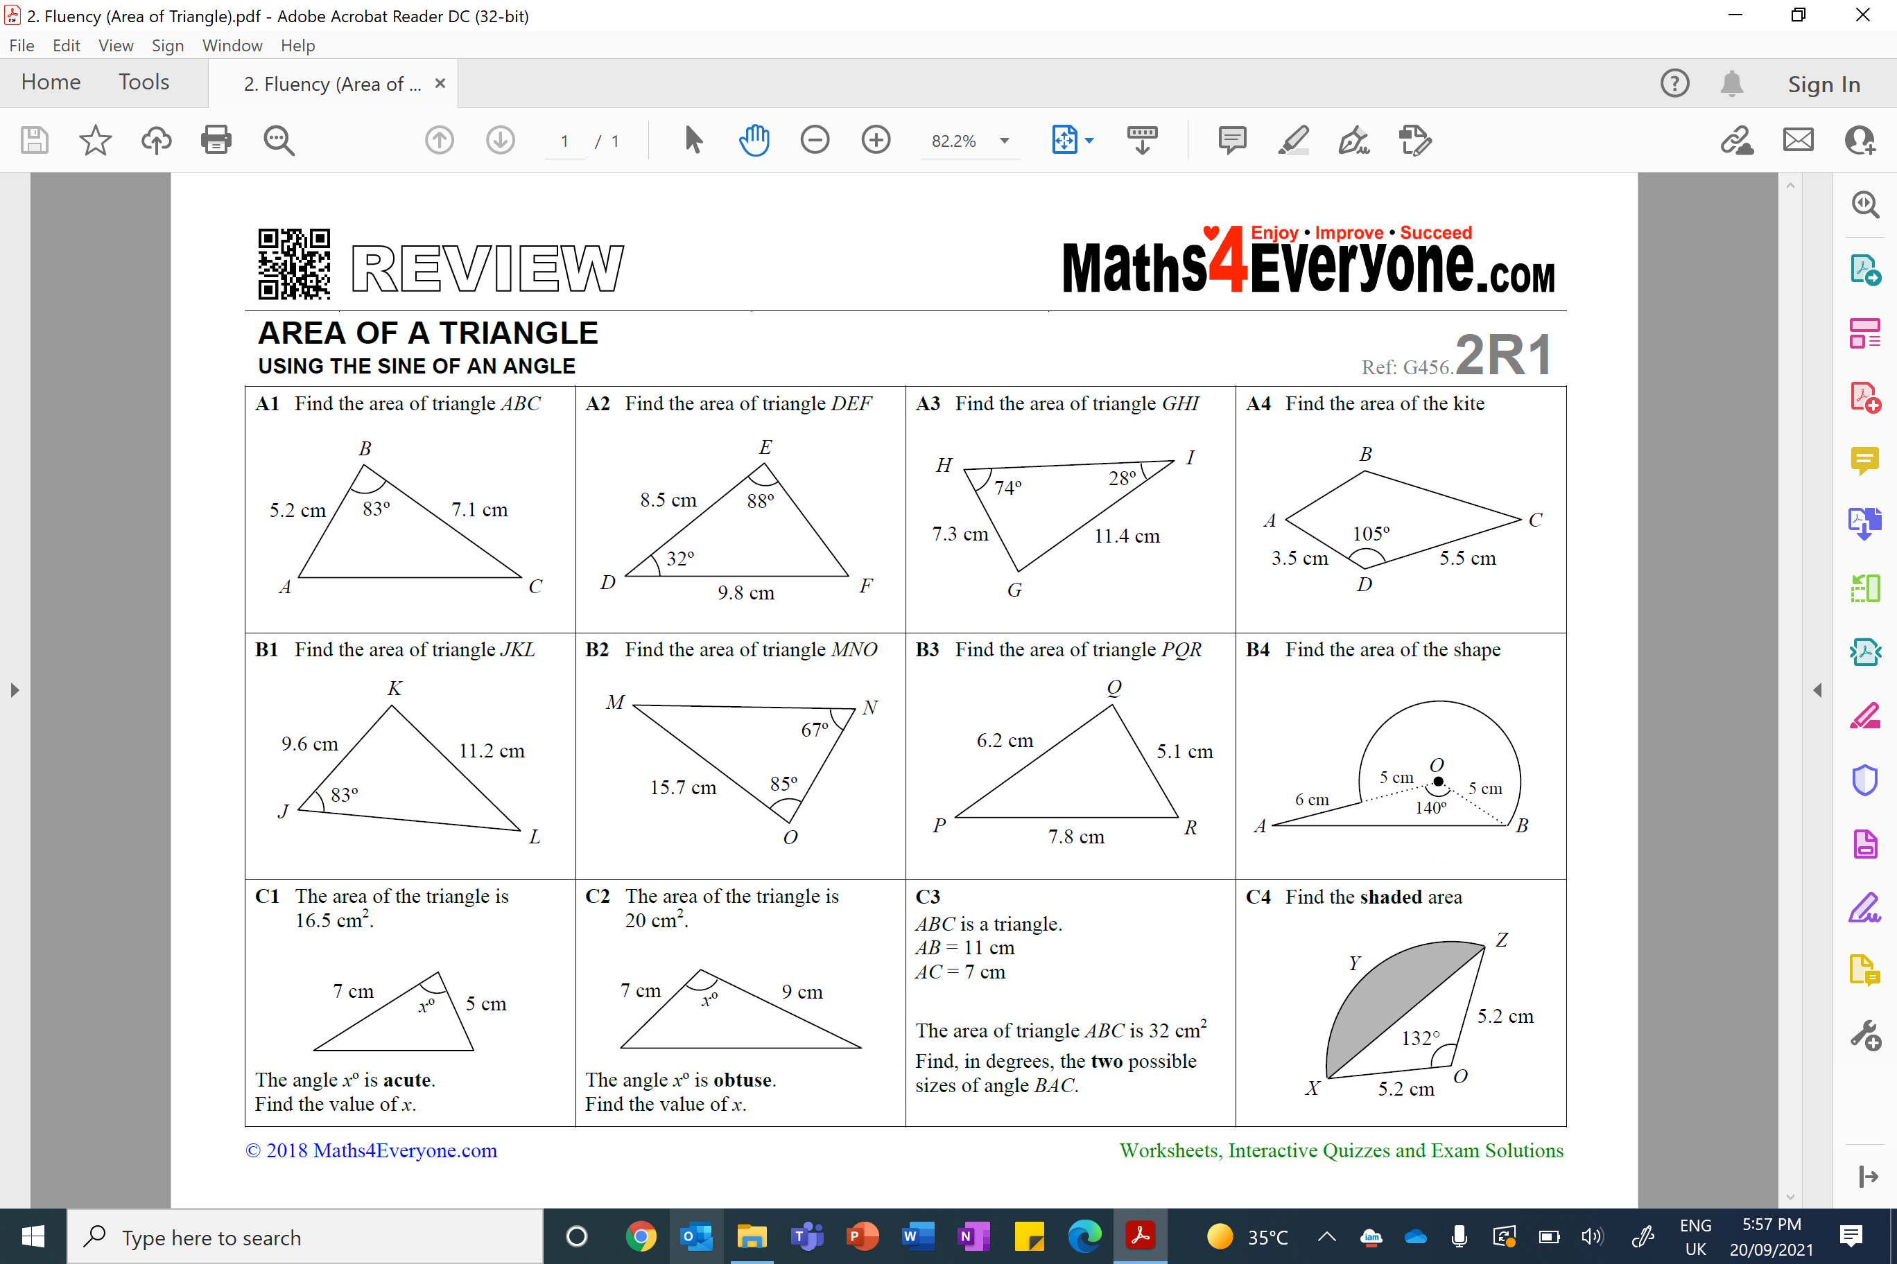
Area of a Triangle – Using Trigonometry
Area of a Triangle – Using Trigonometr

