Death Star – Parallelograms and Trapeziums
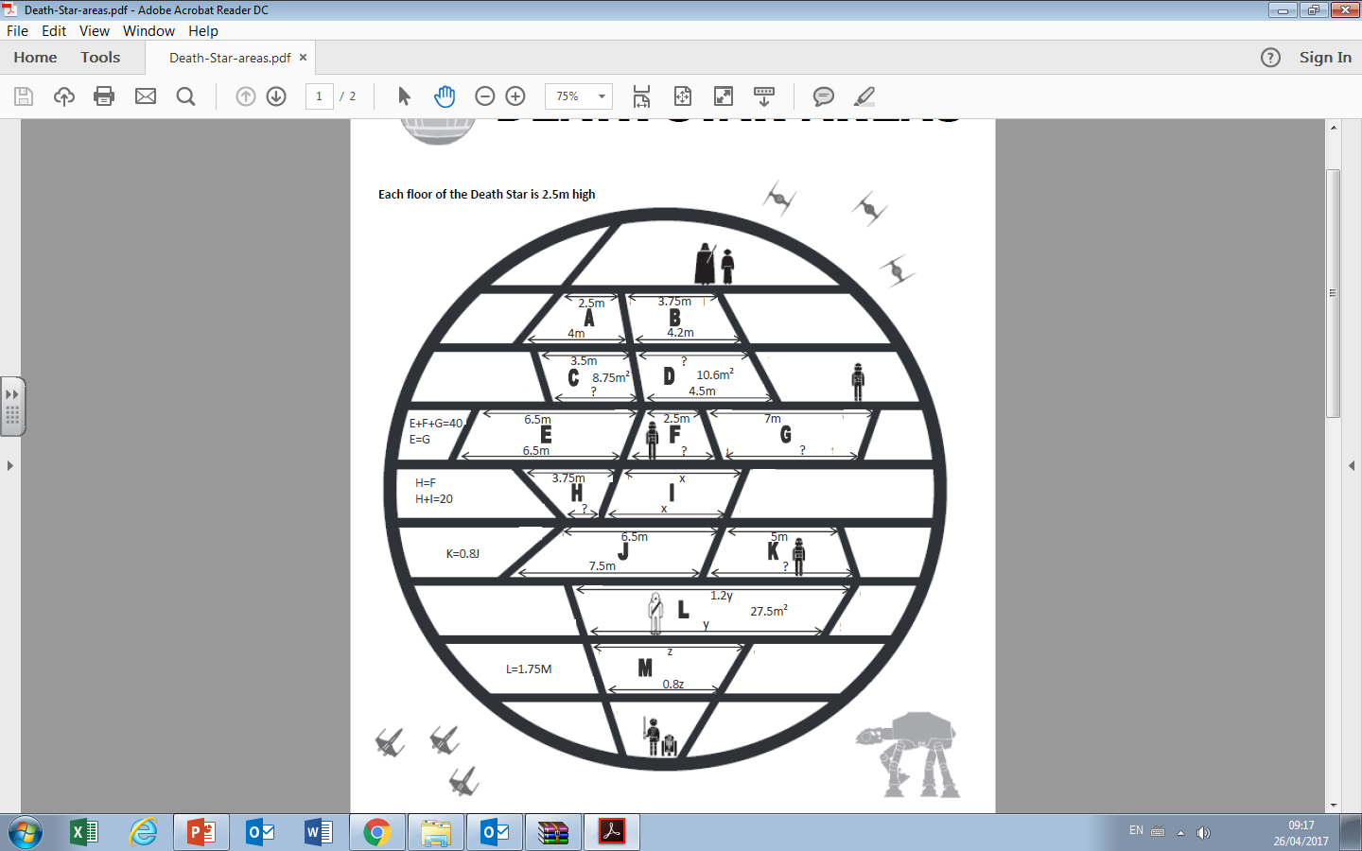
Death Star – Parallelograms and Trapeziums

