Direct and Inverse Proportions – Real Life Situations
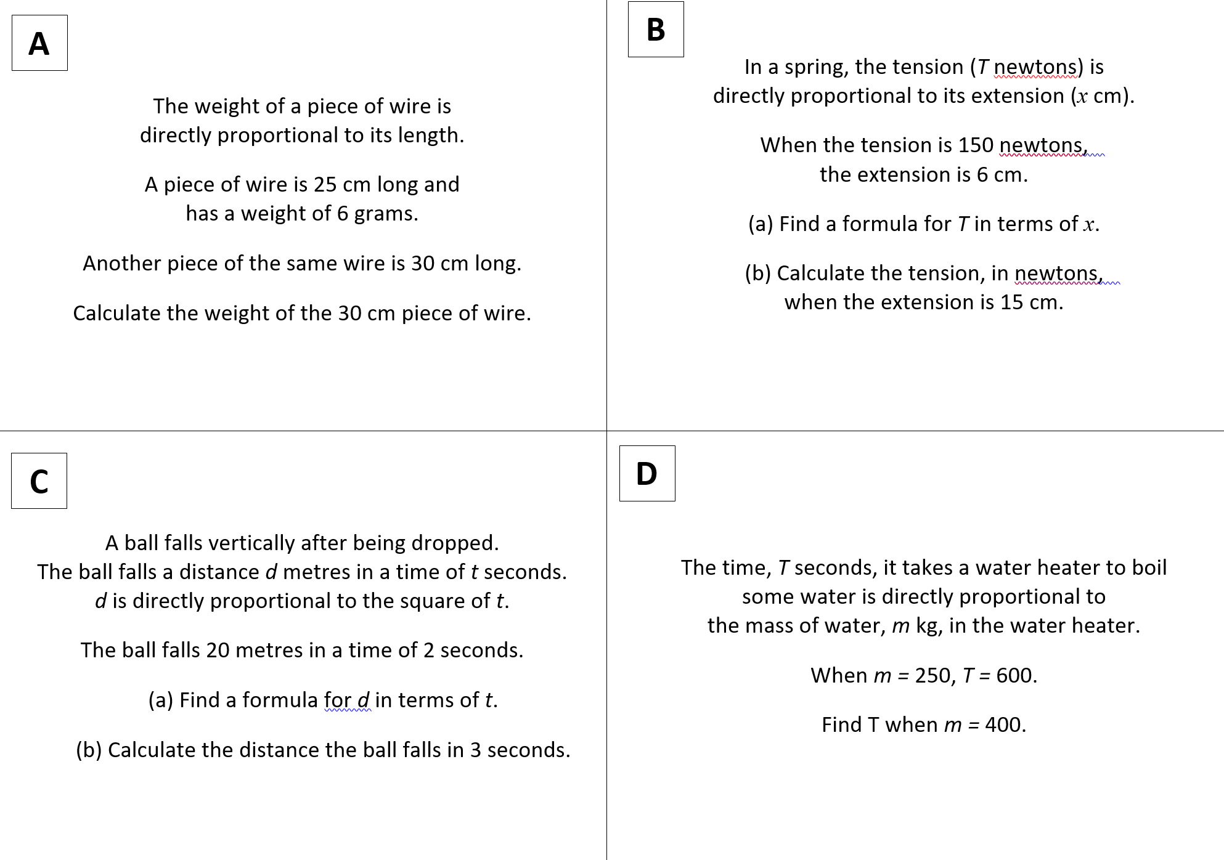
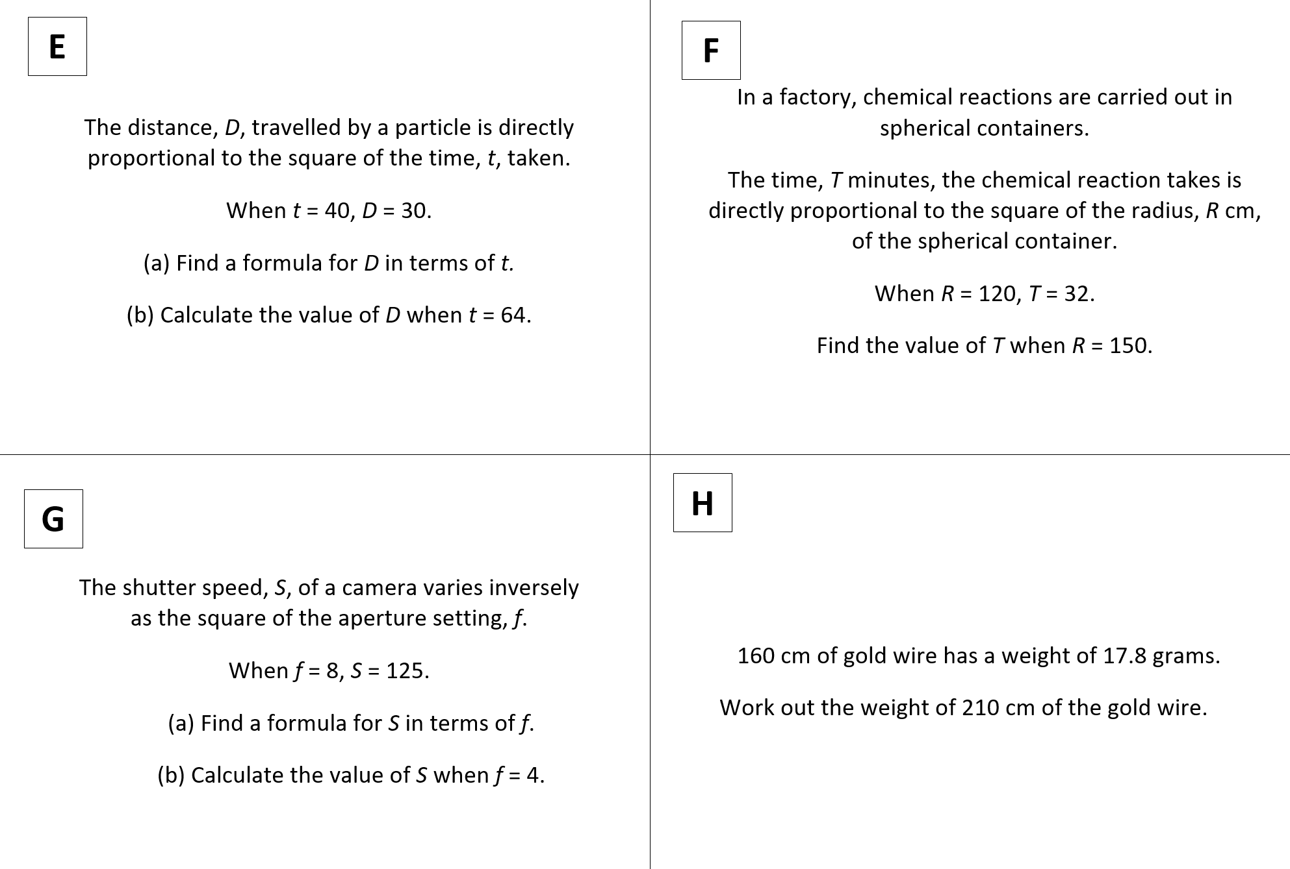
Direct and Inverse Proportions – Real Life Situations

