Parallel Lines and Angles (Comparing Methods)
Write your answers in the grid and tick all the angle facts you used in each case.
Compare your grid to your partner's grid - did you use the same methods?
If not, explain your methods and see if they can follow your thinking.
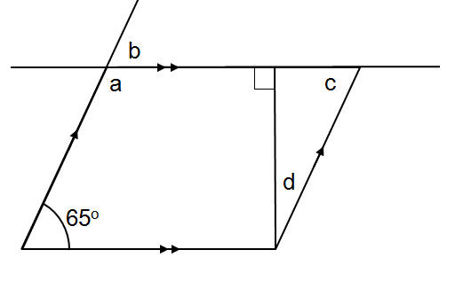 | 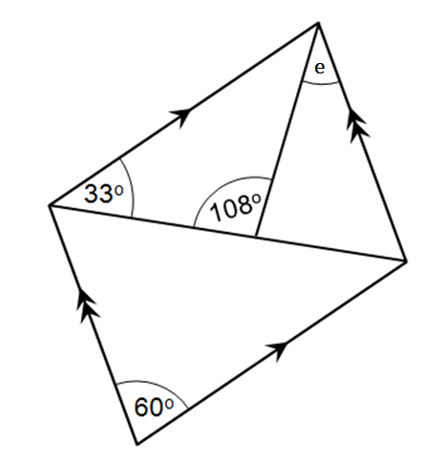
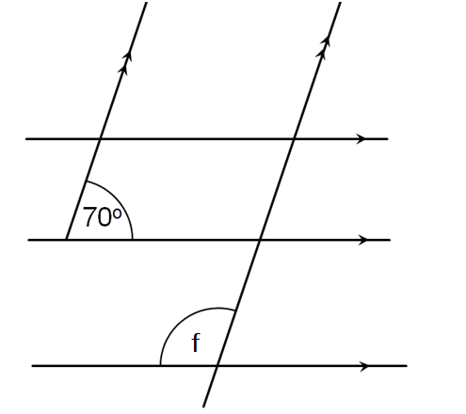 | 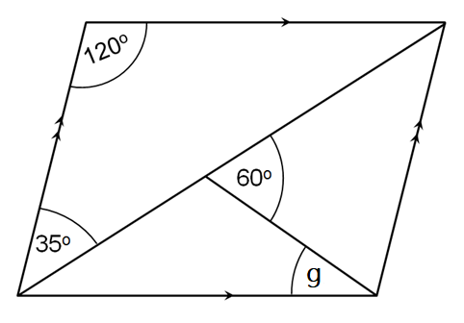
 |  | Angle Facts Used
Angle | Size | Alternate angles are equal | Corresponding angles are equal | Co-interior angles are supplementary | Vertically opposite angles are equal | Angles in a triangle sum to 180º | Adjacent angles on a straight line sum to 180º | Angles at a point sum to 360º | Opposite angles in a parallelogram are equal
a
b
c
d
e
f
g

Parallel Lines and Angles (Comparing Methods)
Write your answers in the grid and tick all the angle facts you used in each case.
Compare your grid to your partner's grid - did you use the same methods?
If not, explain your methods and see if they can follow your thinking.
 |  | Angle Facts Used
Angle | Size | Alternate angles are equal | Corresponding angles are equal | Co-interior angles are supplementary | Vertically opposite angles are equal | Angles in a triangle sum to 180º | Adjacent angles on a straight line sum to 180º | Angles at a point sum to 360º | Opposite angles in a parallelogram are equal
a
b
c
d
e
f
g

