Simplifying Expression – Like or Unlike Terms
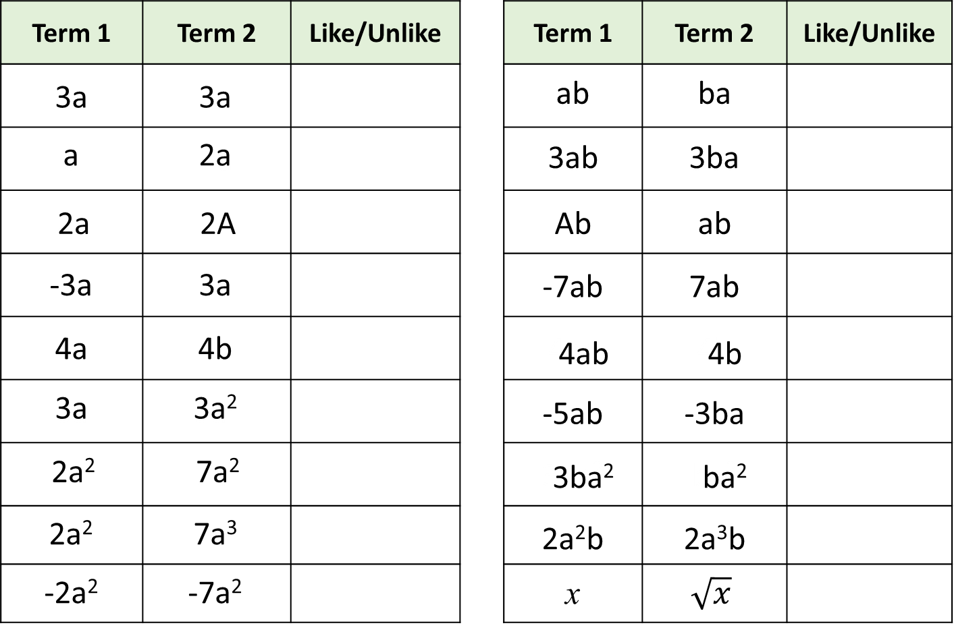
Simplifying Expression – Like or Unlike Terms

