25.13 cm²
38.48 cm²
Answer
Answer
Answer
Answer
Question
Question
Question
Question

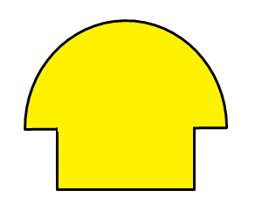

6cm

2cm
4cm
8cm

153.94 cm²
72.55 cm²

20cm
14cm

157.08 cm²
34.07 cm²
Answer
Question
Question
Question
Answer

Question


9cm

8cm
3cm
6cm

12cm
2cm

Answer
Answer

15.14 cm²
37.13 cm²

6cm
8cm

3cm

127.23 cm²
56.55 cm²
Answer
Answer
Question
Question

Question
Question

6cm
18cm

Answer
Answer

28.27 cm²
64.27 cm²

10cm
4cm

5cm

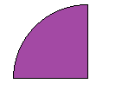
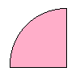

3cm
4cm
6cm
5cm
63.62 cm²
50.27 cm²
68.55 cm²
9cm
7cm
19.63 cm²
Answer
Answer
Answer
Answer
Question
Question
Question
Question

