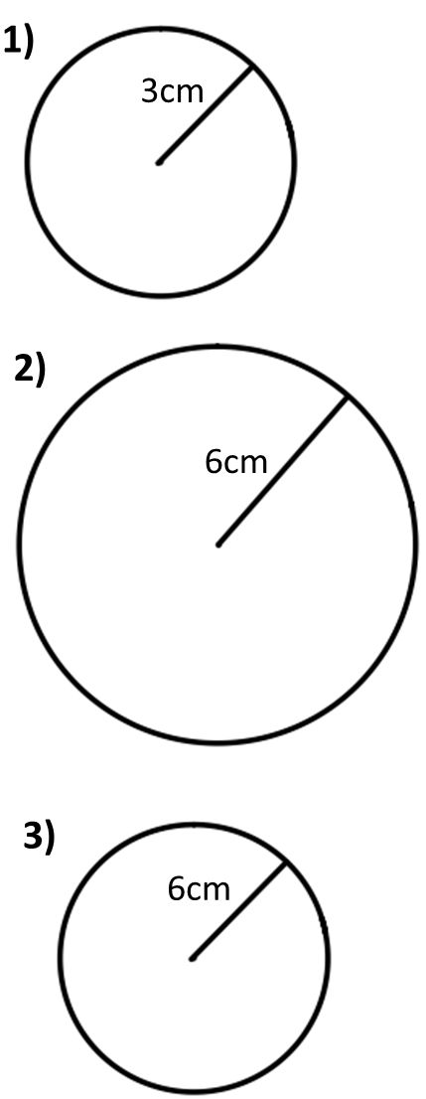
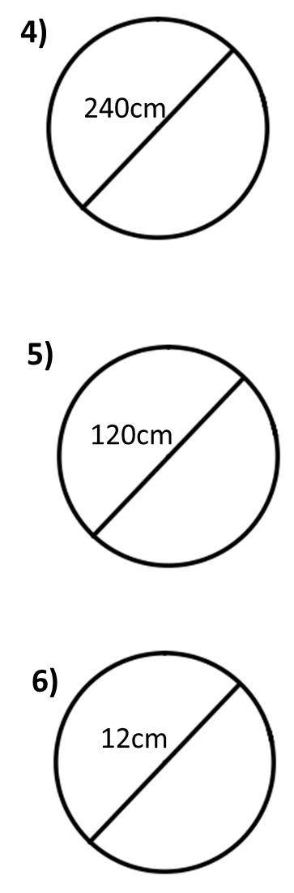
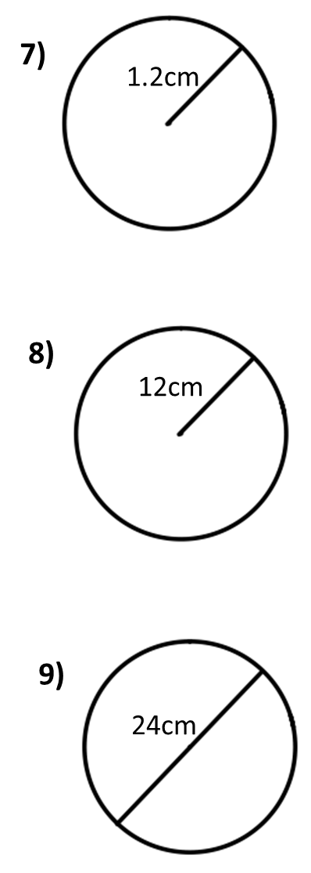
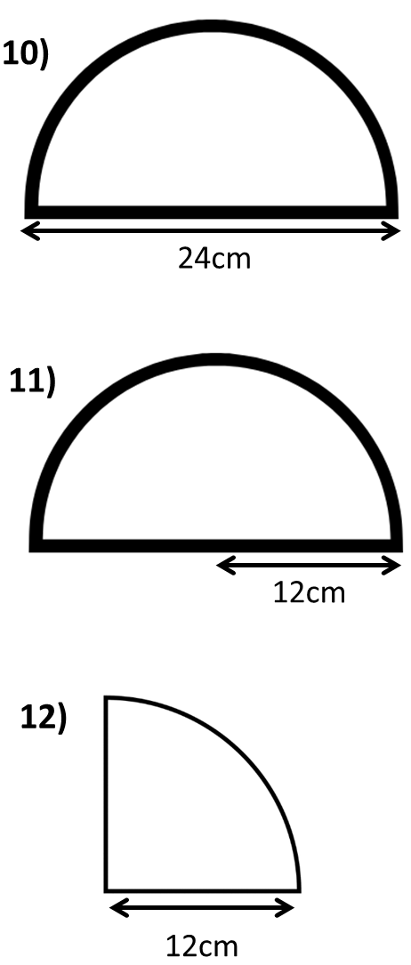
1) $Area\text{ =}$ 181.5 cm²
What’s the radius?

2) $Area\text{ =}$ 181.5 m²
What’s the diameter?

3) $Area\text{ =}$ 18150 cm²
What’s the radius?

4) $Area\text{ =}$ 452.39cm²
What’s the radius?

5) $Area\text{ =}$ 452.39cm²
What’s the diameter?

6) Area = 100cm²
What’s the radius?
7) Area = 200cm²
What’s the diameter?

8) Area = 0.02m²
What’s the radius?

9) Area = 0.7854m²
What’s the radius?

10) $Area\text{ =}$ 0.7854x m²
What’s the radius?

11) $Area\text{ =}$ 78.54x m²
What’s the radius?

12) $Area\text{ =}$ 78.54x m²
What’s the diameter?

