Data | Lowest | LQ | Median | UQ | Highest | Box Plot  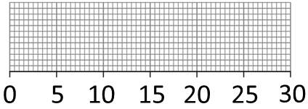
  12 | 13 | 15 | 16 | 16 | 19 | 20
  23 | 23 | 28 | 28 | 29 | 30
Data | Lowest | LQ | Median | UQ | Highest | Box Plot  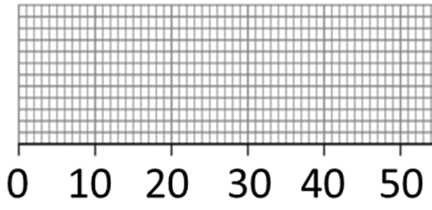
  13 | 20 | 23 | 23 | 25 | 26 | 26 | 27 | 30
  32 | 34 | 34 | 35 | 37 | 41 | 43 | 44
Data | Lowest | LQ | Median | UQ | Highest | Box Plot  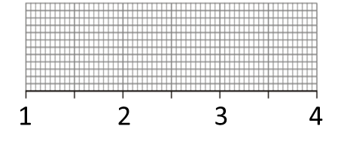
  1.5 | 1.8 | 2 | 2.1 | 2.5 | 2.6 | 2.6
  2.7 | 3.2 | 3.5 | 3.8 | 3.8 | 3.9
Data | Lowest | LQ | Median | UQ | Highest | Box Plot  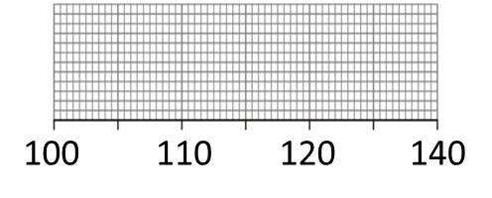  130
  123 | 132 | 124 | 104 | 115 | 128 | 100
  116 | 104 | 119 | 120 | 115 | 101
Data | Lowest | LQ | Median | UQ | Highest | Box Plot  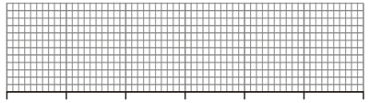
  65 | 71 | 62 | 80 | 90 | 67 | 74 | 84
  60 | 75 | 67 | 83 | 67 | 82 | 68 | 89
To able to produce box plots from raw data

