The Open Box Problem
The managing director has asked you, as design manager,
to design an open box that will give maximum volume.

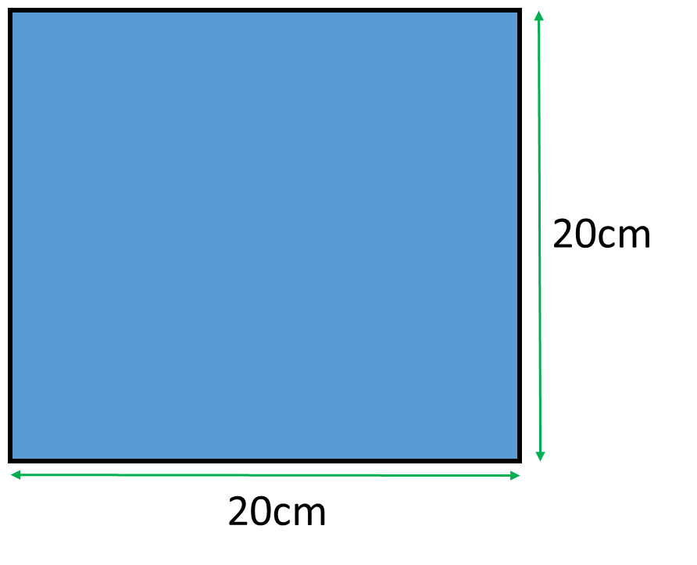
The MD has asked you to make the box from
a 20cm square card.

The factory machinery is only able to cut squares
to the nearest whole number (1cm, 2cm, 3cm…etc.)

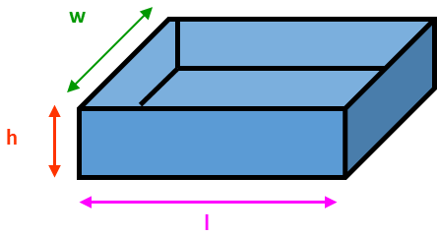

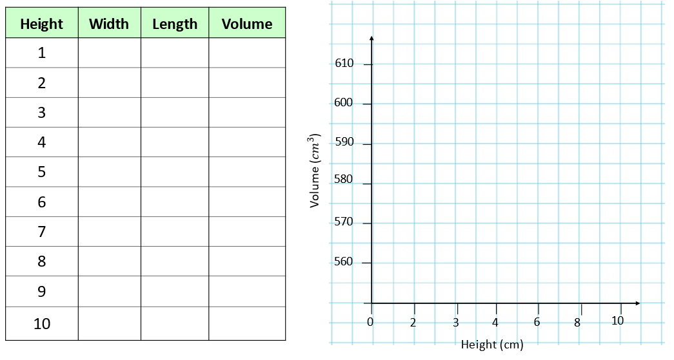
The machinery that cuts the squares
is upgraded and can now cut to the nearest tenth.

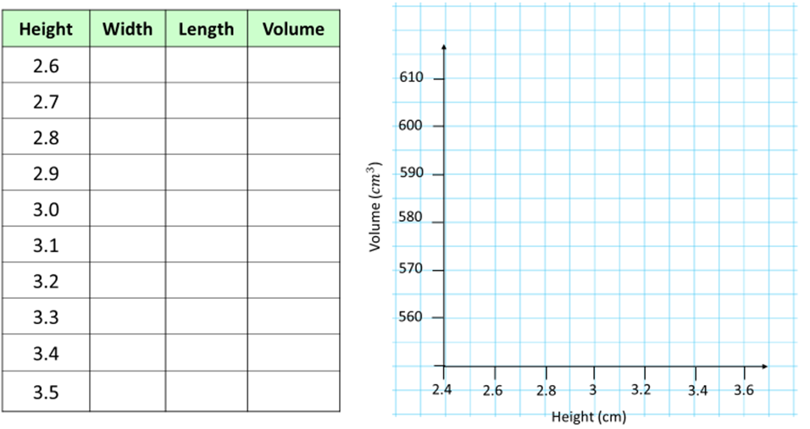
Can you write a formula for calculating Length,
using only the letters L, C and H?

Can you write a formula for calculating Volume,
using only the letters V, C and H?

