Year 8 Delta 2 Unit 3 Revision
2D Shapes and 3D Solids — Grade 4–6
Plans & Elevations • Surface Area & Volume of Prisms • Circles • Cylinders • Pythagoras
Target: Grade 4 → Grade 6 | Time: 55 minutes | Calculator: allowed
Name: ______________________________ Date: ________________ Score: _______ / 115
Section | Time | My score | Red | Amber | Green
1. Plans & Elevations | 6 mins | _____ / 17
2. Surface Area of Prisms | 8 mins | _____ / 16
3. Volume of Prisms | 9 mins | _____ / 19
4. Circumference of a Circle | 7 mins | _____ / 19
5. Area of a Circle | 6 mins | _____ / 13
6. Cylinders | 8 mins | _____ / 14
7. Pythagoras' Theorem | 9 mins | _____ / 17
Total | 55 mins | _____ / 115
Mark each section using the answer booklet, write your score, then tick one colour: Red = need help, Amber = getting there, Green = confident.
How to use this booklet
Each section starts on a new page with a Key Facts box.
Read it first, then work through the questions in order — they get harder as you go.
Every question is tagged with a grade.
The purple Problem Solving questions are exam-style: read carefully, draw or label a diagram, then solve.
Show your working — method marks are often worth more than the final answer. Don't look at the answers until you have finished. Unless told otherwise, give answers to 1 decimal place and use the π button on your calculator.

Problem-solving toolkit
1. Sketch a diagram and label everything you know.
2. Decide which formula you need and write it down.
3. Substitute the values, then calculate.
4. Check your answer makes sense — and include the units (cm, cm², cm³).
1. Plans & Elevations | ⏱ 6 minutes

Key Facts
Plan: the view from directly above. Front elevation: the view from the front. Side elevation: the view from the side.
Draw each view as a flat 2D shape — no 3D effects. Use the same scale for all views.
A prism has the same cross-section all the way through. A cross-section is the 2D shape you get when you slice through a solid.
Faces are flat surfaces, edges are where two faces meet, vertices are corners.
Q1 Complete the table. [Grade 4]
Solid | Faces | Edges | Vertices
(a) Hexagonal prism
(b) Octagonal prism
(c) Pentagon-based pyramid
(d) Hexagon-based pyramid
Q2 The solid below is made from 5 cubes. (a) On the grids, draw its plan, front elevation and side elevation. [3] (b) How many more cubes are needed to turn it into a cuboid 3 cubes long, 2 cubes wide and 2 cubes tall? [1] [Grade 4–5]
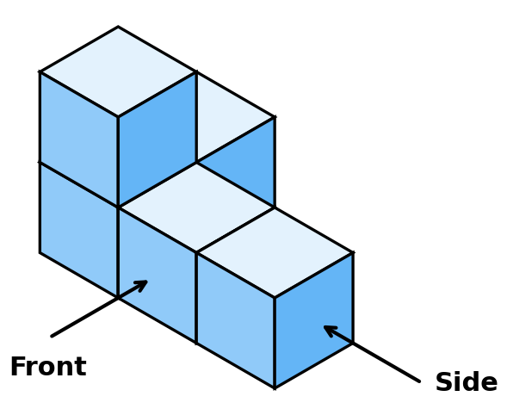
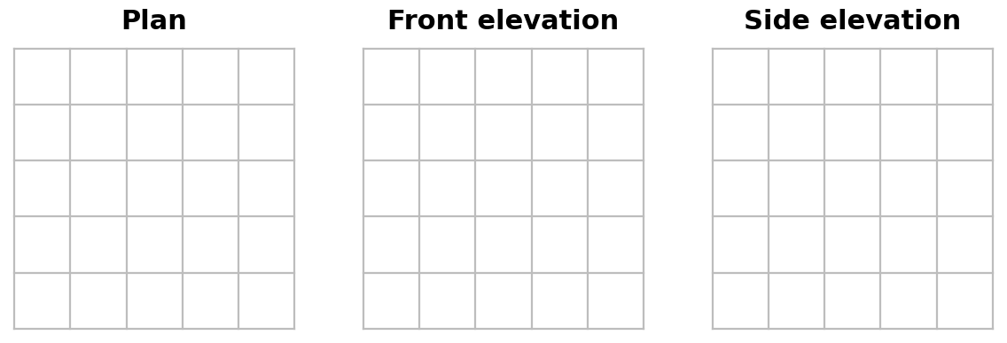
Q3 Each row shows the plan, front elevation and side elevation of a 3D solid. Name each solid. [Grade 4]
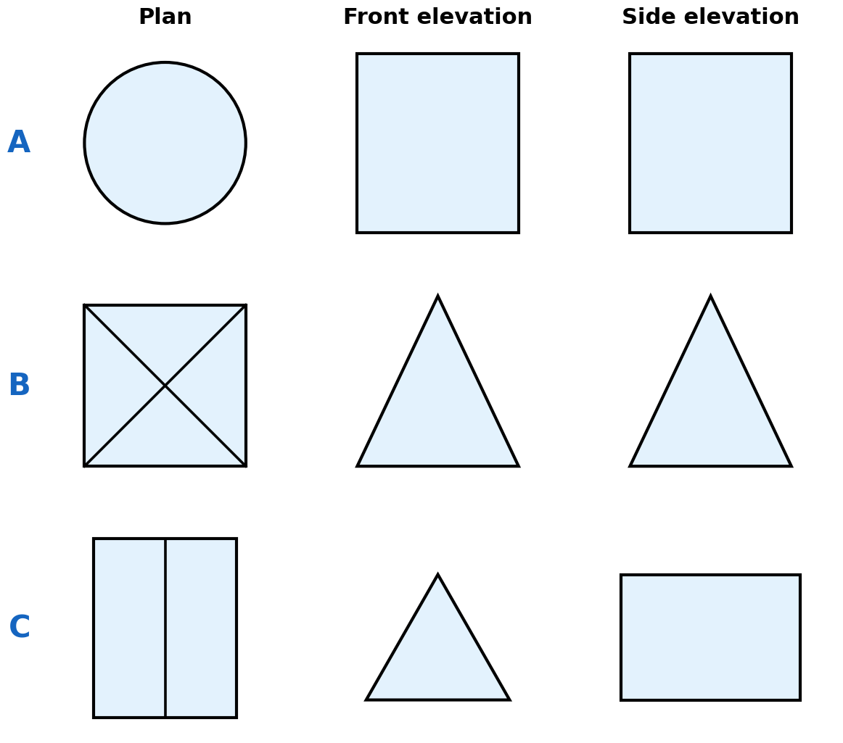
A = | B = | C =
🧩 Problem Solving — think, plan, then solve
Q4 Name the shape of the cross-section when: [Grade 5]
(a) a cone is sliced parallel to its circular base | (b) a cone is sliced vertically, straight down through its point (apex) | (c) a cube is sliced from one edge diagonally through to the opposite edge
Q5 A prism has 24 edges.
(a) What shape is its cross-section? (b) How many faces and how many vertices does it have? (c) Explain why a prism can never have exactly 20 edges. [Grade 6]
Working:

2. Surface Area of Prisms | ⏱ 8 minutes

Key Facts
Surface area = the total area of ALL the faces. Sketching the net helps you not miss any.
Cuboid: surface area = 2(lw + lh + wh). Cube: surface area = 6 × side²
Triangular prism: 2 triangles + 3 rectangles. Triangle area = ½ × base × height.
Shortcut for any prism: SA = 2 × (area of cross-section) + (perimeter of cross-section) × length
Area is measured in square units: mm², cm², m²
Q6 Work out the surface area of:
(a) a cuboid 6.5 cm by 4 cm by 3 cm [2]
(b) a cuboid 1.2 m by 80 cm by 50 cm, giving your answer in m² [2] [Grade 4–5]
(a) Cuboid 6.5 cm × 4 cm × 3 cm | (b) Cuboid 1.2 m × 80 cm × 50 cm (answer in m²)
Q7 Work out the surface area of this triangular prism. [Grade 5]
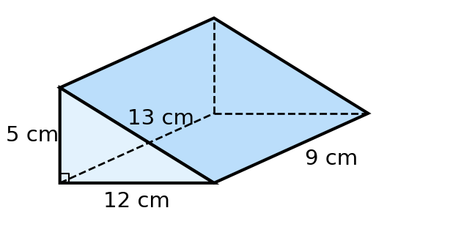
Working:
Q8 Work out the surface area of this L-shaped prism. Work out any missing lengths first. [Grade 5–6]
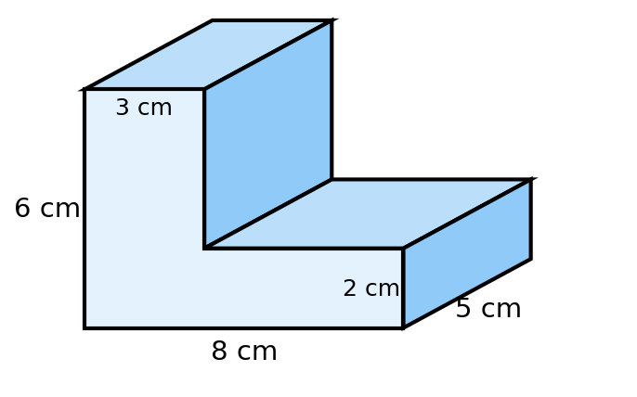
Working:
🧩 Problem Solving — think, plan, then solve
Q9 A cube has a surface area of 294 cm². Find its volume. [Grade 5–6]
Working:
Q10 An open box (no lid) is a cuboid with a square base of side 30 cm and a height of 20 cm.
Card costs 2p for every 100 cm². Work out the cost of the card needed to make the box. [Grade 5–6]
Working:

3. Volume of Prisms | ⏱ 9 minutes

Key Facts
Volume of a prism = area of cross-section × length. Cuboid: V = l × w × h
Volume is measured in cubic units: mm³, cm³, m³.
1 cm = 10 mm, so 1 cm³ = 10 × 10 × 10 = 1000 mm³. 1 m = 100 cm, so 1 m³ = 100 × 100 × 100 = 1 000 000 cm³.
1 litre = 1000 cm³ (1 ml = 1 cm³)
Missing lengths: rearrange. Length = volume ÷ area of cross-section.
Q11 Work out the volume of: [Grade 4–5]
(a) a cuboid 12 cm × 4.5 cm × 2 cm | (b) the triangular prism in Q7 | (c) the L-shaped prism in Q8
Q12 Convert: [Grade 5]
(a) 0.6 m³ to cm³ | (b) 3.2 cm³ to mm³ | (c) 450 000 cm³ to m³
(d) 2.5 litres to cm³ | (e) 85 000 mm³ to cm³ | (f) 0.03 m³ to litres
Q13 Ben says "1 cm = 10 mm, so 4 cm³ = 40 mm³".
Explain Ben's mistake and give the correct value. [Grade 5]
Working:
🧩 Problem Solving — think, plan, then solve
Q14 A cuboid has a volume of 378 cm³. Its base is a square of side 6 cm. Find its height. [Grade 5]
Working:
Q15 A triangular prism has a volume of 420 cm³ and a length of 14 cm.
(a) Find the area of its cross-section. [1]
(b) The cross-section is a right-angled triangle with a base of 5 cm. Find its perpendicular height. [2] [Grade 5–6]
Working:
Q16 A fish tank is a cuboid 60 cm long, 35 cm wide and 40 cm tall. It is filled with water to 5 cm below the top. A jug holds 1.5 litres. How many jugs of water are needed? [Grade 6]
Working:

4. Circumference of a Circle | ⏱ 7 minutes

Key Facts
Radius (r): centre to edge. Diameter (d): edge to edge through the centre, d = 2r.
Circumference (C): the distance all the way round the circle.
Chord: a straight line joining two points on the circle. Tangent: a straight line that touches the circle at one point.
Arc: part of the circumference. Sector: a "pizza slice" between two radii. Segment: the region between a chord and an arc.
C = πd or C = 2πr. Working backwards: d = C ÷ π
Q17 Use words from the box to name each part of the circle labelled A to F. [Grade 4]
radius diameter chord tangent sector segment arc
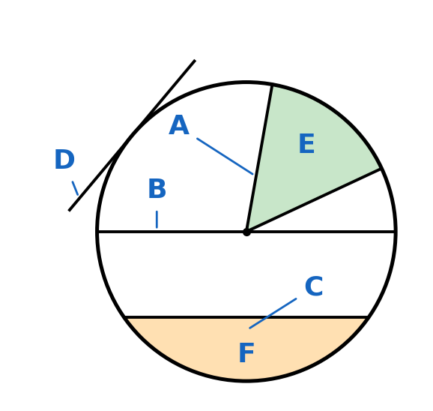
A = | B = | C = | D = | E = | F =
Q18 Work out the circumference of each circle. Give (a)–(c) to 1 d.p. and (d) in terms of π. [Grade 4–5]
(a) diameter = 12.5 cm | (b) radius = 3.8 m | (c) radius = 0.75 m | (d) diameter = 9 cm
Q19 A circle has a circumference of 80 cm. Find (a) its diameter [2] (b) its radius [1] [Grade 5]
Working:
🧩 Problem Solving — think, plan, then solve
Q20 A bicycle wheel has a radius of 32 cm. The wheel makes 250 complete turns. How far does the bike travel? Give your answer in km to 2 d.p. [Grade 5–6]
Working:
Q21 Find the perimeter of this quarter circle. [Grade 6]
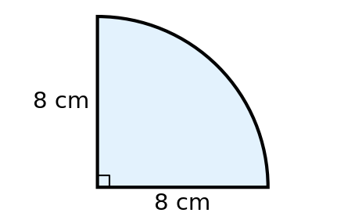
Working:

5. Area of a Circle | ⏱ 6 minutes

Key Facts
Area of a circle: A = πr² (square the radius FIRST, then multiply by π).
Given the diameter? Halve it first to get the radius.
Working backwards: r² = A ÷ π, so r = √(A ÷ π).
Semicircle area = ½πr². Quarter circle area = ¼πr². Shaded areas: work out the whole shape, then subtract the part you don't want.
Q22 Work out the area of each circle. Give (a)–(c) to 1 d.p. and (d) in terms of π. [Grade 4–5]
(a) radius = 6.5 cm | (b) diameter = 15 m | (c) radius = 0.4 m | (d) radius = 3 cm
Q23 Mia says the area of a circle with radius 6 cm is 2 × π × 6 = 37.7 cm². Explain her mistake and find the correct area. [Grade 5]
Working:
Q24 A circle has an area of 200 cm². Find (a) its radius [2] (b) its circumference [2] [Grade 6]
Working:
🧩 Problem Solving — think, plan, then solve
Q25 The diagram shows a square of side 12 cm. A quarter circle is drawn with its centre at the bottom-left corner of the square. Find the shaded area. [Grade 6]
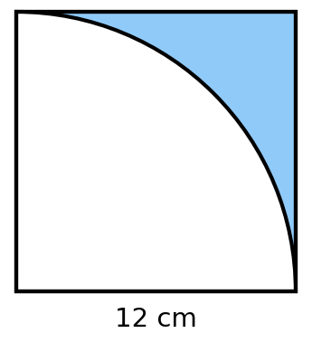
Working:

6. Cylinders | ⏱ 8 minutes

Key Facts
A cylinder is like a prism with a circular cross-section. Volume: V = πr²h (area of the circle × height)
Curved surface area = πdh = 2πrh (the label on a tin opens out into a rectangle: circumference × height)
Total surface area = 2πr² + 2πrh (two circles + the curved surface) Missing height: h = V ÷ (πr²)
Q26 Work out the volume of each cylinder. Give your answers to 1 d.p. [2 each] [Grade 5]
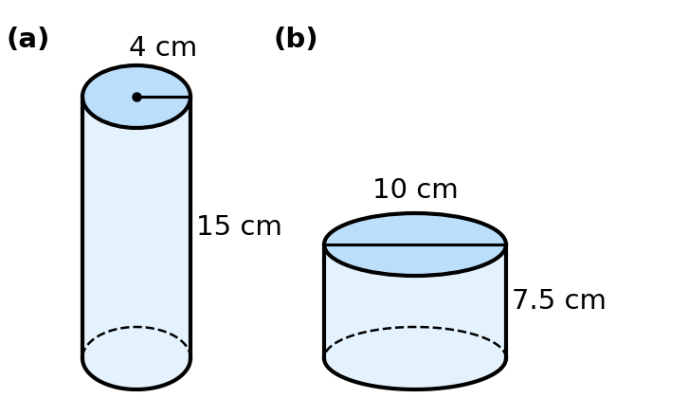
(a) | (b)
Q27 Work out the total surface area of cylinder (a) in Q26. [Grade 5–6]
Working:
🧩 Problem Solving — think, plan, then solve
Q28 A cylinder holds exactly 1 litre and has a radius of 5 cm. Find its height. [Grade 6]
Working:
Q29 A tin of soup has a diameter of 7.5 cm and a height of 11 cm.
(a) A paper label covers the curved surface. Find the area of the label. [2]
(b) 12 tins fit exactly in a box 30 cm by 22.5 cm by 11 cm. What percentage of the box is empty space? [3] [Grade 6]
Working:
7. Pythagoras' Theorem | ⏱ 9 minutes

Key Facts
Pythagoras' theorem only works in RIGHT-ANGLED triangles.
The hypotenuse (c) is the longest side. It is always opposite the right angle.
a² + b² = c²
Finding the hypotenuse: square both sides, ADD, then square root. Finding a shorter side: square both sides, SUBTRACT, then square root.
Length of AB from coordinates: find the horizontal and vertical distances, then use Pythagoras.
Q30 Write down the letter of the hypotenuse in each triangle. [Grade 4]
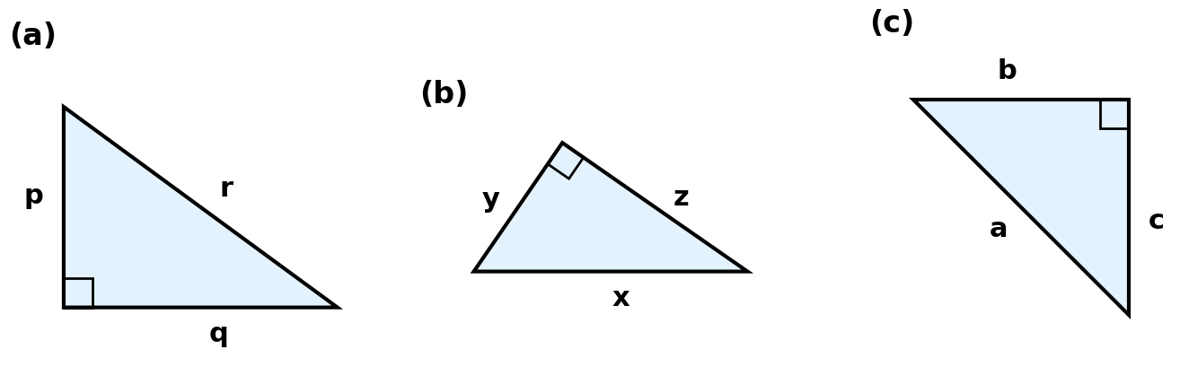
(a) | (b) | (c)
Q31 Find the length of the side marked x. Give your answers to 1 d.p. where needed. [Grade 5]
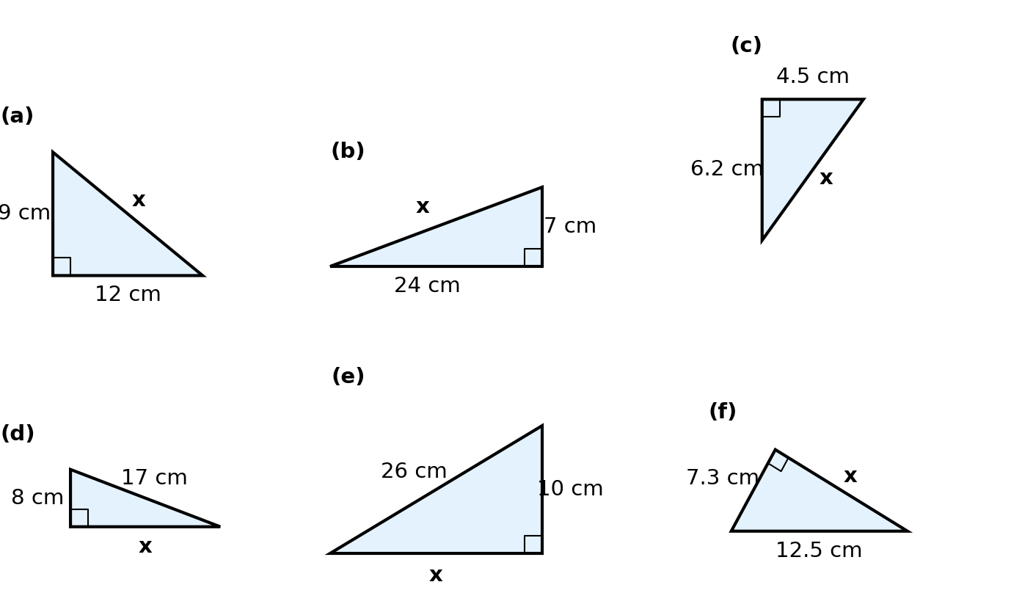
(a) | (b) | (c)
(d) | (e) | (f)
🧩 Problem Solving — think, plan, then solve
Q32 A ladder 6.5 m long leans against a vertical wall. The foot of the ladder is 2.5 m from the wall.
(a) How far up the wall does the ladder reach? [2]
(b) The foot of the ladder slides 1 m further away from the wall. How far down the wall does the top of the ladder slide? [2] [Grade 6]
Working:
Q33 (a) Find the length of AB. [2] [Grade 5–6]
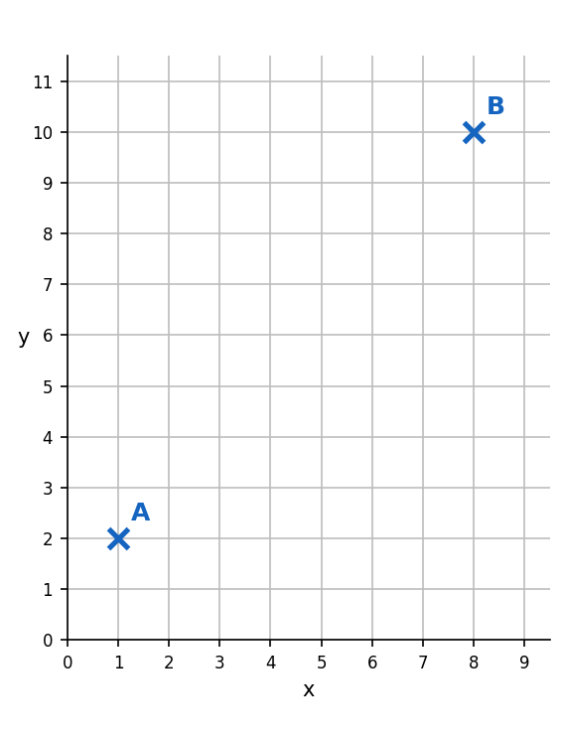 | Working:
(b) P is the point (−4, 3) and Q is the point (5, −2). Find the length of PQ. [2] [Grade 6]
Working:

