Lawn 1 (Foundation)
Use a scale of 1cm for 1m for both lawn questions

The diagram is of a garden lawn.
A tree stands at point T.
At noon it casts a circular shadow of radius 1.5 metres.
Show clearly the area of lawn that is in shadow.

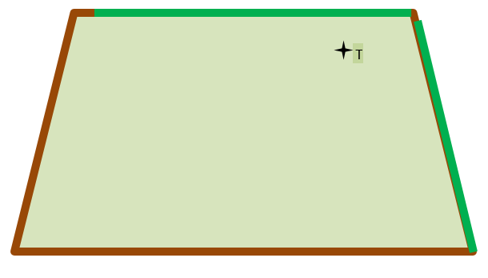

Lawn 2
Two birds land in the garden at A and B.
In order to not frighten them the gardener walks
across the lawn keeping equidistant between them.
Show his path on the diagram.
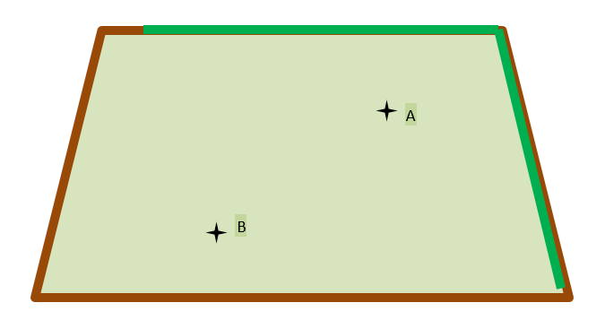
Korky’s Dilemma (Intermediate)
1 cm on the diagram represents 0.5 metres

Tizer the dog is tied up at point A on a rope 225 centimetres long.
Another dog, Max is tied up at point B on a rope 1.75 metres long.

Shade accurately on the diagram the areas
where each dog is able to roam.

Korky the cat walks across the lawn from corner C keeping equidistant from the fence and the hedge.
Construct accurately Korky’s path.

Can Korky safely traverse the garden without being caught by a dog?

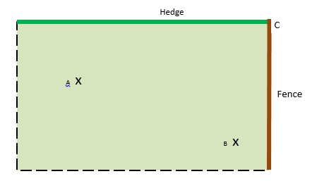

Conclusion………………………………………………………………………………………..

…………………………………………………………………………………………………………-

Disputed Waters (Higher)
Use 1cm to represent 20km

Square Island (S) and Circle Island (C) are in dispute
over fishing rights.

- Both claim to own the waters up to 60km off their shores.
- Show the fishing areas claimed by each island **
- Shade in clearly the disputed area

- A ship travels equidistant between
Lighthouse 1 (L1) and Lighthouse 2 (L2)
- Plot the course of the ship, showing clearly its passage
- Using your scale drawing, how far does the ship travel in Square Island’s Fishing Waters?
C
S

L1

L2

**Think carefully exactly what is the shape of each fishing area
Make sure your locus is measured from the shoreline of the islands

Asif’s Garden Design (Gold)
Use a scale of 1cm represents 1 metre

Asif is designing a garden for his new house. The diagram shows the outline of the garden. Help him decide where he can plant his carrots in the garden using the following criteria:

- The carrots cannot be within 3m of the tree because the tree will soak up all the water. Show this area in blue

- They cannot be within 4m of the wall because the wall will cast a shadow. Show this area in green

- He cannot plant them within 2 metres of the shed because it will flood as the rain runs off the roof. Show this area in yellow

- Show clearly in red on the diagram the possible planting area.

WALL
TREE
SHED

