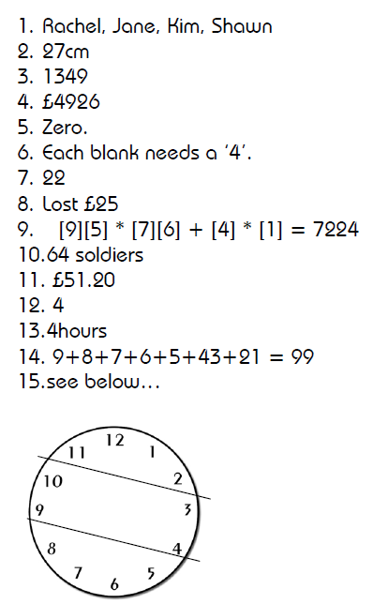
16. 161 Big Bags and 224 Small Bags.

