Tessellations and Tetris
Fit all the pentominoes below into the grid.
Do not let them overlap.
You can rotate or reflected them.

Puzzle 1
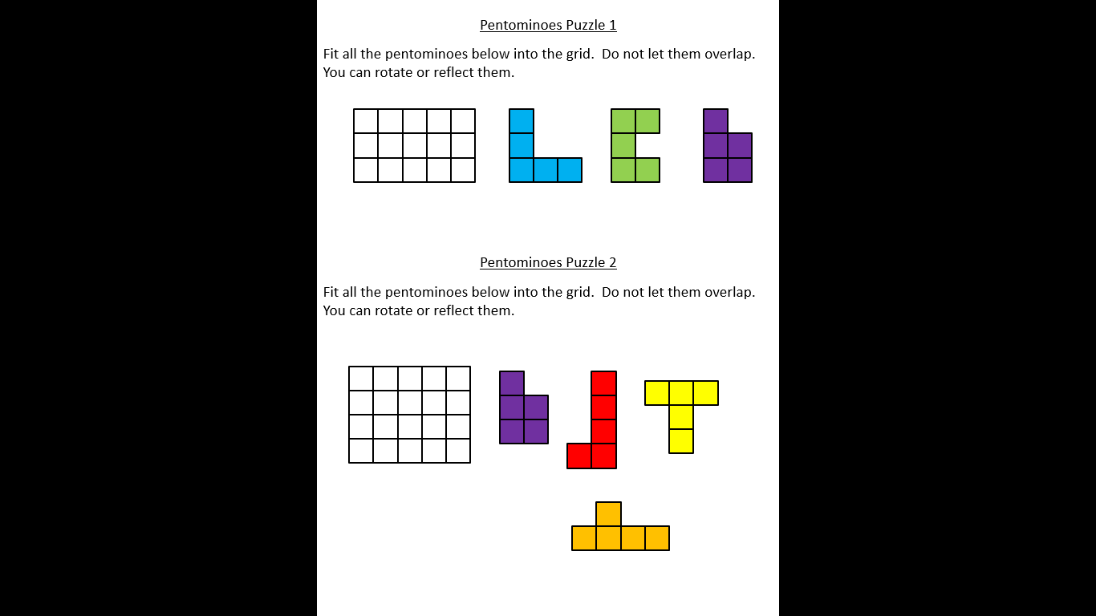

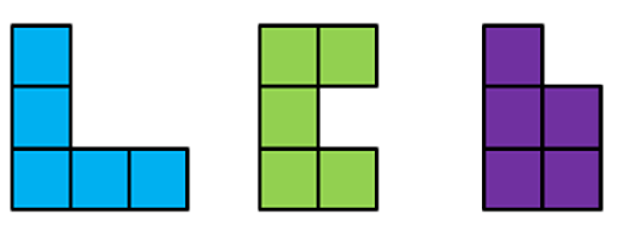

Puzzle 2

Puzzle 3
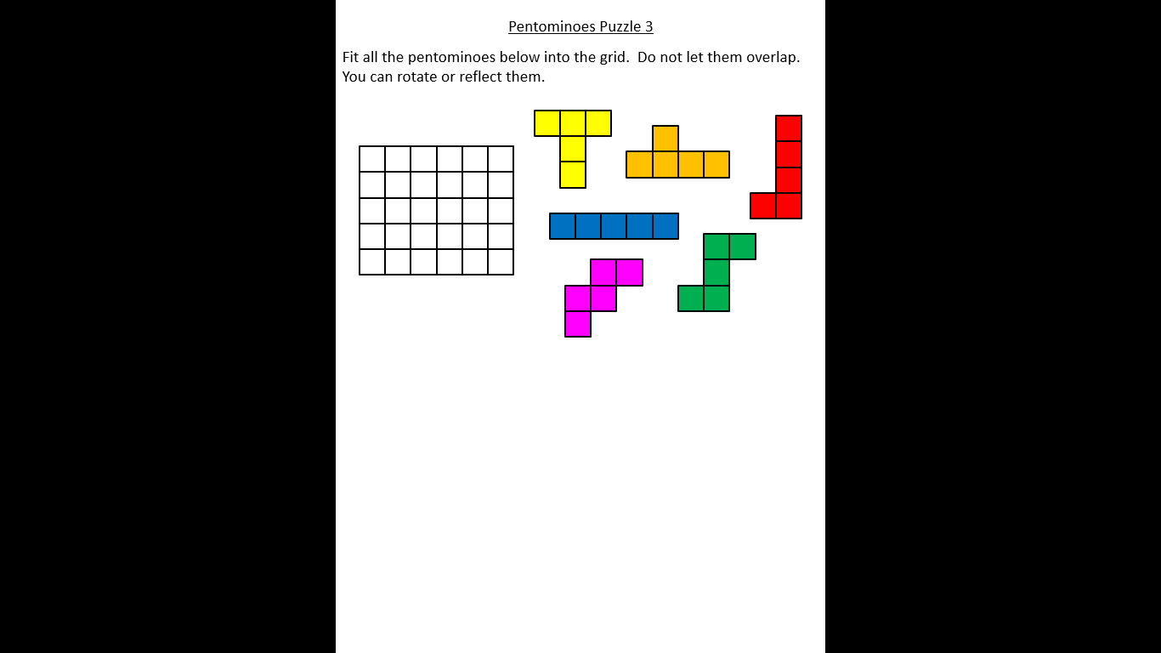

Puzzle 4
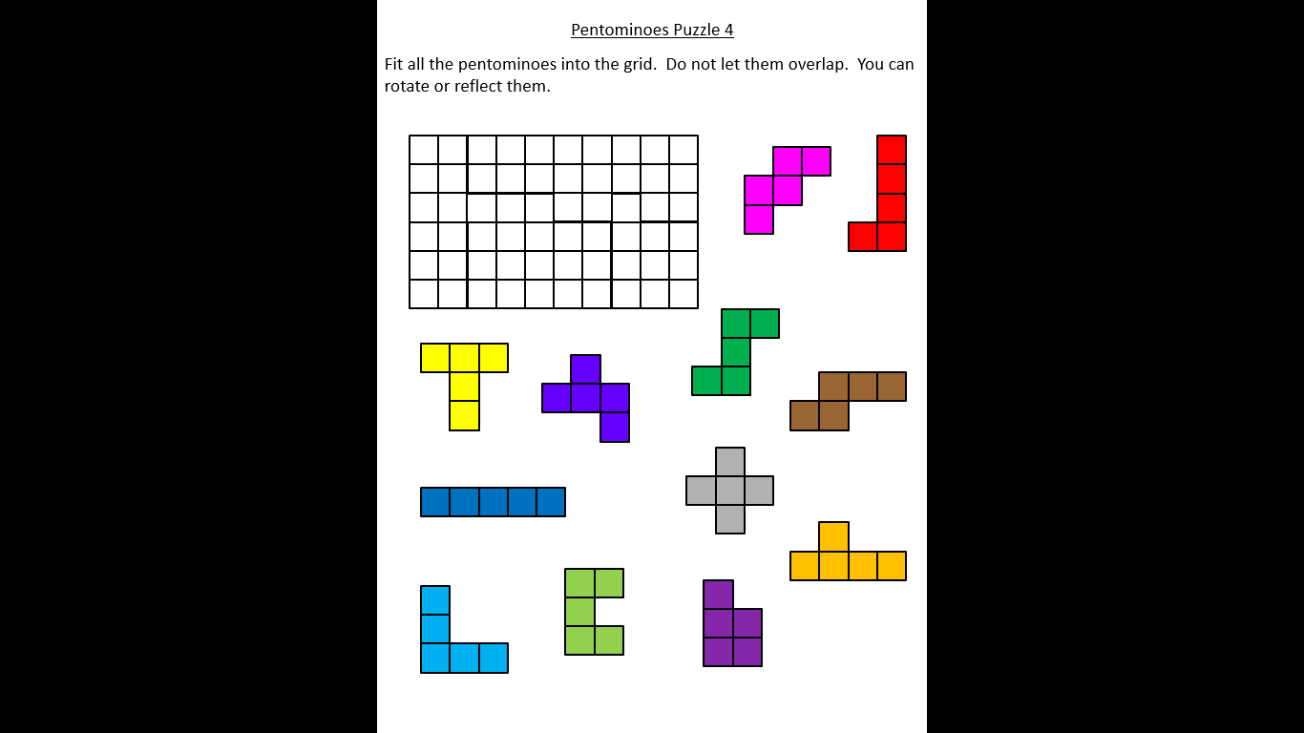
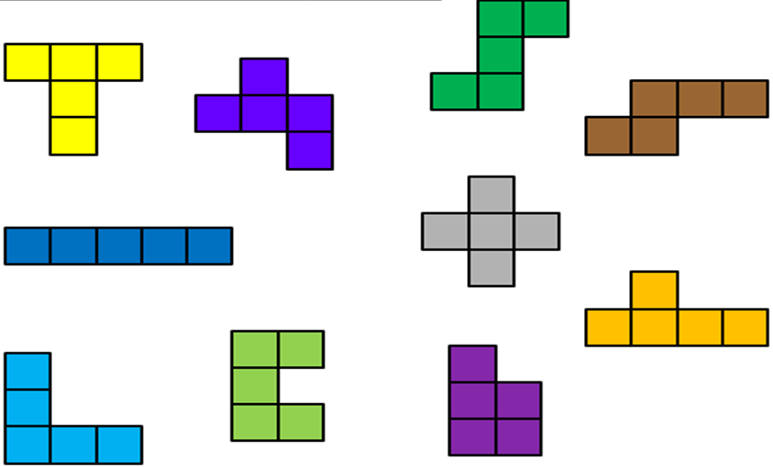
Puzzle 5
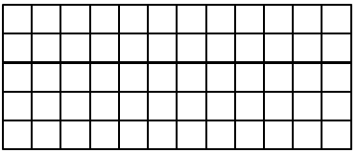

Puzzle 6
