y = f(x) | y = f(x) + 3 | y = f(x) - 1 | y = f(x - 1)
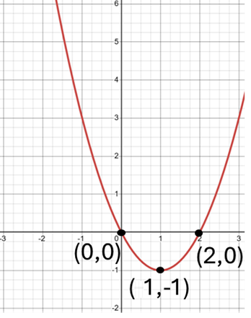 | 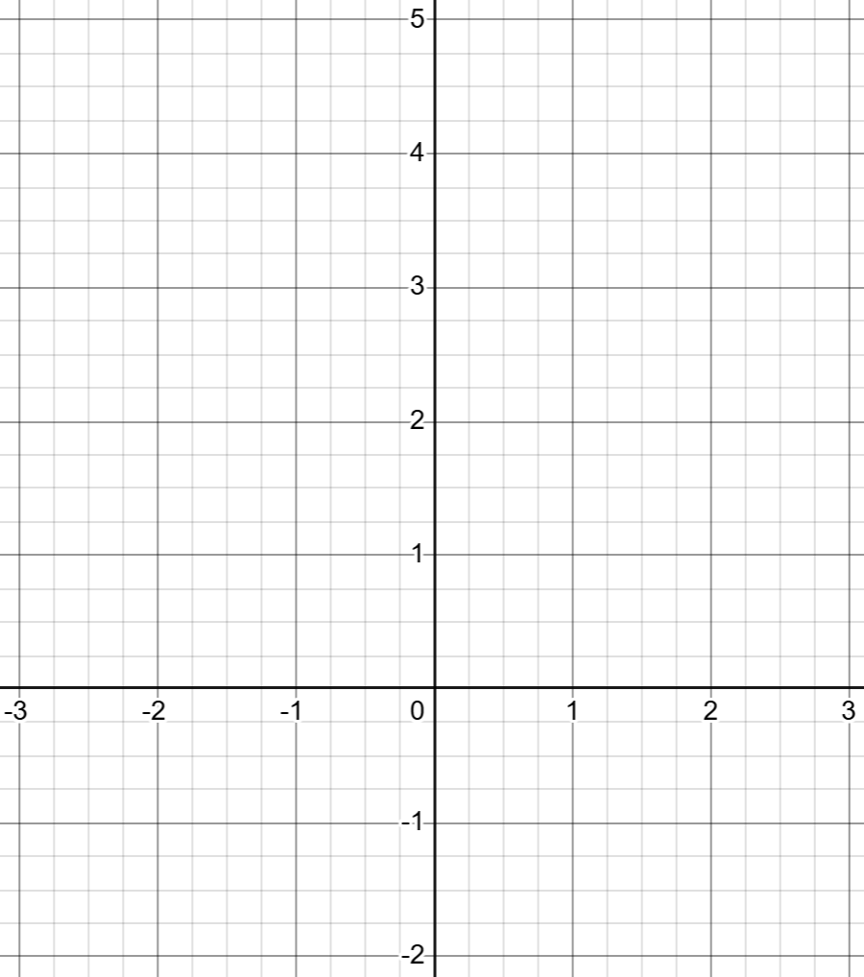
y = f(x + 3) | y = -f(x) | y = f(-x) | y = 2f(x)

y = f(2x) | y = f(x + 3) - 1 | y = f(x - 1) + 2 | Y = -2f(x)

