Reflections using Co-ordinate Grids
1) Reflect each shape and write the new co-ordinate of the black point.
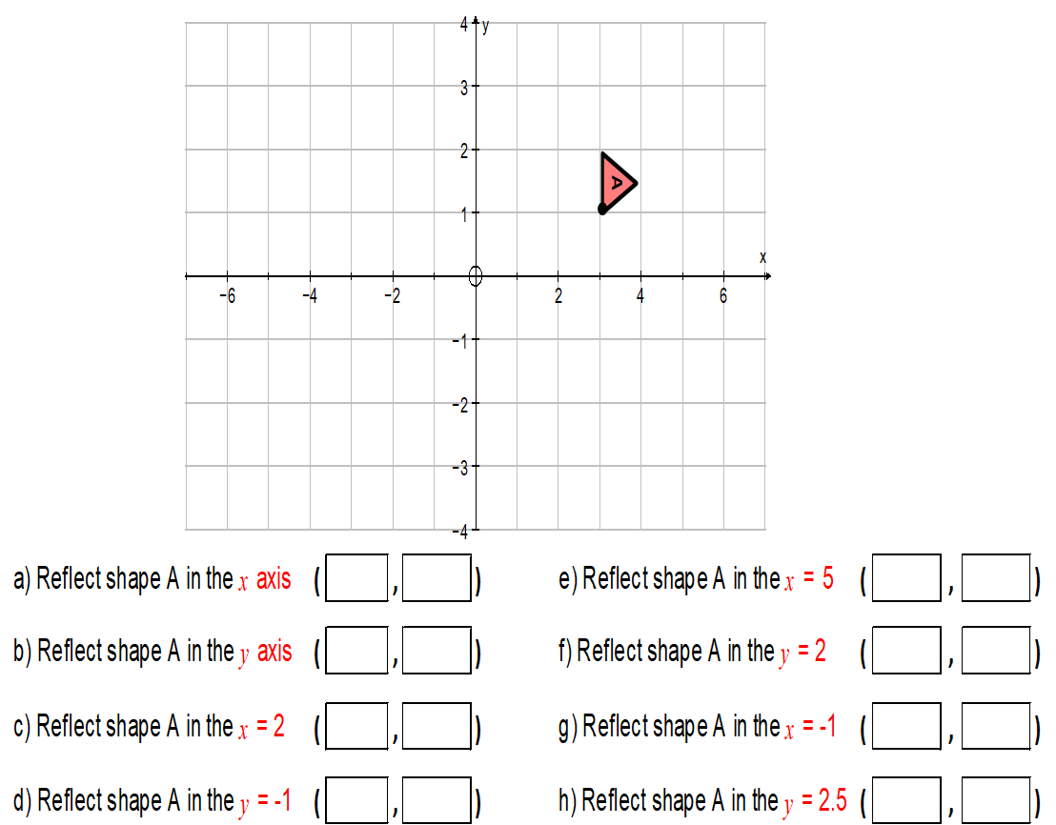
a) Reflect Shape A in the x-axis e) Reflect Shape A in the x = 5
( , ) ( , )
b) Reflect Shape A in the y-axis f) Reflect Shape A in the y = 2
( , ) ( , )
c) Reflect Shape A in the x = 2 g) Reflect Shape A in the x = -1
( , ) ( , )
d) Reflect Shape A in the y = -1 h) Reflect Shape A in the y = 2.5
( , ) ( , )
2) Reflect each shape and write the new co-ordinate of the black point.

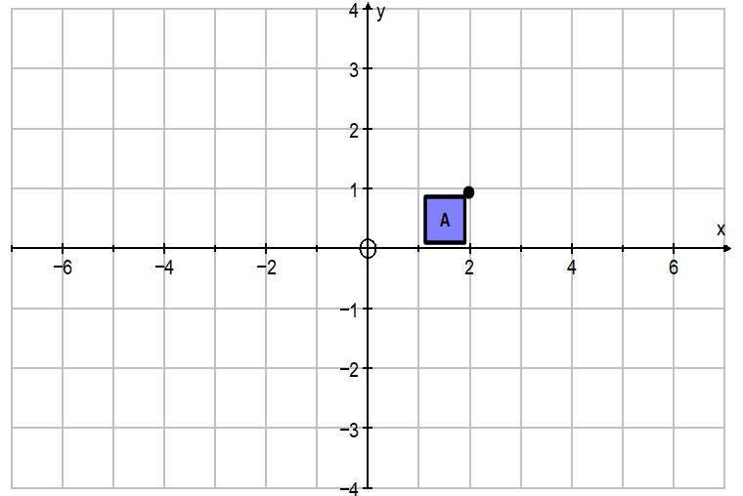

a) Reflect Shape A in the y = x d) Reflect Shape A in the x axis
( , ) ( , )

b) Reflect Shape A in the y = -1 e) Reflect Shape A in the y = -2
( , ) ( , )

c) Reflect Shape A in the x = 3 f) Reflect Shape A in the x = 2
( , ) ( , )

3) Reflect each shape and write the new co-ordinate of the black point.

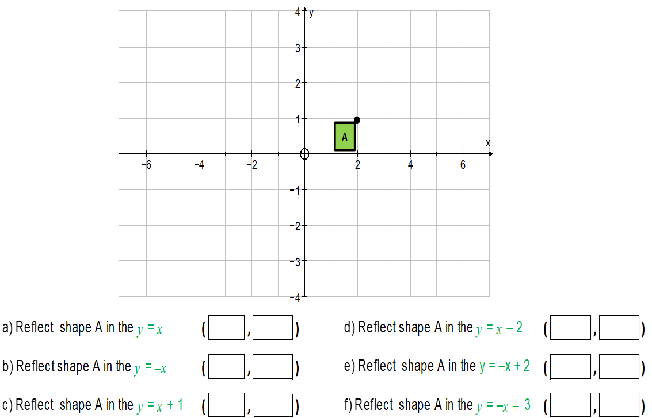

a) Reflect Shape A in y = x d) Reflect Shape A in x = 5
( , ) ( , )

b) Reflect Shape A in y = -x e) Reflect Shape A in y = -5
( , ) ( , )

c) Reflect Shape A in y = 4 f) Reflect Shape A in x = -8
( , ) ( , )

4) Write the equation of the lines of symmetry that map each shape.
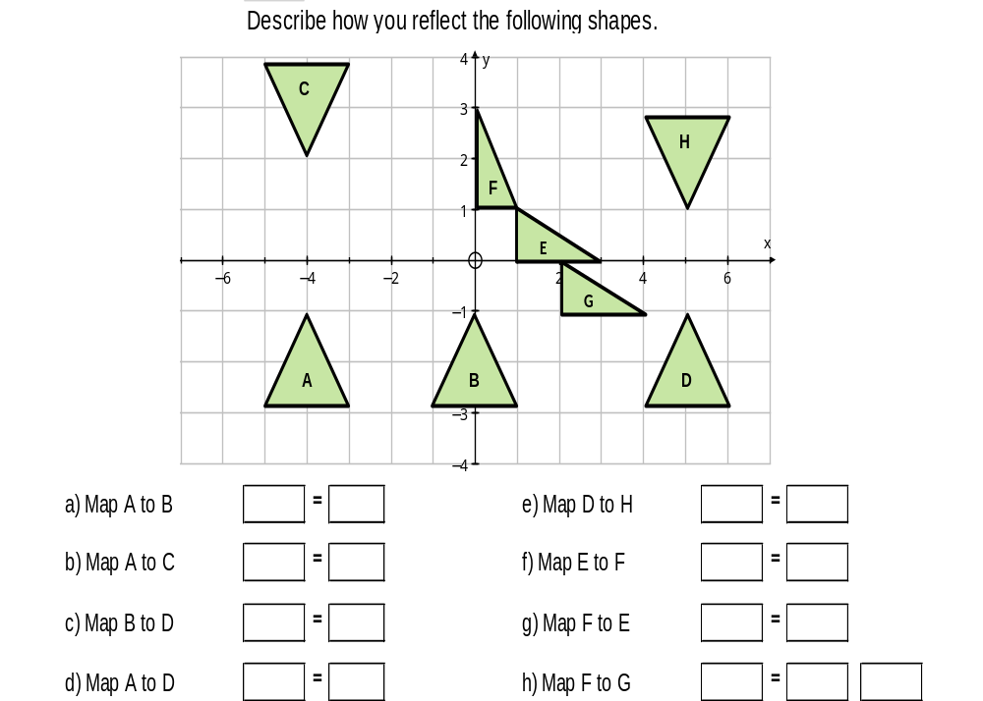

a) Map A to B e) Map D to H

b) Map A to C f) Map E to F

c) Map B to D g) Map F to E

d) Map A to D h) Map F to G

