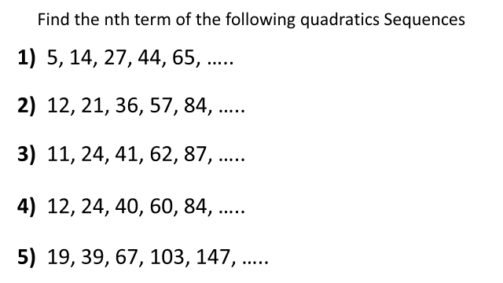
Find the general formula for calculating
the number of dots in a diagram.
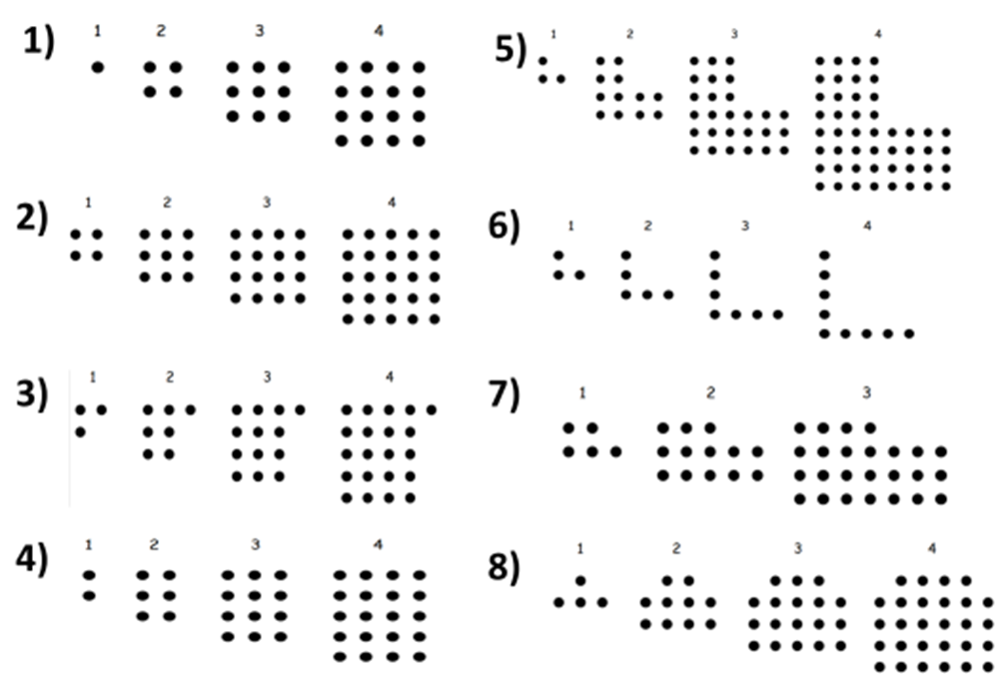
Find the general formula for calculating
the number of dots in a diagram.

