Scatter Graphs
1a) Below are the marks of eight students in their Maths and Science tests.
Plot the points on the scatter graph underneath.
Maths mark | 56 | 73 | 51 | 62 | 24 | 67 | 94 | 35
Science mark | 62 | 68 | 45 | 68 | 35 | 73 | 88 | 32
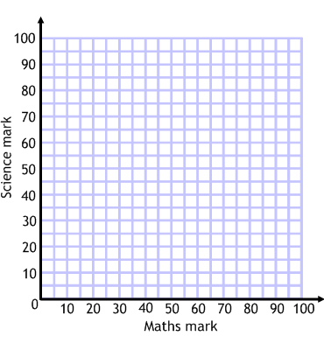
1b) A student got 65 in their maths test but was absent for their science test.
What score should the teacher estimate for them?

2a) The data below shows the number of scarves sold by a shop in a week and the temperature that day. Produce a scatter graph.
Sales of scarves | 73 | 56 | 54 | 38 | 7 | 39 | 82
Temperature (⁰C) | 9 | 13 | 15 | 19 | 25 | 12 | 5
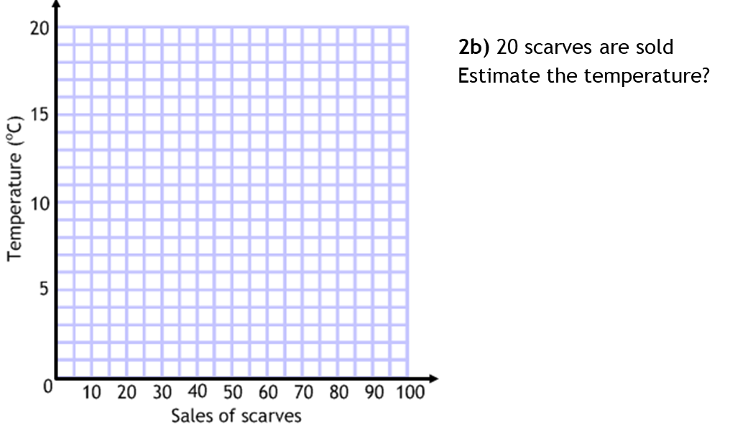
3a) The data below shows the amount of petrol used by a car and the distance driven on eight different journeys. Produce a scatter graph.
Distance (km) | 75 | 140 | 237 | 180 | 20 | 93 | 104 | 42
Petrol used (l) | 7 | 12.5 | 25.3 | 16 | 3.5 | 8.9 | 9.5 | 4.1
