Estimating Rates of Change
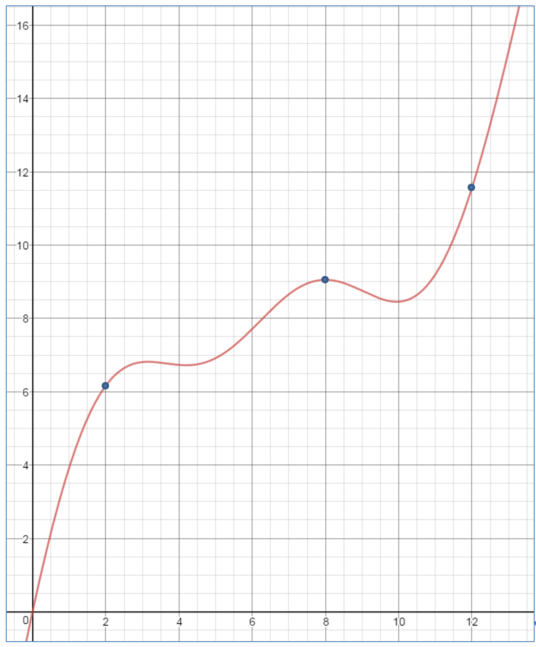
1) Estimate the rate of change when:
a) t = 2
b) t = 8
c) t = 12
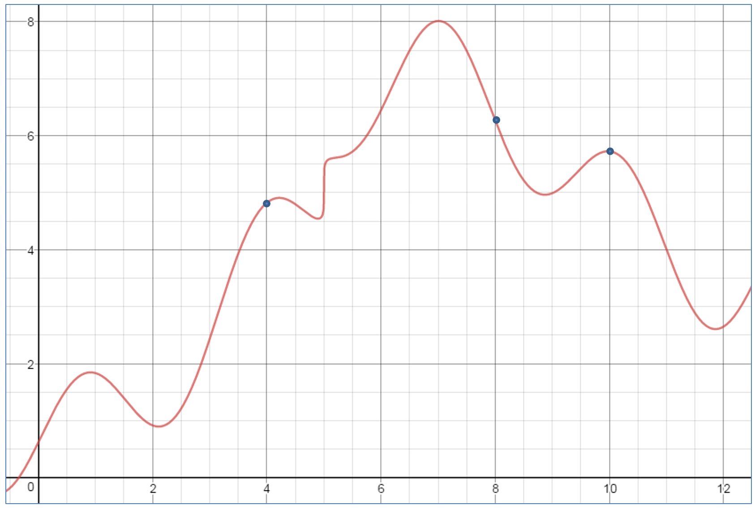

2) Estimate the rate of change when:
a) t = 4

b) t = 8

c) t = 10

d) between t = 2 and t = 10

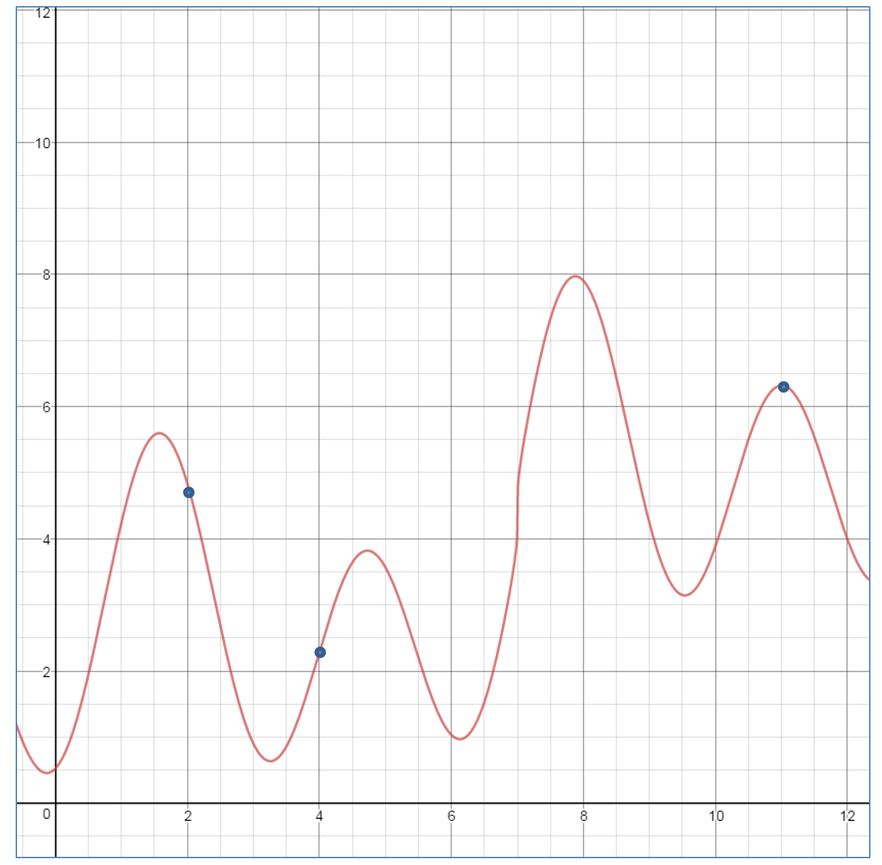
3) Estimate the rate of change when:
a) t = 2

b) t = 8

c) t = 11

d) between t = 2 and t = 10
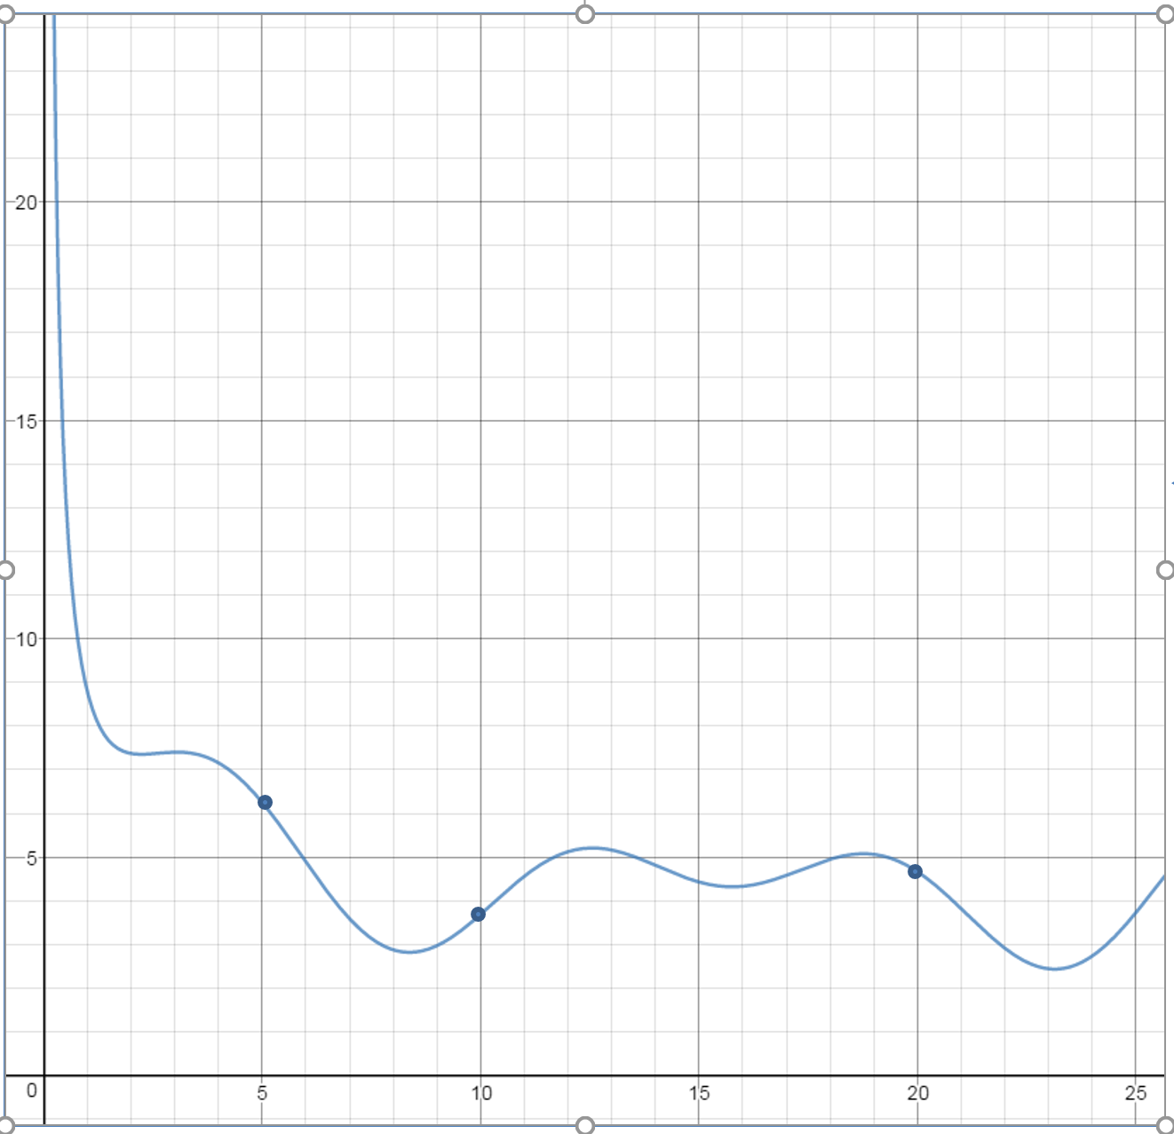
4) Estimate the rate of change when:
a) t = 5

b) t = 10

c) t = 20

d) between t = 5 and t = 20

