Murder Mystery – Jail or Jewels
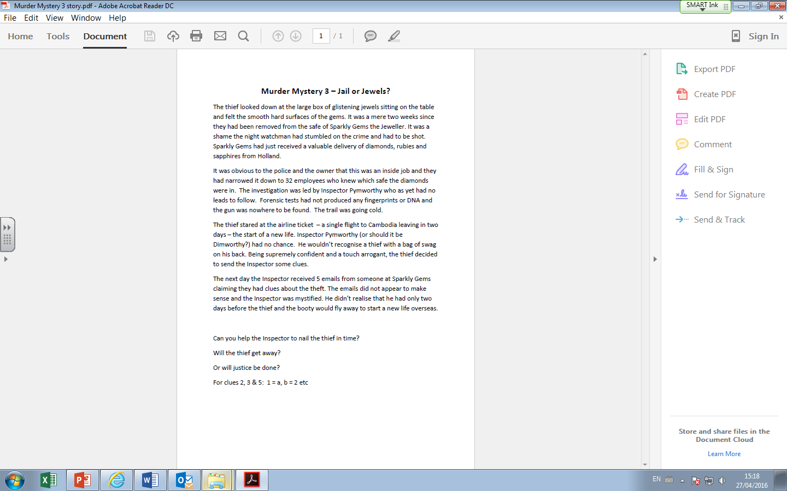

Clue 1: Wave the flag
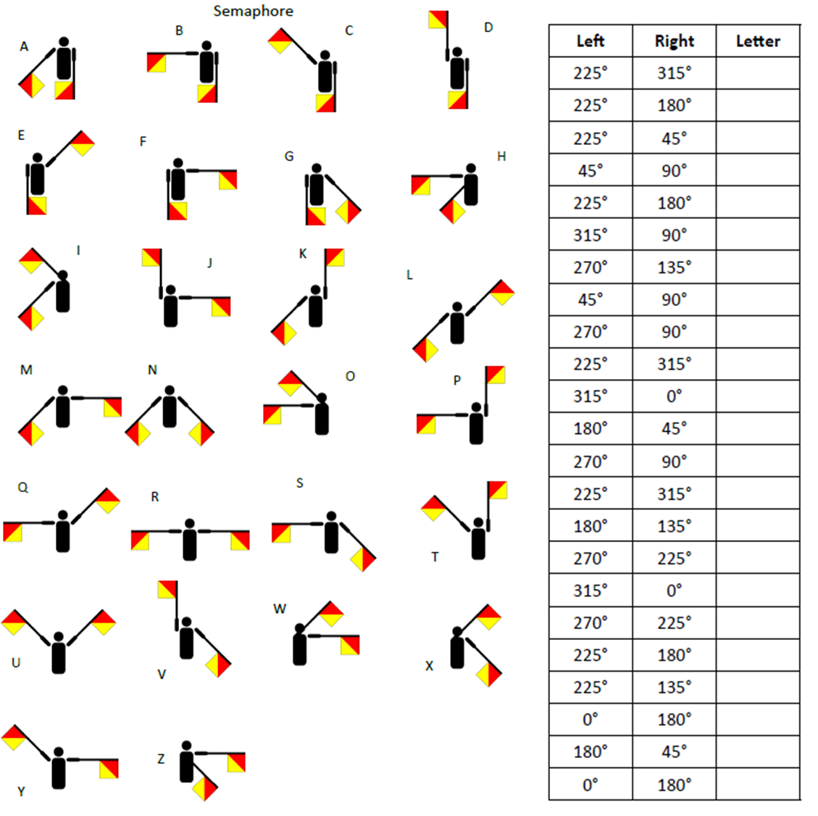
Clue 2: The Dating Game
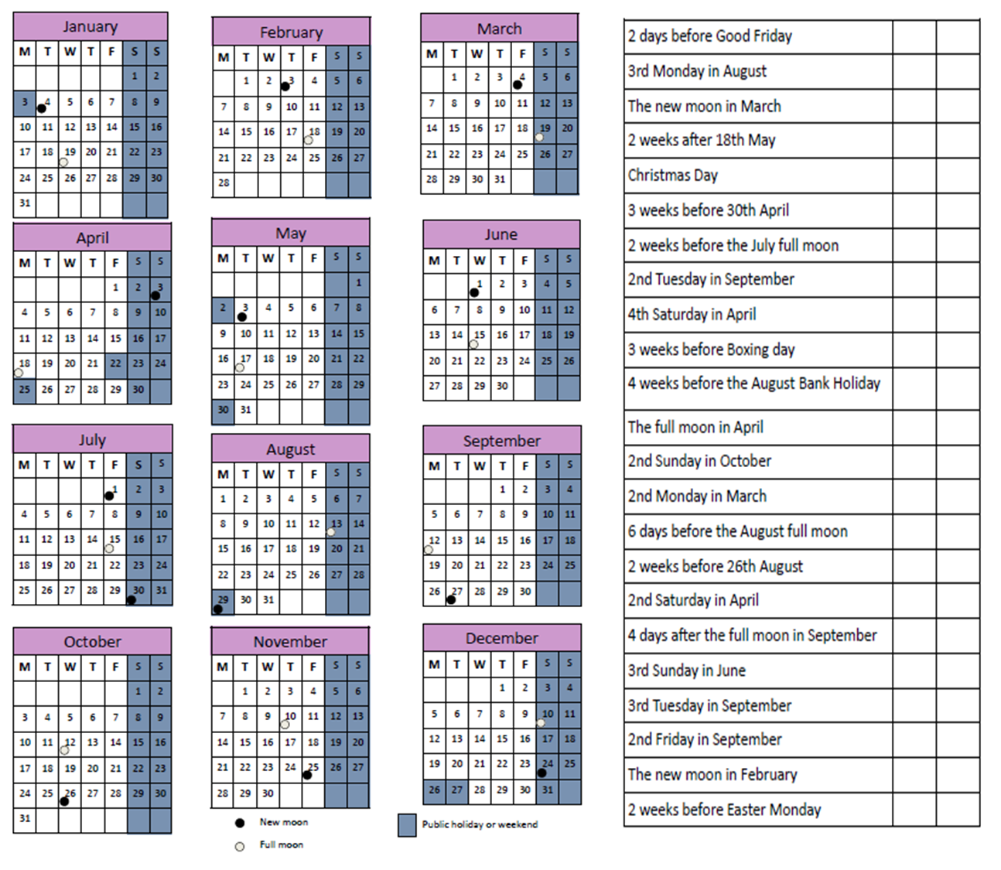
Clue 3: 100% Proof
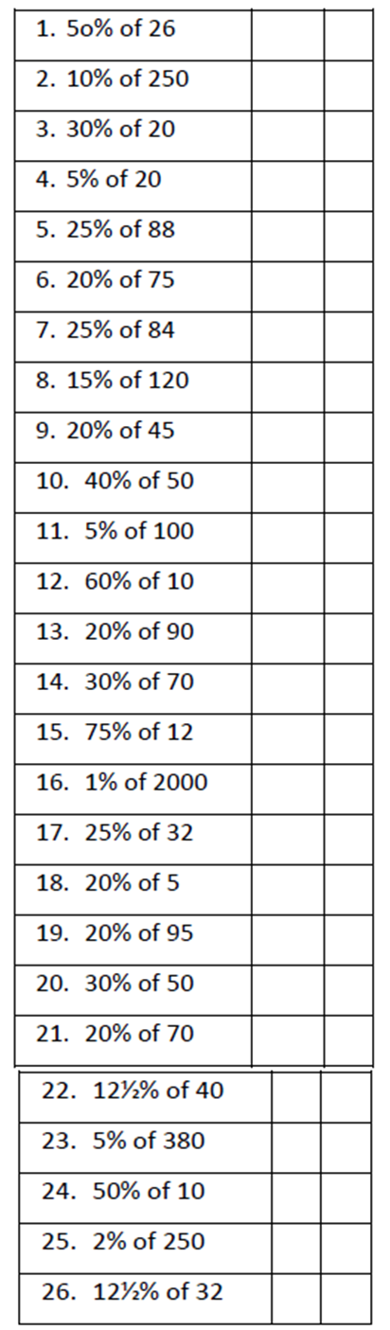

Clue 4: Black and White
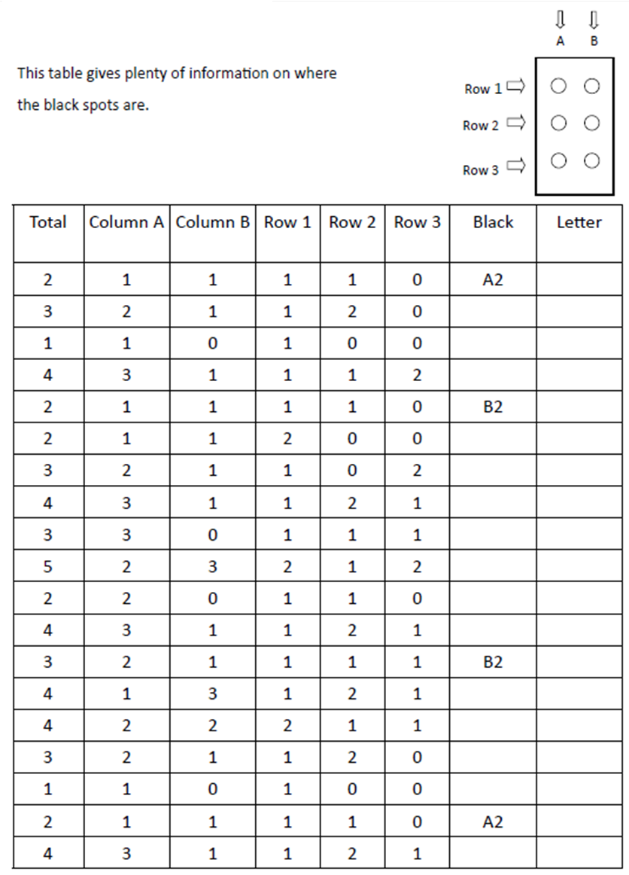
Clue 4: Black and White (Continued)
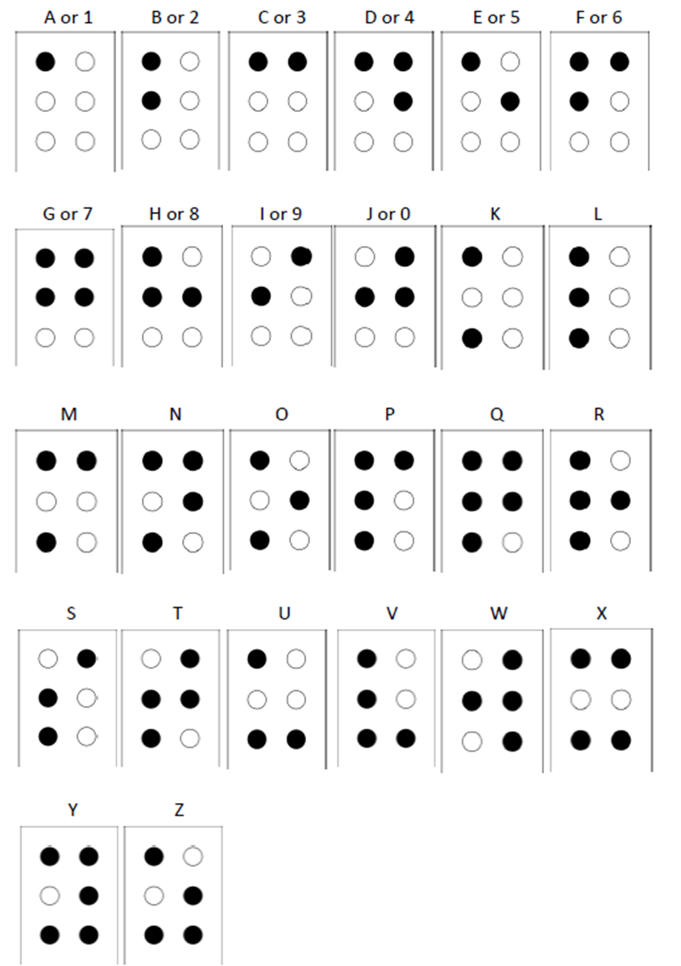
Clue 5: When in Rome
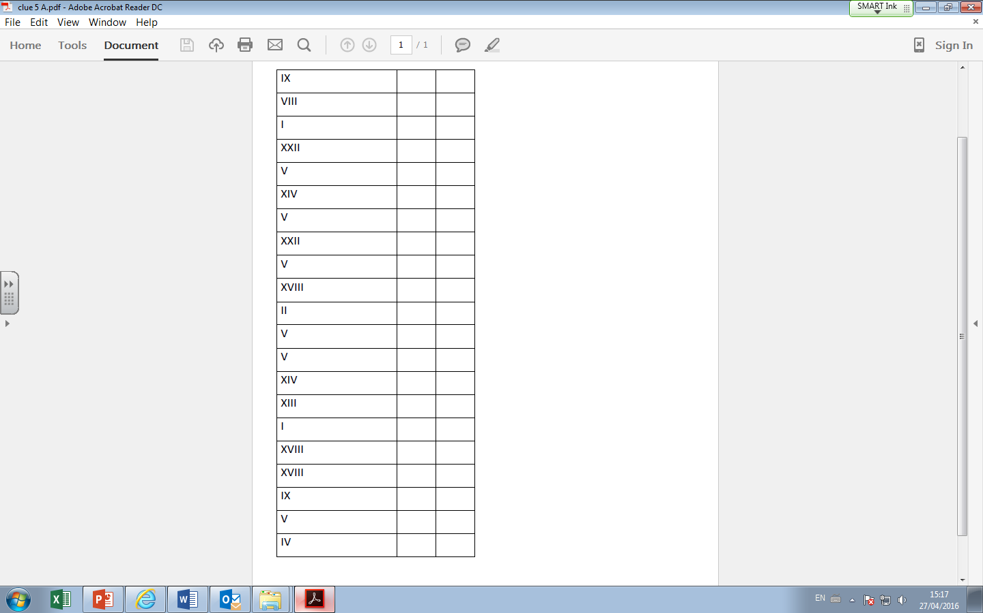
Suspect Sheet:
