Pixar Problems – Converting Measurements

Pixar characters have a habit of getting into trouble! Can you help them?

1) Oh no, Woody has knocked Buzz out the window.
Woody throws a rope out the window to try to get him back.
He first lets 20m of rope down, and then another 200cm so that Buzz could reach it. How many centimetres of rope has Woody thrown down?

2) Marvin and Dory are being chased by a shark!
They swim away as fast as they can.
They swim 7km at top speed, and then swim another 1200m
to hide in a coral reef. How many metres have they swum in total?
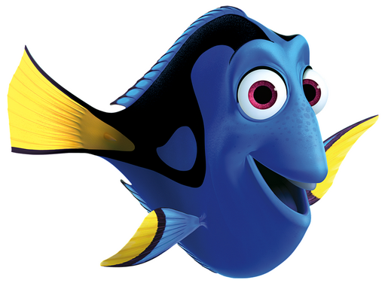

3) Sully is determined to break the scream record!
In his first room, he collected 3.2 litres of scream,
and in his second he collected 700ml of scream.
How many litres of scream has he collected so far?


4) Mater needs to rescue Lightning McQueen when he breaks down!
Lightning weighs 2500kg, and has 80000g of luggage in his boot.
How much does he weigh in kg?

CHALLENGE!
Eve needs to take the plant from Earth to the spaceship to save humanity!
She flies 3500m to escape the Earth, 6.5km towards the ship, and then 750cm through the ship entrance to see the captain. How far has she flown in total?

Pixar Problems – Converting Measurements

Pixar characters have a habit of getting into trouble! Can you help them?

1) Oh no, Woody has knocked Buzz out the window.
Woody throws a rope out the window to try to get him back.
He first lets 20m of rope down, and then another 200cm so that Buzz could reach it. How many centimetres of rope has Woody thrown down?
2) Marvin and Dory are being chased by a shark!
They swim away as fast as they can.
They swim 7km at top speed, and then swim another 1200m
to hide in a coral reef. How many metres have they swum in total?

3) Sully is determined to break the scream record!
In his first room, he collected 3.2 litres of scream,
and in his second he collected 700ml of scream.
How many litres of scream has he collected so far?

4) Mater needs to rescue Lightning McQueen when he breaks down!
Lightning weighs 2500kg, and has 80000g of luggage in his boot.
How much does he weigh in kg?

CHALLENGE!
Eve needs to take the plant from Earth to the spaceship to save humanity!
She flies 3500m to escape the Earth, 6.5km towards the ship, and then 750cm through the ship entrance to see the captain. How far has she flown in total?

