Connections - Standard Form Calculations
Multiplying
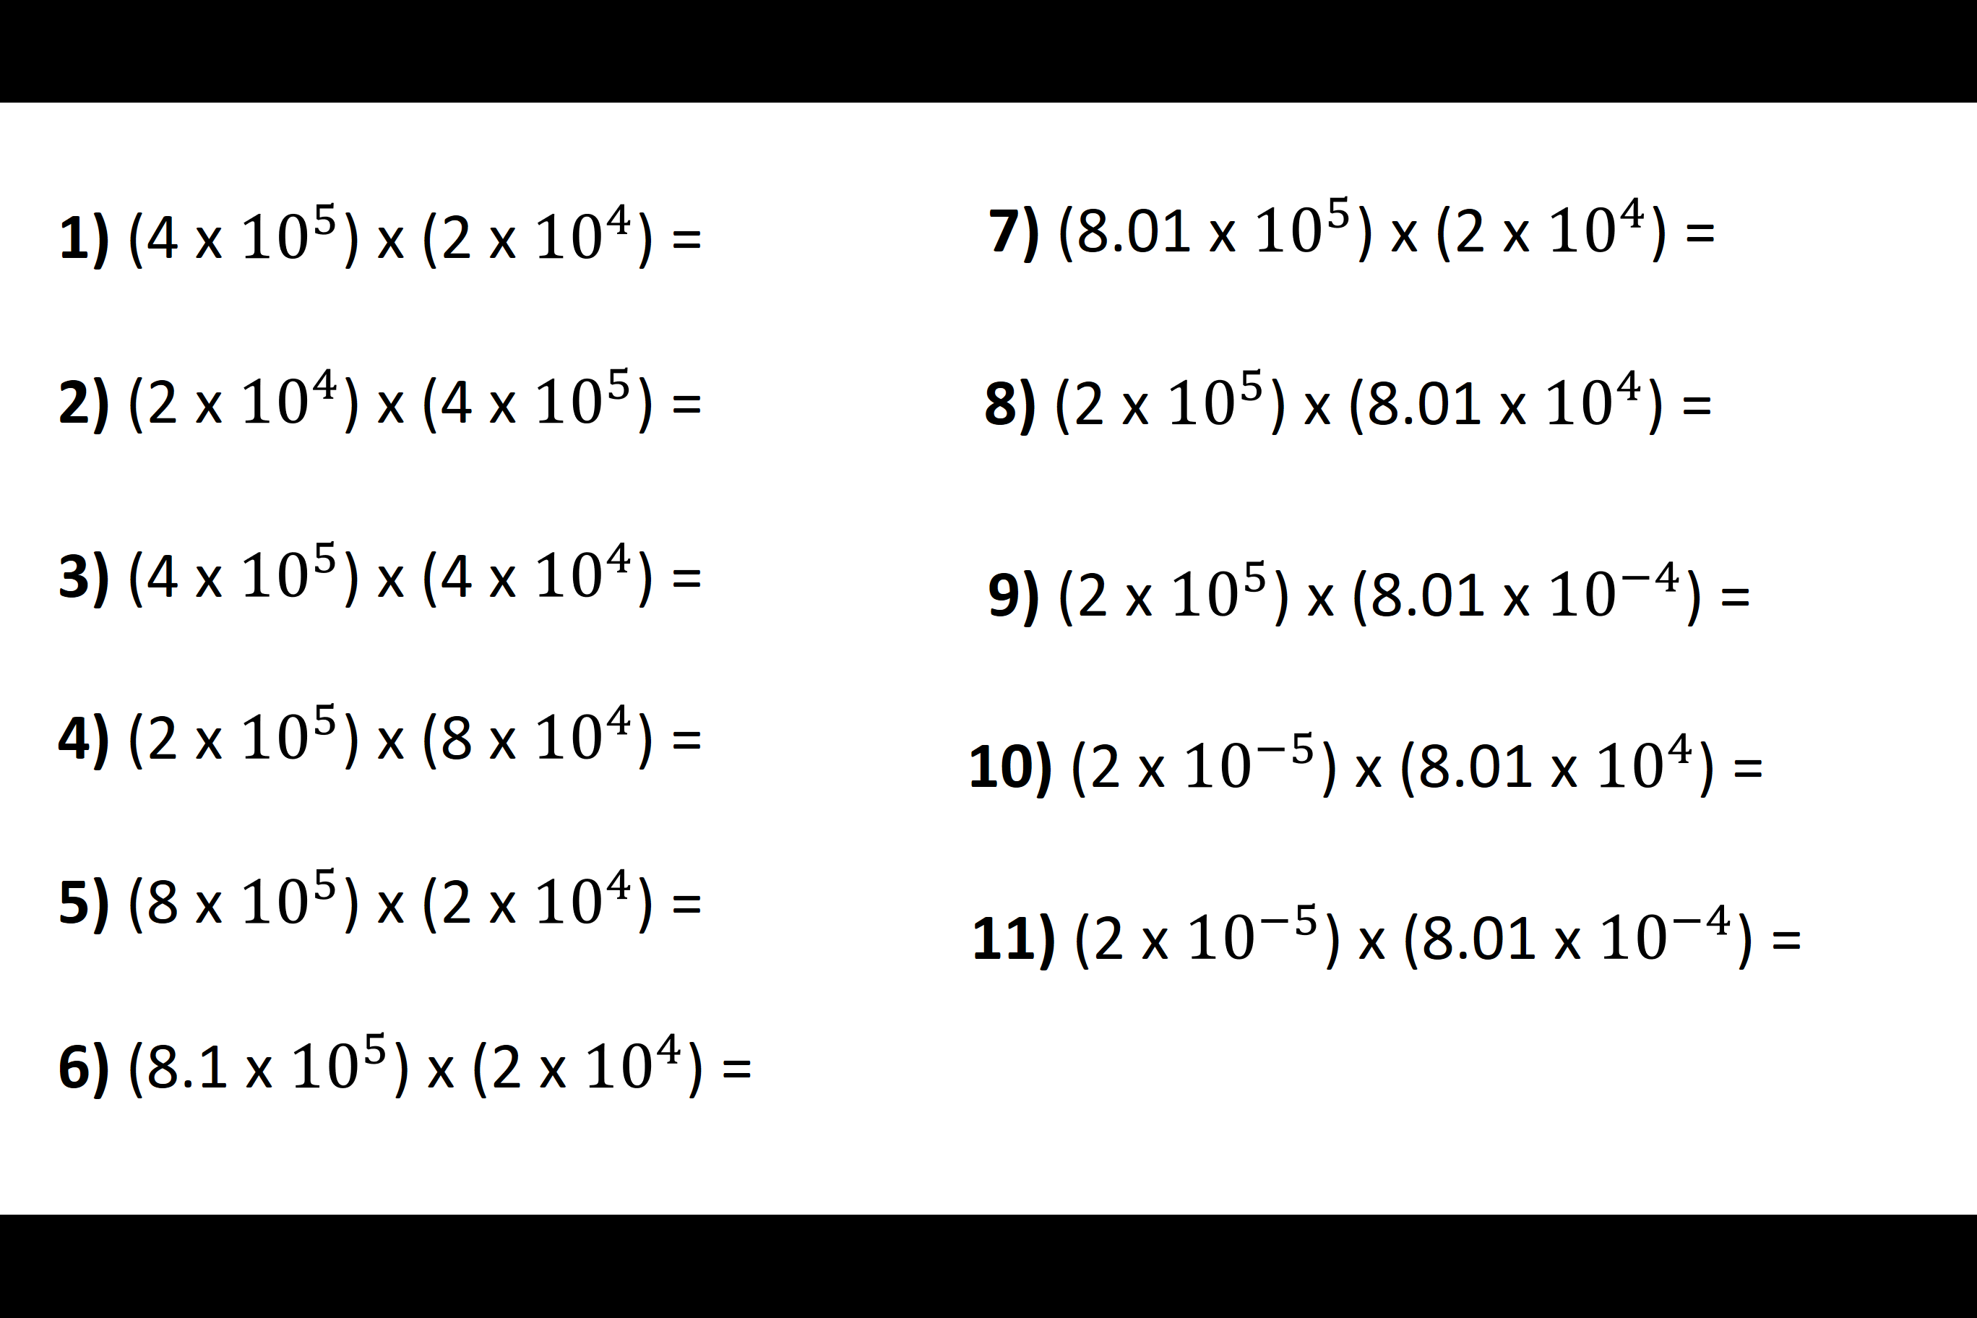
Dividing
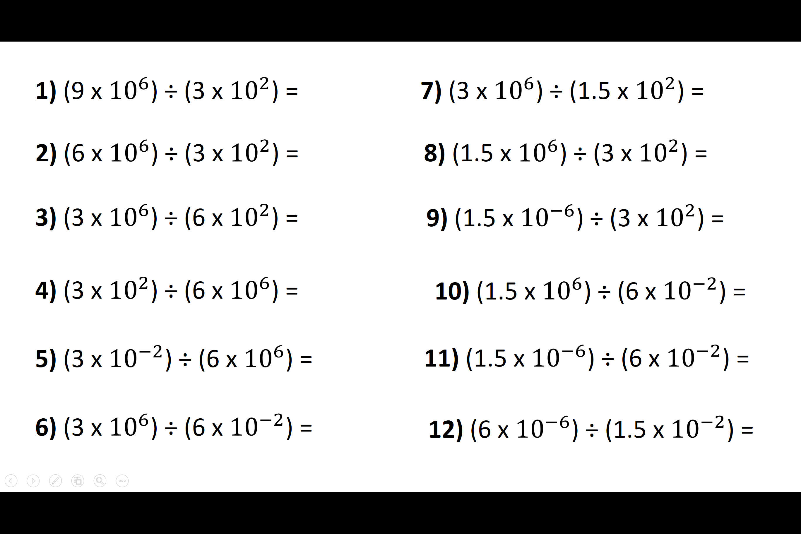
Connections - Standard Form Calculations
Multiplying
Dividing

