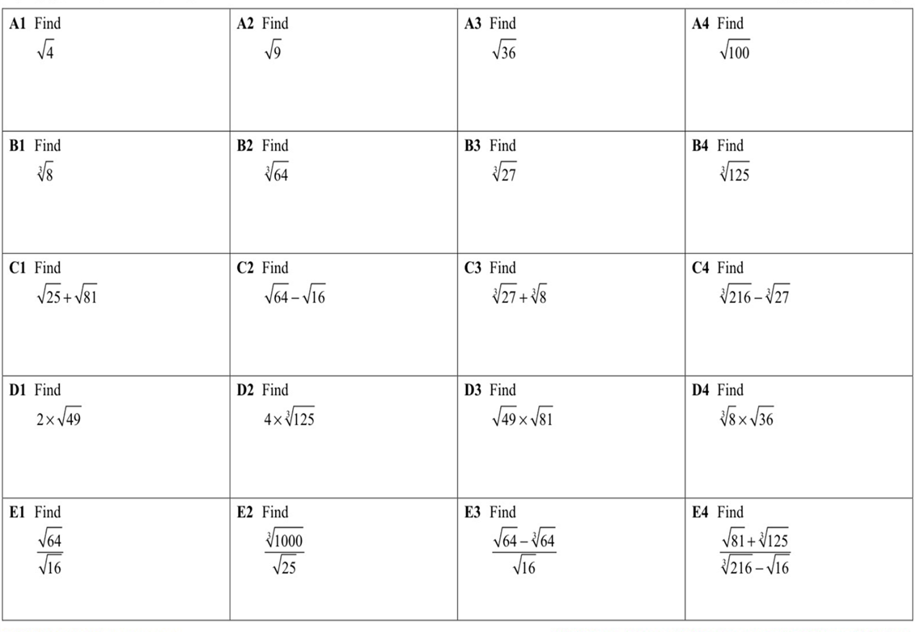
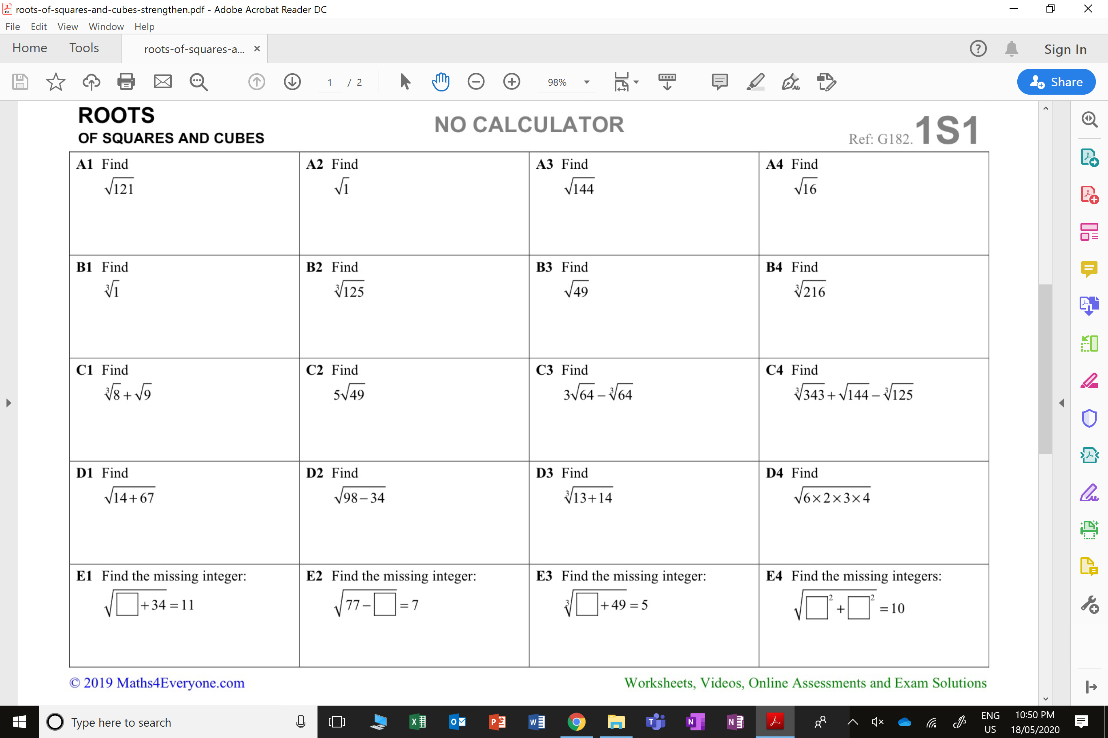
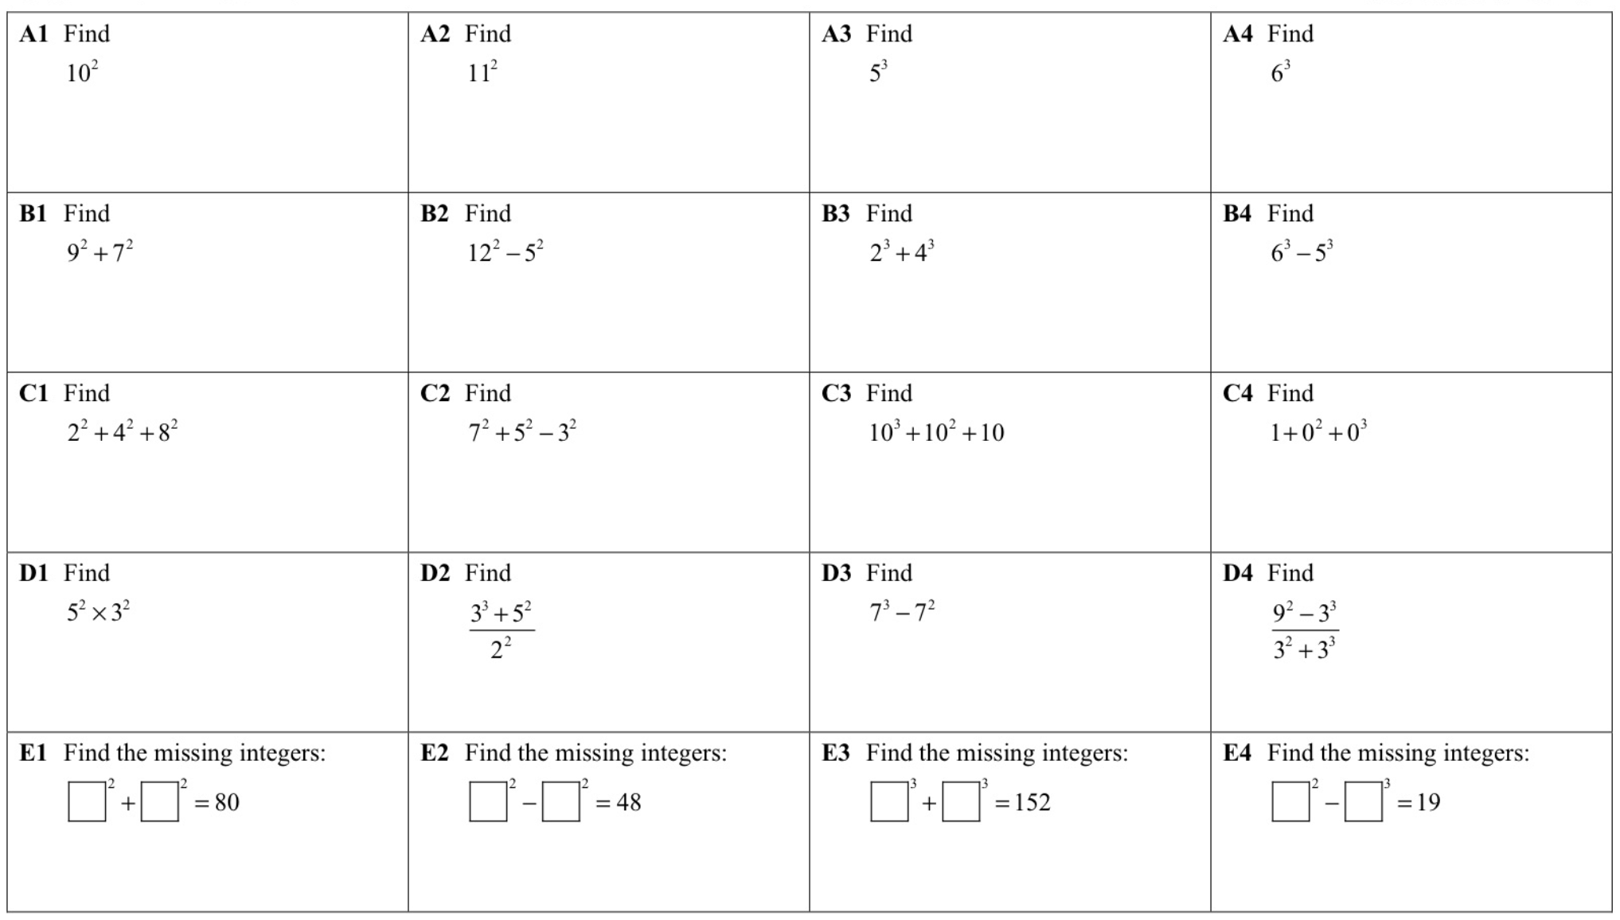

Show by finding the product of prime number the following:
What is the square root of 225?
What is the square root of 441?
What is the square root of 625?
What is the square root of 900?
What is the square root of 1,600?
What is the cube root of 216?
What is the cube root of 343?
What is the cube root of 512?

