Factorise
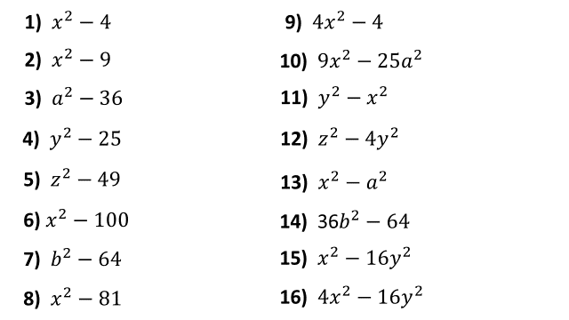
Factorise and Simplify
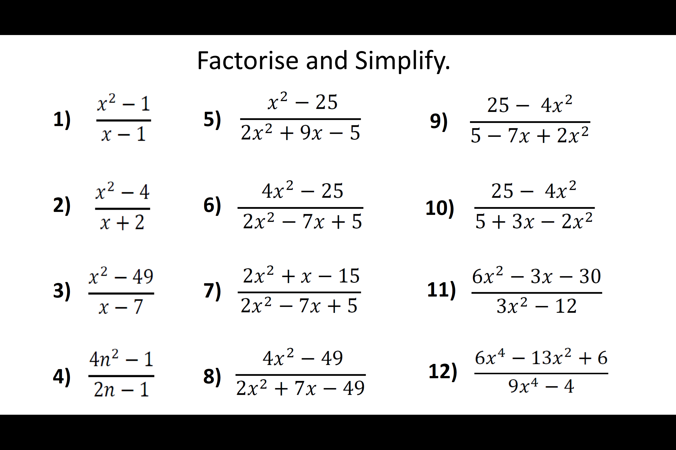
Factorise
Factorise and Simplify

