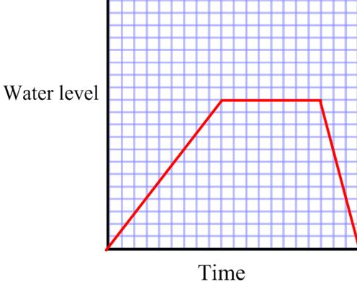  1) | A) Maria had a long soak and stayed in the bath for 15 minutes.
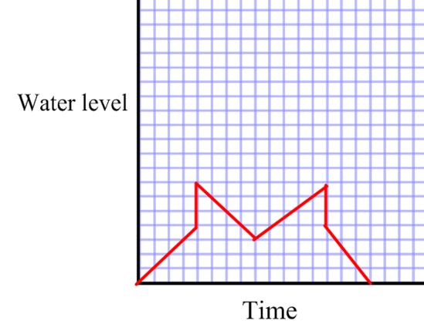 | B) Paula was in the bath for 2 minutes before turning the tap back on. She then got out to get the shampoo from the cupboard.
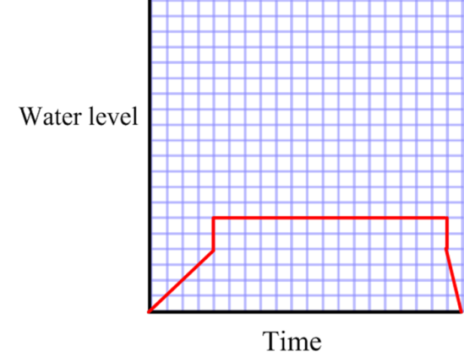  3) | C) Howard accidently knocked the plug out of the bath when he got in, so he had to put the tap back on for 5 minutes.
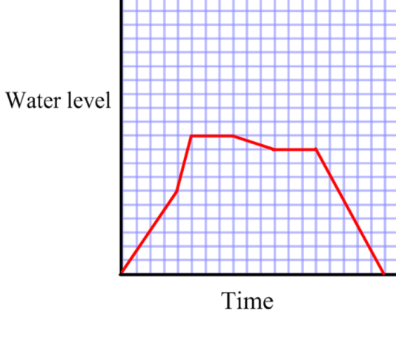  4)  2) | D) Peter ran the tap for 3 minutes. Then he left the bath to cool for 2 minutes before getting in. He emptied the bath after being in it for 10 minutes.
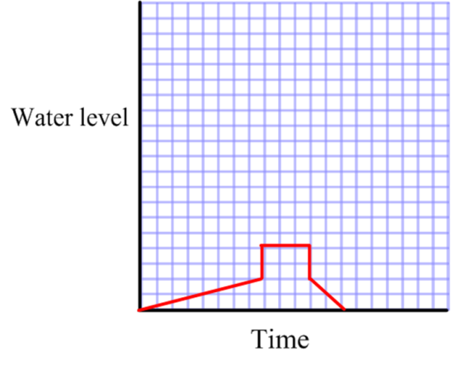  5) | E) Carlos got into the bath while it was still running. He splashed some water out onto the floor while washing his hair. He was in the bath for 10 minutes in total.
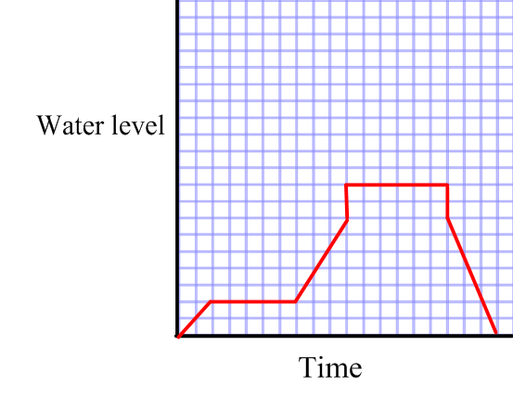 | F) Monica does not like baths so only stayed in it for 2 minutes.
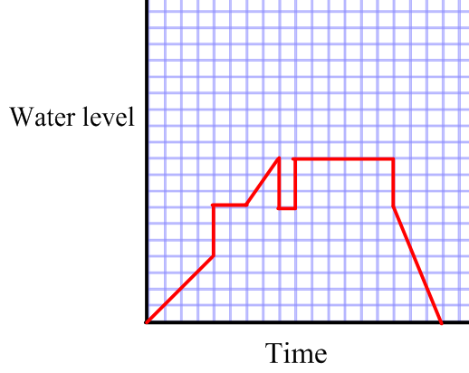  7) | G) Jane’s bath tap was running slowly so her bath did not get very full before she got into it. Due to this she only stayed in for 3 minutes before getting out then taking the plug out.
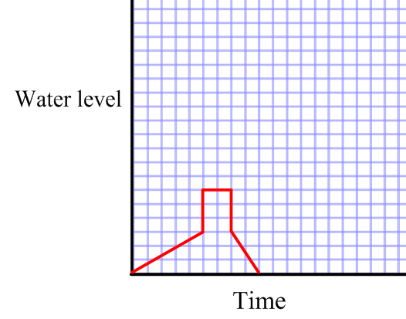  8)  6) | H) Amelia forgot about her bath and it was over-flowing for 8 minutes before she managed to take out the plug.
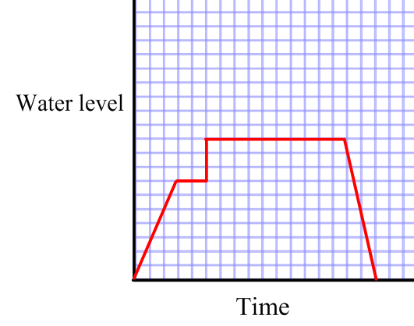  9) | I) Nia started to run a bath but then changed her mind and took the plug out.
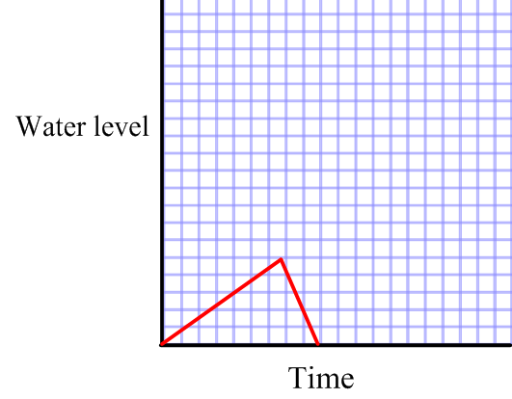  10) | J) Harry stopped the tap after 2 minutes because he had to run to the shop. When he got back he ran the tap for 3 minutes before getting in.

