Product of Prime Factors
Write each number below as a product of prime factors.
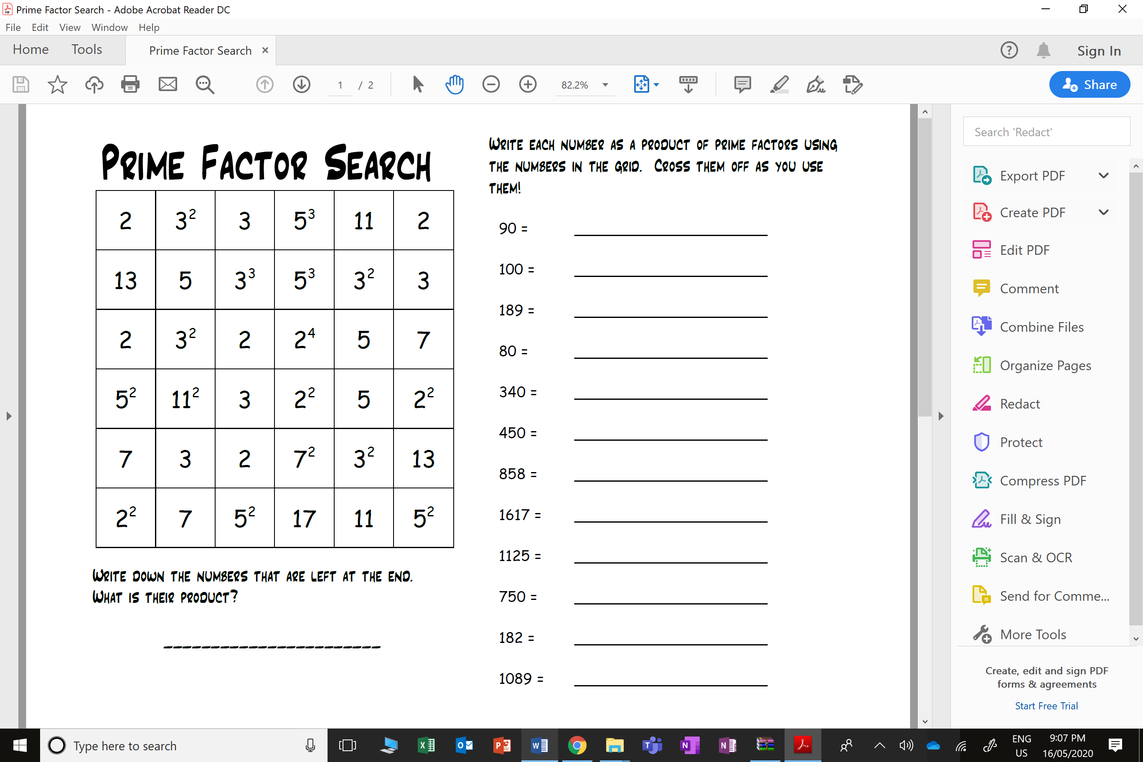
Cross off the numbers in the grid that were used above.
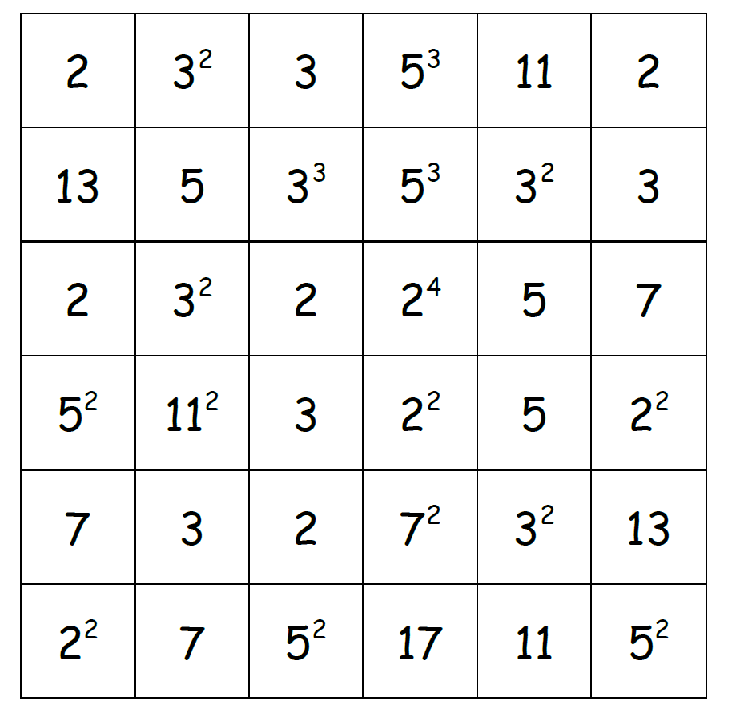
Write down the numbers that are left at the end.
What is their product?
Product of Prime Factors
Write each number below as a product of prime factors.
Cross off the numbers in the grid that were used above.
Write down the numbers that are left at the end.
What is their product?

